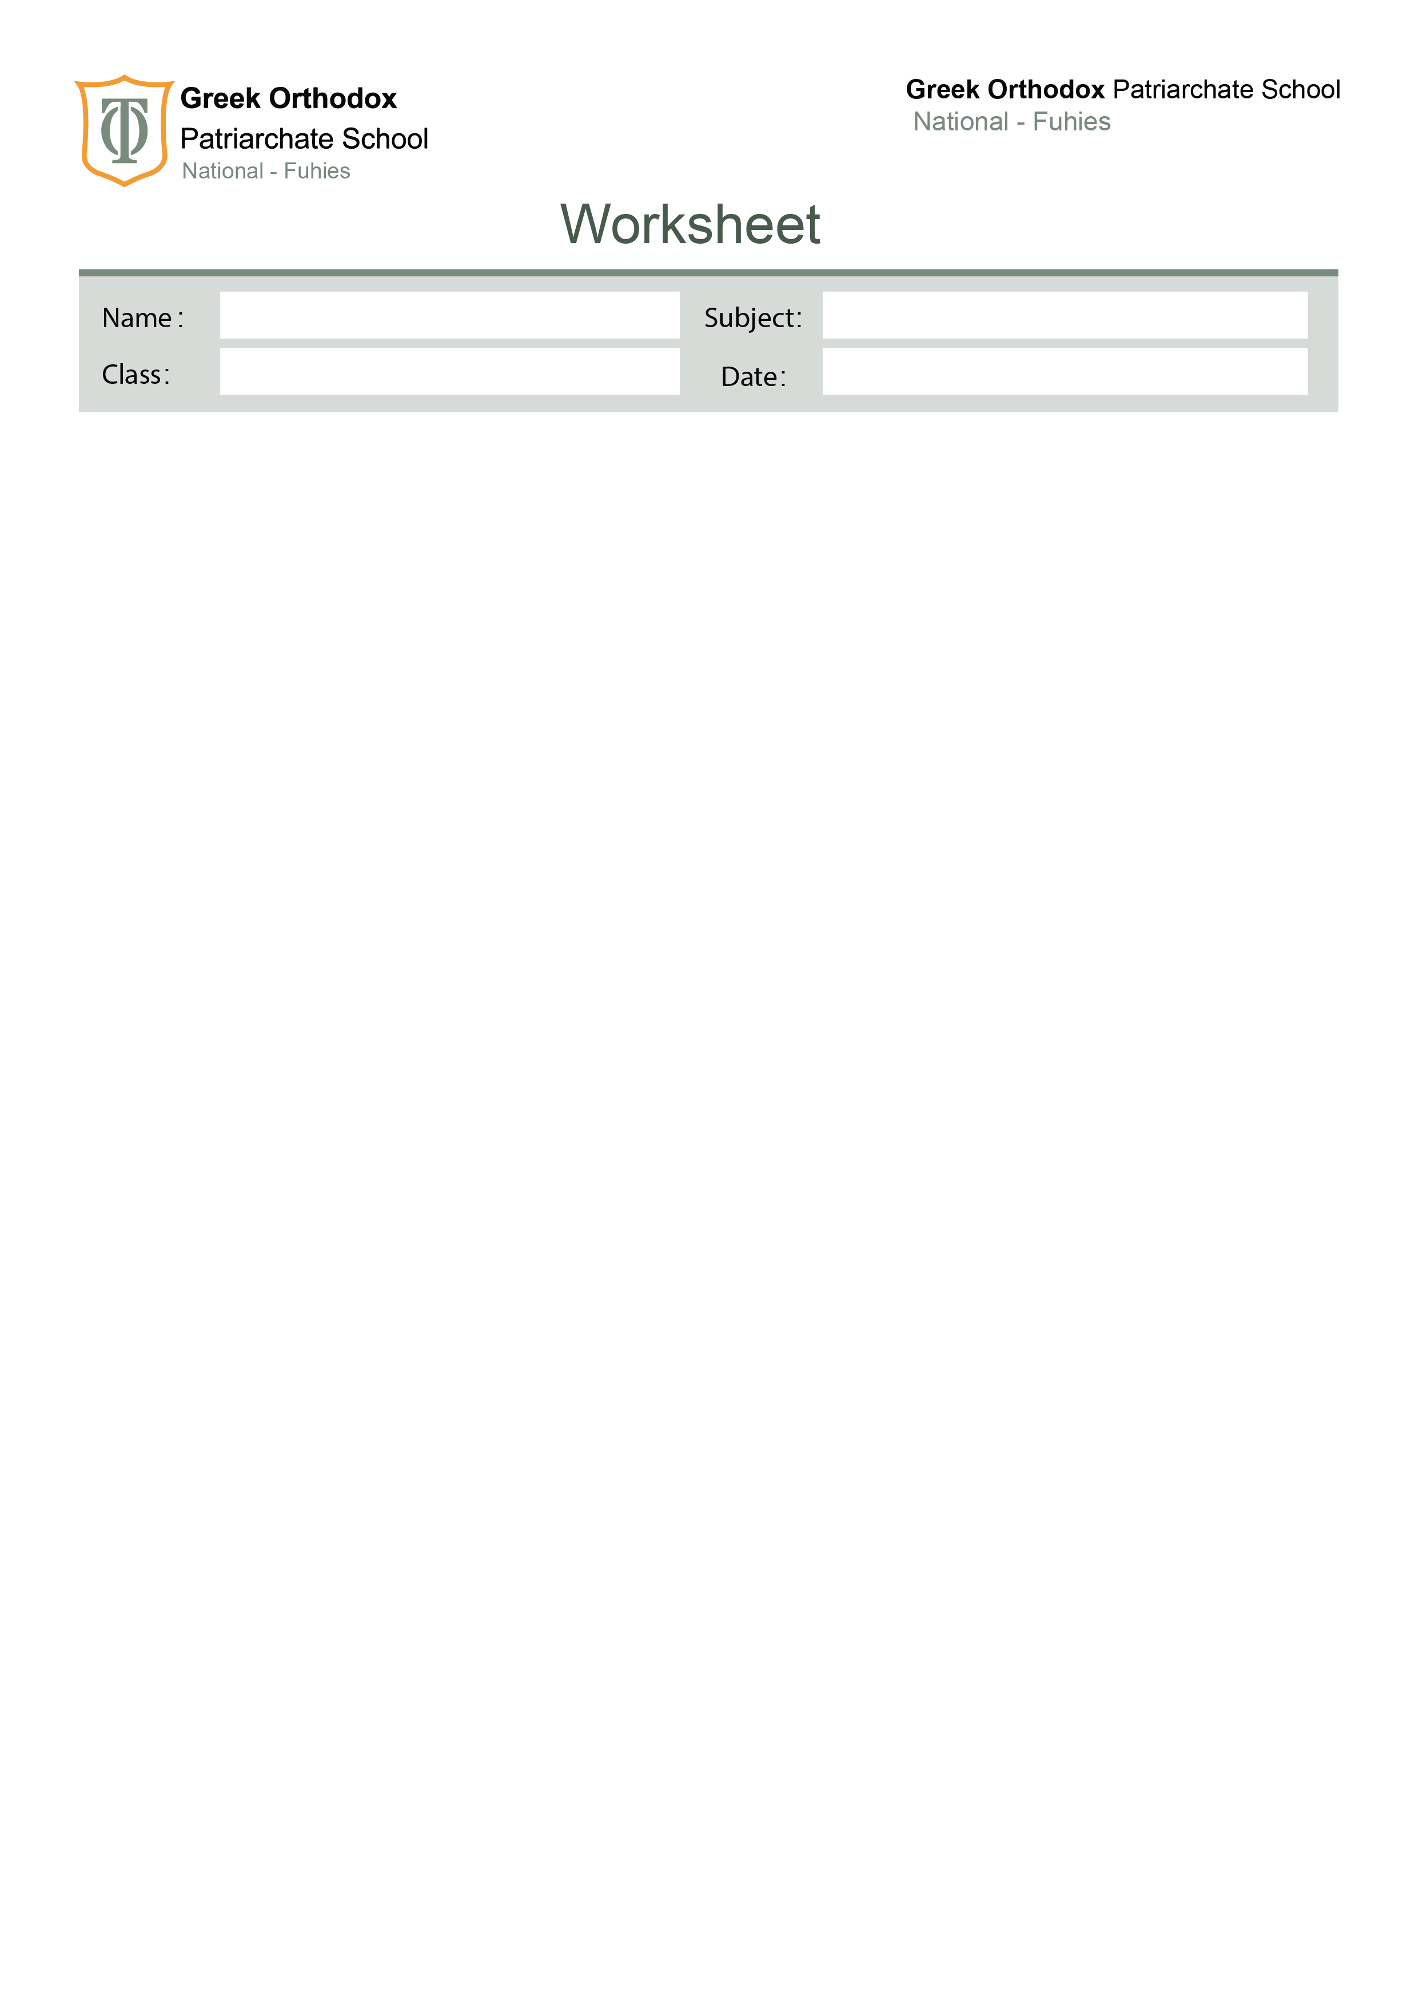

No. ( 4 )

Countable and uncountable nouns
Eight

Countable and Uncountable Nouns

Common Uncountable Nouns in English

advice -air - beef -blood -bread- butter -cheese – chocolate- coffee- cotton – flour- food -furniture- gold -grass - homework -honey- ice- information- jam -juice -ketchup -knowledge- lamb-luggage- mayonnaise-meat- milk - money -music -mustard-news -noise- oil -oxygen- paper- pepper- petrol -plastic – rain- rice - salad -salt -sand - snow - sugar – tea- toothpaste- traffic- trouble- vinegar – water- weather - wood -wool -work

Countable nouns have singular and plural forms while uncountable nouns can be used only in the singular form.

E.g. table, tables; month, months; pen, pens.

E.g. Her jewellery is designed by a well-known celebrity.
I needed some advice, so I went to see the counsellor.

Some nouns can be countable or uncountable depending on the context or situation.
E.g.
I saw two hairs on my pillow. (countable).
I don’t like short hair. (uncountable).

Quantifiers :

1.A lot of vs. Lots of
A lot of and lots of are used to express that there is a large quantity of something.

We use a lot of in positive sentences, negative sentences and questions. This expression can be used with countable or uncountable nouns.

There are a lot of dogs in the street. (Countable noun)
I have a lot of time to answer your questions. (Uncountable noun)

2. Much vs. Many

Much and Many are used to express that there is a large quantity of something.
Much and Many are used in negative sentences and questions.
Many is used with countable nouns
Much is used with uncountable nouns.

They don't have much money to buy a present. (Uncountable noun)
How many brothers do you have? (Countable noun)
Is there much milk in the fridge? (Uncountable noun)

I have much money. (Incorrect because the sentence is positive / affirmative)
I have a lot of money. (Correct)

3. Few vs. Little
We use a few and a little to suggest a small quantity or not much of something.
A few is used with countable nouns (= some; not many)
A little is used with uncountable nouns (= some; not much)

I have a few crazy friends. (Countable noun)
I would like a little milk for my coffee. (Uncountable noun)

Few and Little usually have negative meanings.

He is sad because he has few friends. (Countable noun)
There are few chairs. We can’t seat all the people who are coming. (Countable noun)
There is little hope of finding your wallet. I think you lost it forever. (Uncountable noun)
They have very little money. They can’t buy food. (Uncountable noun)

4. Some and Any
The general rule is that any is used for questions and negatives while some is used for positive.

Both may be used with countable and uncountable nouns.

Do we need any rice?
No, we don’t need any rice.
We have some rice in the cupboard.

Some may also be used for questions, typically offers and requests, if we think the answer will be positive.

Would you like some wine?
May I have some more chocolate?

These are some containers we use with uncountable nouns.

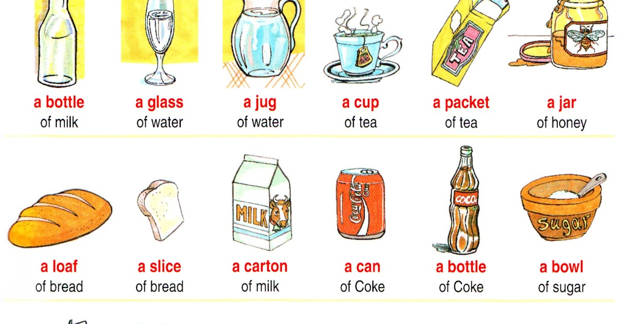

Exercises

- Choose the correct quantifier.

1.We met ……………... interesting people at the party.
an any some
2. How ................ people are coming to the party?
some much many
3. I haven't got my camera, so I can't take …………….. photographs.
some any much
4. I haven't got ………………. luggage.
many some any

5. How ……………... milk do you want in your coffee?
much many some
6. I drink …………... tea.
much a lot of many

7. There aren't …………..... hotels in this town.
many much some

8. How ………… time do we have?
many any much

9. They moved to France ……………… years ago.
a few some few

10. He had ___ time to study, but he still failed.
many a lot of much

11. Can we have ___ cake ?
some any many

12. There aren't ___ tickets let for the concert.
few much many

13. I'm so tired today. I paid ___ attention in class.
few little a little

- Fill in the gaps with either( some or any).

- There isn’t ___________ time to finish your lunch. We need to leave now!
- We have ____________ham sandwiches in the fridge if you’re hungry.
- Shall we bake ____________ cupcakes for the party?
- Do you have ___________ family in Italy?
- I won’t need to do ___________more revision after my exams.
- There aren’t ___________ shopping centres near my house.
- Is there ___________news on the royal couple’s wedding plans yet?
- We finally have ___________ news about the royal wedding!
- Would you like ___________ more soup, or are you full?
- Pick ____-_______ birthday card you like. I think they’re all nice.

- Fill in the gaps with either ( few, little, a few or a little).

- There’s __________ chance of Mary coming to the wedding. She’s in Australia!
- We have __________ options for our next holiday and they all look good.
- __________ people visit Siberia in the winter because it’s too cold.
- You have ___________ time before the next class if you want to get a drink.
- Let’s spend __________ days reviewing the proposal as I don’t want to rush it.
- There’s __________ point in repeating yourself because she never listens!
- I have very ___________ colleagues that I would trust in a crisis.
- __________ is known about the singer’s early life.
- Your dessert was delicious! Can I have __________ more, please?
- The staff training course takes ___________ days to complete.

- Choose the correct container.

1. Can I have a loaf/ bottle of bread please?
2. He has a bottle/ packet of spaghetti.
3. Do you want a knife/ spoon of sugar in your tea?
4. I bought a jar/ bottle of honey.
5. I need a slice/ glass of cheese.
6. Do you usually have a bottle/ cup of coffee in the morning?
7. A jar/ bottle of honey costs a lot of money.
8. I ate a can/ tin of tuna for lunch.
9. We always buy two cartons/ pieces of milk.
10.We have a bowl/ jug of soup for dinner.

Your English teachers: Nayfeh Abu Hanna & Lara Bajjali
Education is the passport to the future, for tomorrow belongs to those who prepare for it today

