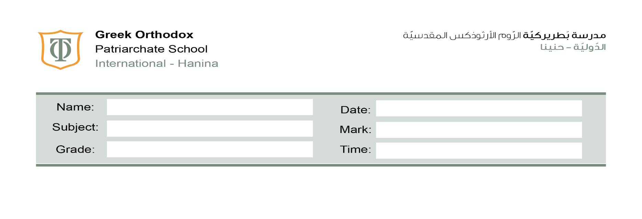
45 minutes
/20
27th /10/2025
Fifth Grade
Science Second Assessment

- Write the correct word for each of the following descriptions:
Choose from the box
Mucus | Hygiene | Defence | Host | Fertilisation | Puberty

a- The age at which a person becomes able to reproduce.
__________________puberty________________________
b- The joining of a male sex cell and a female sex cell.
___________________fertilisation______________________
c- The living thing that a parasite infects.
_________________host________________________
d- Protection against something.
_______________defence___________________________
e- A sticky substance found in our noses, windpipes and other air passages.
_______________________mucus___________________
f- Keeping yourself and the things around you clean.
__________________hygiene ______________________
/6

2- Read about malaria, then answer the questions.
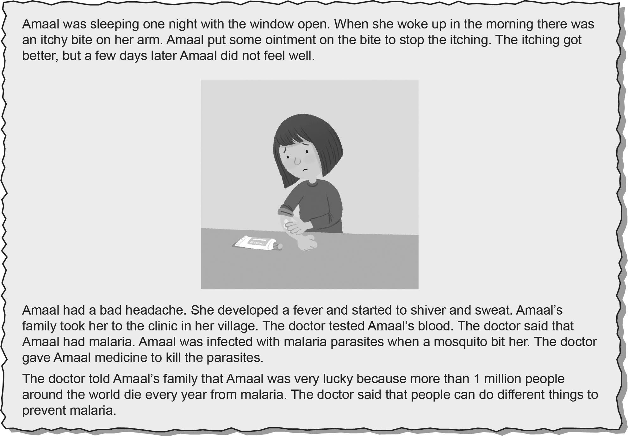
1- Use the words in the box to complete the sentences.
prevent headache malaria fever mosquito
a Two signs that showed Amaal was ill were a _______fever________ and a _headache______________.
b The disease that Amaal had is _____malaria__________.
c A _______mosquito________ spread the disease to Amaal.
d We can do things to stop or ____prevent___________ us from getting malaria.
2 Name a reason from the story why Amaal was bitten by a mosquito.
She left the window open at night.
3 Write a word from the story that means there is a germ inside a person’s body that is
making the person ill.
Infected
4 How did the doctor find out which disease Amaal had?
He tested her blood.
5 Explain why malaria is called an infectious disease.
Because more than 1 million people around the world die every year from malaria.
Or
It is caused by a parasite that enters or infects the body.
6 Write a word from the story that means a living thing that lives inside or on the body
of another living thing.
Parasite
7 Suggest three things that Amaal and her family could do so that no-one else gets the disease.
wear a mask
cover her mouth
keep doors and windows closed at night when mosquitoes are active

11

3-Match each of the body’s defences with the way it helps to protect the body from disease.
Body defence
Stomach acid
mucus
Skin
How it protects the body from disease
Trap germs
Stops bacteria entering the body
Kills bacteria in food we eat

/3

