Worksheet number ( 2 ) / Unit 2 Amazing Animal

Vocabulary 2
……./10/2025
6th Grade ( A+ B)

Learning Objective :- students should be able to use these words in spoken and written languages .

1- survival (n): continuing to live in spite of danger.
E.g. The lost climbers have little chance of survival in this terrible weather.
___________________________________________________________
2- tale (n): a story.
E.g. When we were young, Dad used to tell us tales of his travels as a sailor.



___________________________________________________________

3-brush (v): take something off the surface of something, using a brush or hands, etc.
E.g. A cow uses its tail to brush flies off its back.
___________________________________________________________

4-frighten (v): make somebody/something afraid.
E.g. My brother tried to frighten me with a tiny spider.


5- wag (v): what a dog does when it moves its tail from side to side.
E.g. Edith’s dog, Barney, always wags his tail like mad when she comes home.
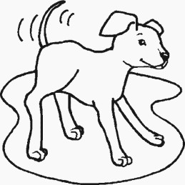

_________________________________________________________

6-similar (adj): like somebody/something but not the same.
E.g. My friend and I have got similar interests; we both love exploring nature.


___________________________________________________________

7-balance (v): put something in a position where it doesn’t fall easily.
E.g. It’s amazing how acrobats can balance when they walk on a tightrope.


English Department
Teacher
Saly Al-Shaheen

