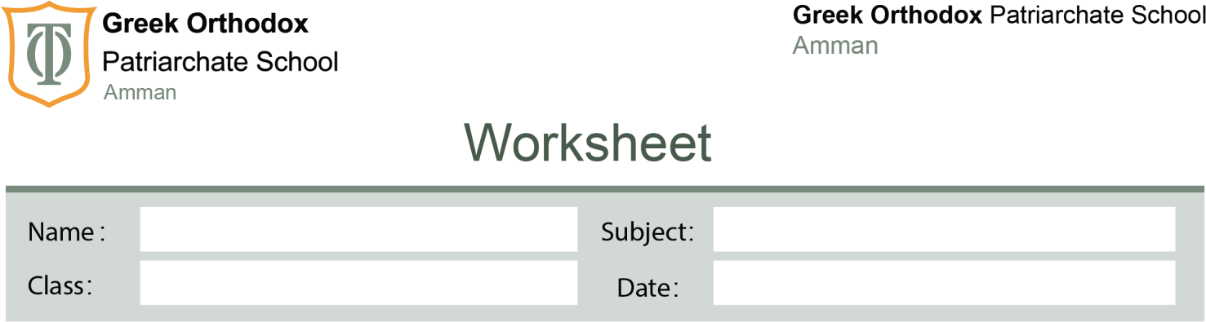

Past simple and past continuous

Grade

9

5/11/2025

1
#
Answer Key

Grade 9 – Past Simple and Past Continuous (Answer Key)

3. Guided Practice

A. Choose the correct verb form:
1. When I arrived, they were having dinner.
2. She was walking to school when she saw an accident.
3. We were watching TV when the lights went out.
4. He didn’t finish his homework last night.
5. What were you doing at 7 p.m. yesterday?

B. Fill in the blanks with the correct form of the verbs in brackets:
1. While I was reading, my brother was playing video games.
2. The teacher was explaining the lesson when the bell rang.
3. We didn’t go to the party because we were tired.
4. I was cooking dinner when my friend called me.
5. It was raining heavily all night.

4. Challenge Section

A. Error Correction:
1. He was play football → He was playing football when he broke his leg.
2. We didn’t was studying → We weren’t studying last night.
3. While they ate dinner → While they were eating dinner, someone was knocking at the door.
4. Did you were watching → Were you watching the movie yesterday?
5. the lights goes out → I was reading a book when suddenly the lights went out.

5. Quick Quiz
1. b) was cooking
2. b) lost
3. b) were playing
4. a) Were / watching
5. a) were / doing

