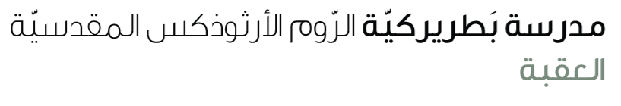
Name: A tale ( tail ) of survival 6th grade

Vocabulary:
Squirrel | a small animal with a long bushy tail that climbs trees and eats nuts.
Cheetah | a large wild cat that runs very fast; the fastest animal on land.
Rattlesnake | a poisonous snake that makes a rattling sound with its tail.
Scorpion | a small animal with eight legs and a curved tail that can sting.
scales | the small, hard plates that cover a fish or reptile.
Roll | to turn over or move in a circular way
Low | not high; near the ground or a small level.
Read the text carefully (S.B P 20)
- What do cats and squirrels use their tails for?
_____________________________________________________________________
- How do horses and donkeys use their tails?
_____________________________________________________________________
- Which animal can swing from tree to tree with its tail?
_____________________________________________________________________
- Why do fish need their tails?
______________________________________________________________________
- What does a rattlesnake do with its tail?
______________________________________________________________________
- What does a dog show when it wags its tail?
______________________________________________________________________
- The underlined pronouns refer to:
- They (line (2): cats and squirrels
- They line (5,6): horses and monkeys
- They line (9) : spider monkeys

- Find out:
Nouns | Monkeys / horses / animals / cheetahs/ parrots / wall / table
Verbs | Use / help / swing / work / jump
Adjectives | Different/ thick / thin/ short/ long/ fastest /
Verb to be | is , are
Articles | a, an, the
Prepositions | In , on, onto
Pronouns | , they , its , you
Adverb | Quickly / friendly

