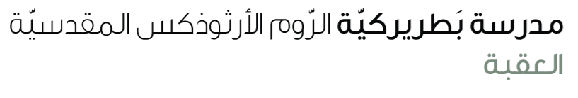
Name: If type 2 6th grade
Function:
- We use type two if we want to talk about imaginary or impossible unlikely situations and their consequences now and in the future.
- Or to give advice
Form:
S
IF
S
V(inf)
Would
V(2)
0
… ,
Example:
- If I were you, I would take the case to court.
- If I were you, I wouldn’t take the case to court.
- If I had a billion pounds, I would travel around the world
Complete the sentences with the correct verbs.
- If I __________ money, I would buy some fruits. (have)
- If you __________ to bed late, you ___________ so tired. (go, be)
- We ______________ to the park if the weather ___________ good. (go, be)
- If I ______________ the queen of the earth, I ______________ money to everyone. (be, give)
- If I _____________ taller, I ______________ this dress. (be, buy)
- We ____________ the thief, if we ___________. (,know ,focus)
- If I spoke French well, I ____________ for the translator’s job. (apply)
- If I had a car, I ___________to take the train every morning. (not have)
- I’d be on the beach if I ____________________ on holiday right now. (be)
- If I didn’t like travelling, I _______________ so often. (not fly)
- If I took my exams again, I ___________ really upset. (be)
- I’d go for walks every day if I___________ in the countryside. (live)

Your teacher: Mona Badawi

