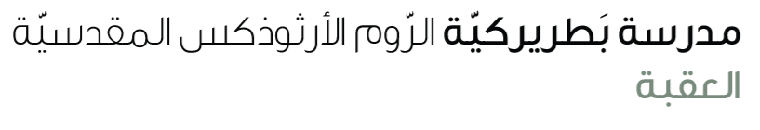
Name: If type 1 6th grade
Function:
- We use type one when we want to talk describe a future outcome of a certain future actions or events.

Form:
S
IF
V (inf)
Will
S
V(1)
,

Example:
- If you study hard, you will pass the exam. (study, pass)
- If you don’t study hard, you won’t pass the exam.

Complete the sentences with the correct form of verb.
- If you _________ an interview for a job, you ____________ to show a real care. (have, need)
- If it _____________, we ____________ a picnic next week. (not rain, have )
- I ______________ to university if I ____________ the Tawjihi exams . (go , pass)
- Even if I __________, I _____________ to the library this afternoon. (be, go)
- If she ____________ with me, I ____________ to the library. (not come, not go )
- If the book ___________ expensive, my father ____________ it for me. (be , not buy)

Done by: Mona Badawi

