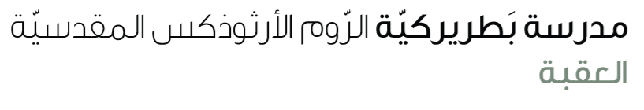
Name: present perfect ( just/ already/ yet) 5th grade

Word | Meaning | Use in a Sentence | Position in the Sentence
Already | Something happened before now or earlier than expected | I have already finished my homework. | After have/has and before the past participle (V3)
Just | Something happened a very short time ago | She has just left the classroom. | After have/has and before the past participle (V3)
Yet | Something expected but not done until now | I haven’t finished my work yet.  Have you eaten yet? | At the end of the sentence

Note: 'Yet' is used only in negative sentences and questions.
Exercises
Fill in the gaps with (already / just / yet):
a) I haven’t seen that movie _______.
b) He has _______ finished his breakfast.
c) We have _______ arrived home.
***************************************************************
Circle the correct answer:
a) Have you done your homework (already / yet)?
b) She has (just / yet) left the office.
c) I haven’t called him (just / yet).

