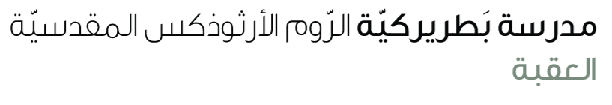
Name: The world is their classroom 5th grade

Vocabulary:
Left | Went away from a place or didn’t stay
Language | The system of words and grammar people use to communicate
Geography | The study of the earth , its countries , land and people
sell | To give something to someone in exchange for money
Fuel | Something that gives power or energy like gas or oil
Dive | To go headfirst into water or move down quickly
Deep | Extending far down from the top or surface not shallow
Read the text carefully (S.B P 20)
- Where are Harman and Candelaria Zapp from?
____________________________________________________
- When did they start their journey?
_______________________________________________________
- How many children do they have?
___________________________________________________________
- What is their home?
___________________________________________________________
- Do their children go to school?
_______________________________________________________________
- What is the best thing about their life?
_______________________________________________________________
- The underlined pronouns refer to:
- They:Zapp’s family
- Find out:
Nouns | Maps / photographs / children / languages
Verbs | Visited / travelled / play
Adjectives | Different / the best / wet
Verb to be | is
Articles | a, an, the
Prepositions | In , on, around
Pronouns | they/ it

