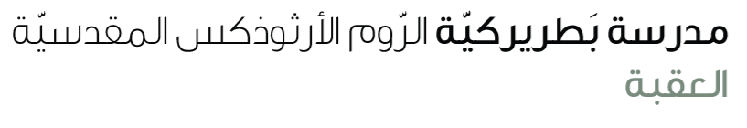
Name: Adverbs 4th grade

We use adverbs pf manner to describe how we do things. They usually go at the end of a sentence.
Quiet | Quietly
Loud | Loudly
Slow | Slowly
Careful | Carefully
Quick | Quickly

Irregular adverb
Good | Well
Fast | Fast

Complete the sentence with correct form of the adverb
- The walked ____________ . ( slow)
- He ran _______________. (fast )
- They shouted ____________. ( loud)
- I ate my meal ___________. (quick)
- He did his homework vey ___________ (good)

