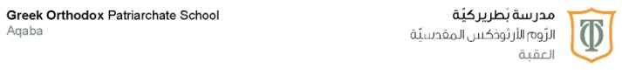
2nd Exam study guide

“Unit two” only

Please pay attention for the following :

- Texts are required from both SB and WB
- Grammar 1 and Grammar 2 are included
- Vocabulary 1 and 2 are included

Note: skills exam had been taken (reading, listening, speaking and writing)
The points of skills exam will be added to the pencil and paper exam

Best of luck Champs
English department
Ms. Shams Alaseel Tareq

