
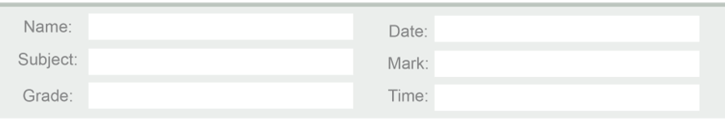

Q1: Choose the correct answer:
1- We eat the roots of the plant like:
a) rice b) radish c) maize

2- We eat the stem of the plant like:
a) sugarcane b) apple c) cabbage

3- We eat the leaves of the plant like:
a) wheat b) spinach c) banana

4- We eat the seeds of the plant like:
a) rice b) mango c) carrot

5- We eat the fruit of the plant like:
a) oats b) barley c) pineapple

Q2: Match:
1. Root | (2 ) potato
2. Stem | (4 ) apple
3. Leaf | (2 ) sugarcane
4. Fruit | (3 ) spinach
5. Seed | (5 ) wheat

Q3: Which part do you eat from these plants:
 the right box:
 | Leaves | Root | Fruit
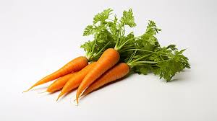
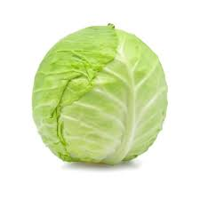
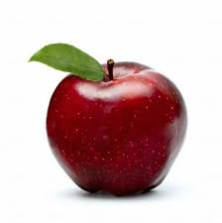
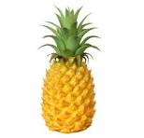
Teacher:
Maria Al Zuraikat

