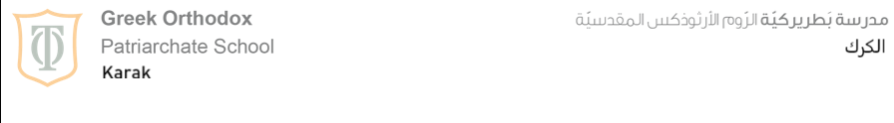

Name: ……………………………. Class: 7th grade
Date: .…………………………….

Worksheet (3)
Present continuous

** Present Continuous is used for:
- Actions that happen around the time of speaking:
- I’m learning French this year.

- Temporary situations:
- We aren’t working this week.

- Actions that are happening at the time of speaking:
- I’m watching a film right now.

** Time expressions used with Present continuous:
- At the moment - now - for the time being – this morning / afternoon / evening / week / month / year / today, etc.

** Form:
** Affirmative:
Sub + verb to be (is – am – are) + v.ing
- I am working.
- We are running.

** Negative:
Sub + verb to be (is – am – are) + not + v.ing (isn’t – aren’t – I’m not)
- She isn’t looking.
- They aren’t watching.

** Question:
a- Yes / No questions:
Verb to be (is – am – are) + sub + v.ing ?
- Is she laughing?
No, she isn’t.
Yes, she is.

- Are they playing football?
- No, they aren’t.
Yes, they are.

b- Wh questions:
Wh word + verb to be (is – am – are) + sub + v.ing?
- What are you doing?
- Where is he going?

** Spelling:
1- With most verbs we add -ing:
- stay→ staying.
- work→ working.

2- Verbs ending in -e we drop the e, add -ing:
- make → making
- close → closing.

3- Verbs ending in ie we change ie into y, add -ing:
- lie → lying.
- die → dying.

4- Verbs ending in one vowel + one consonant we double last letter + -ing:
- run → running
- sit → sitting
-----------------------------------------------------------------------------------------------------------------------------
** Stative verbs:
- DESCRIBE STATES NOT ACTIONS.

💖 Like
Means to enjoy or to feel pleased with something.
✅ I like pizza.
❌ I am liking pizza.
We don’t use like in continuous tense because it shows a feeling, not an action.

❤️ Love
Means to like very much or to have strong feelings for someone or something.
✅ I love my parents.
❌ I am loving my parents.
It expresses a strong, permanent feeling.

🙏 Believe
Means to think that something is true or to have faith.
✅ I believe in God.
❌ I am believing it’s true.
It shows an opinion or belief, not an action.

🧠 Know
Means to have information or to be sure about something.
✅ She knows the answer.
❌ She is knowing the answer.
“Know” expresses knowledge, not something you do at the moment.

💭 Think
Has two meanings:
Stative meaning (opinion):
✅ I think it’s a good idea. (means I believe)

Action meaning (using your mind now):
✅ I am thinking about my homework.
Teacher:
Maria Al Zuraikat

