
Seventh Grade
White light and the prism
Study sheet

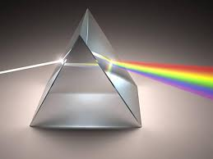
*Prism is a three-dimensional object with identical ,parallel ends, and has a flat surface.

Q: How does the prism work?
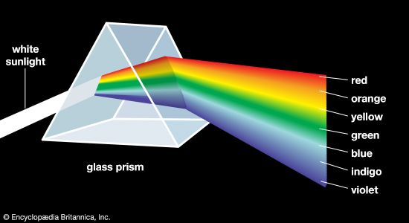
When a ray of sunlight is shone through a prism at certain angles of incidence, and its path is stopped by a white screen, a range of colours, called spectrum, can be seen on the screen.

*This splitting of white into different colours is called dispersion. It occurs because the different colours of light travel at very slightly different speeds and are refracted at slightly different angles by the prism. This makes them spread out or disappear.
*You can remember the order of the colours using a made-up person’s name:
