No. ( 1 )

vocabulary unit.1
Five (A+B)

no | Word | P.O.S | Meaning | Picture
1- | envelope | noun | a paper container | 
2- | letter | noun | a written message | 
3- | post | verb | to send a message | 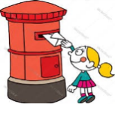
4- | postbox | noun | a public mailbox | 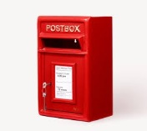
5- | postcard | noun | a card on which a message may be written without an envelope but with a stamp on it | 
6- | post office | noun | a place for handling mails | 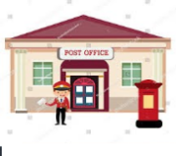
7- | stamp | noun | a special drawing or mark | 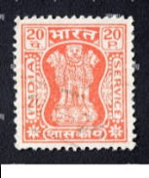

Synonyms
contact / communicate/connect/ keep in touch

______________________  _________________
Exercises

A: Fill in the blanks with the correct words from the box below:

letter envelope post post office contact stamp newspapers

1. It’s very important to have ________________ with people around us.
2. My uncle was trying to __________________his letter to his son.
3. ____________________were the way for people to know the news.
4. I forgot to buy a ____________________for my postcard!
5. It’s more appropriate if you put the money in an__________________.

B: Choose three words and put them in meaningful sentences:

- __________________________________________________________________

- ___________________________________________________________________

3.____________________________________________________________________

C. Replace the underlined words with the suitable words.

- My friend sent me a written message last Monday. _________
- I am trying to send him a postcard but I don’t know how! _________
- If your letter is ready, you can post it in the public mailbox. ___________
- There is a difference between communication now and then.__________

D. Read each statement and write True or False next to it.

- A stamp is used to pay the cost of sending a letter. ___________
- The post office is the place where people go to buy stamps and send mail.________
- You don't need an envelope to send a letter.________
- You can send a letter without writing anything on it._____________

E: Match the Words to Their Meanings Words:
1.Communication a.A person you don’t know.

2.Message b.Talking between two or more people.

4.Conversation c.To find something new.

5.Discover d.When people share ideas or information.

6.Connection e. A piece of information sent to someone

7.Stranger f. A link or relationship between people.

1-…………. 2-…………… 3-……………… 4-………… 5-………… 6-………….. 7-………………….

Your Teacher:
Christa Sweis

