Unit 2 Vocabulary (Life on the road)
Fifth ( A,B)

No. ( 2 )

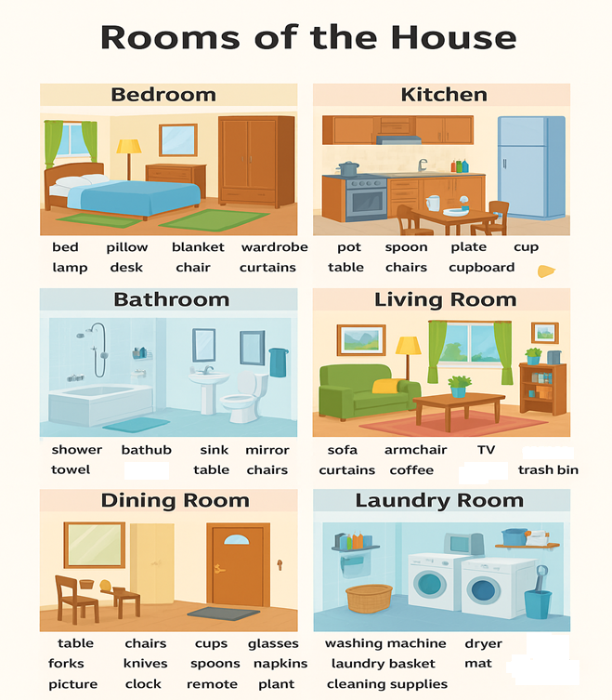

C: Look the pictures and choose from the box to write the name of each item :
sofa, bed, table, armchair, vase, pillow, wardrobe ( closet), blanket, sink, mattress , shelf, table lamp

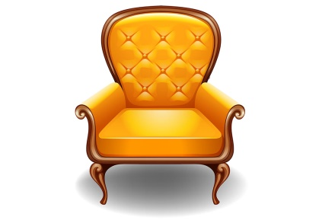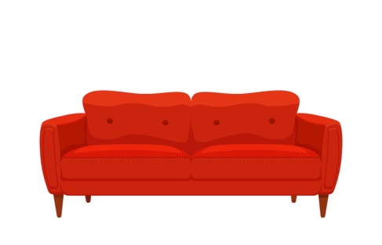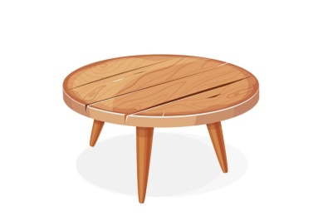
……………………………… …………………………. …………………………….
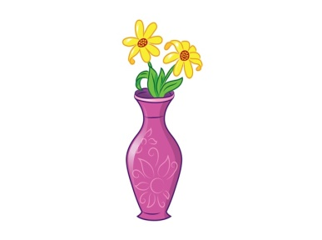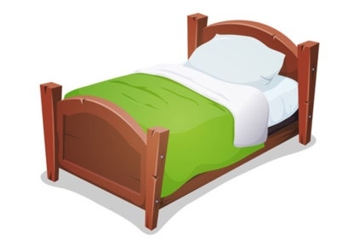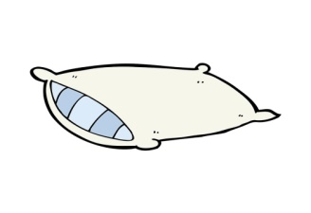
……………………………. ………………………. ………………………..
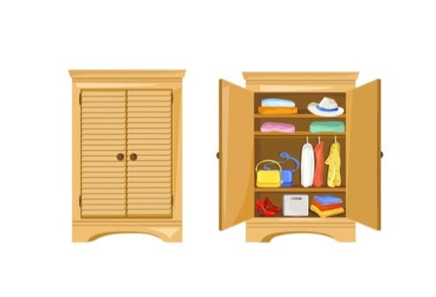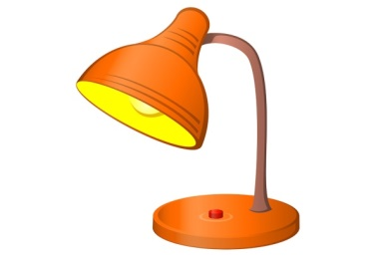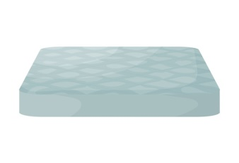
……………………………………… …………………………………… ……………………….
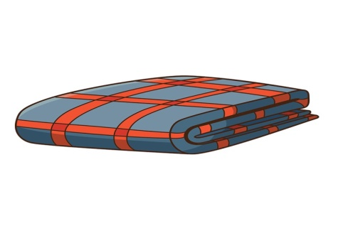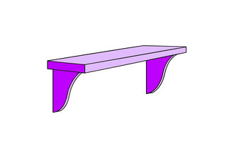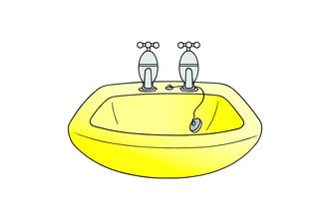
…………………………. ……………………………………… …………………………..

B: Choose the Correct Word
1-You sleep in the ……………………………………..(kitchen / bedroom)
2-You watch TV in the ………………………………..(living room / bathroom)
3-You take a shower in the ……………………………..(bathroom / kitchen)
4-You eat dinner in the ………………………………...(dining room / bedroom)
5-You cook food in the …………………………….(kitchen / living room)

C:write short answers:
1-What room do you like best in your house?...................................................................
2-What do you do in the kitchen?...................................................................................
3-What things are there in your bedroom?.................................................................................
……………………………………………………………………………………………………………………………………

Your teacher: Christa Sweis

