First SEMESTER
Study booklet
DATE: 28 Oct 2025 GRADE:3
UNIT: 2
*Read the text and answer the following questions with :
For some children it isn’t easy to get to school. In big cities it is dangerous because there are lots of cars. In Caracas, Venezuela, some children don’t travel through the city; they travel above the city in cable cars. In Tokyo, many Japanese children travel under the city on the subway. In some cities, like Rouen in France, children go to school on ‘bike buses’. These are bicycles for lots of people. They ride around the city and the children can go to school together. It’s good exercise!
1.Name the country where some students travel to school by cable cars ?

2.How do students go to school in Japan ?

3.What are bike buses ?

*put the letters in order:
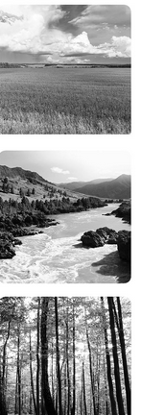
sofret
virre
dilfle

*put the orders in order to make questions:
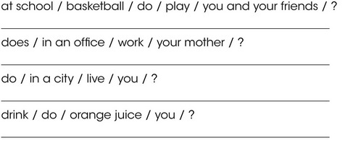

Remember :
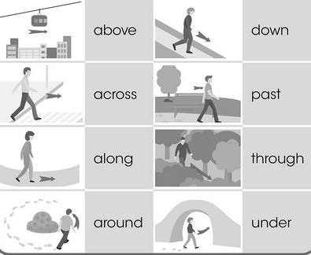

*Circle the correct answer:
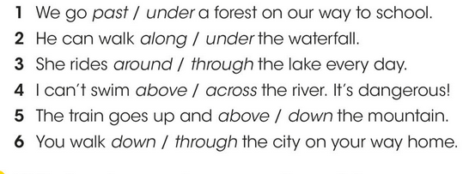

*Write three sentences about things you do everyday:

*Write the missing letter (ee / ea / y ):
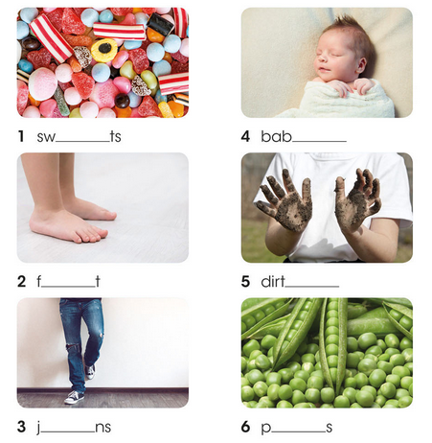
*Circle the correct answer :
1.Do/Does you live in Aqaba?
2.My sister like/likes coffee.
3.I go/goes to school by bike every day.
4.Elyas brush/brushes his teeth every morning.

Teacher : Raneem Alashaal

