First SEMESTER
Study booklet
DATE: 25 Oct 2025 GRADE:2 UNIT: 2
*Read the text and answer the following questions with :
Claudia Chan Shaw is a toy collector in Australia. She’s got lots of cool toys. Claudia has got old and new toys. She really likes toy robots. Look at these robots from her collection!
Claudia has got a robot called Robby. Robby is black. His head is big. His arms and feet are red. He can walk!
Claudia has got another robot called Zoomer. He’s more than 60 years old! He’s got short arms and legs. Zoomer’s body is blue. He can walk too.
1.Where does Claudia live ?

2.What’s the name of the black robot ?

3.Can Zoomer walk ?
*Match:
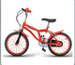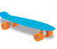
Bike robot skateboard tablet camera

*Remember :

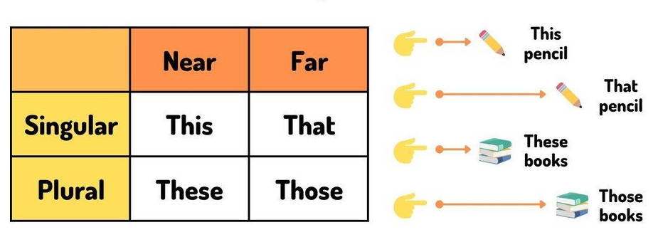

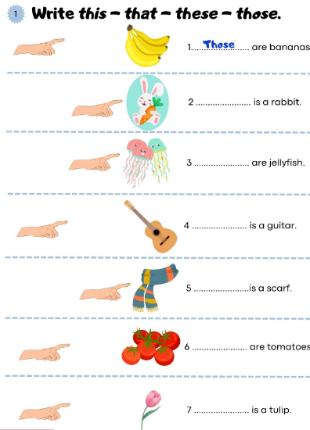
Draw a robot and talk about it:
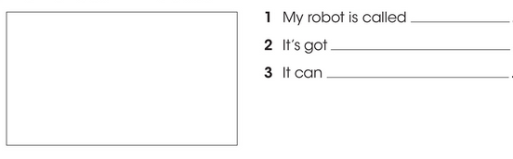
*Circle the words that are opposites:
Borrow cool new old

*Remember:
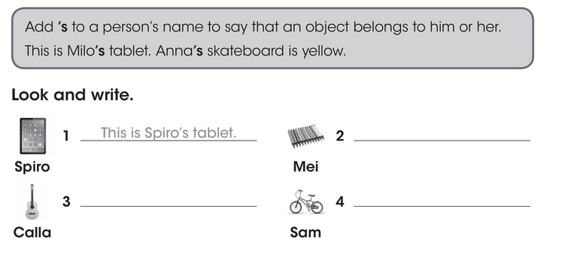

*Write two sentences about things belong to your friend:
Example: This is Maria’s book.
1.
2.

*Write /th/ and draw a line to the correct sound:
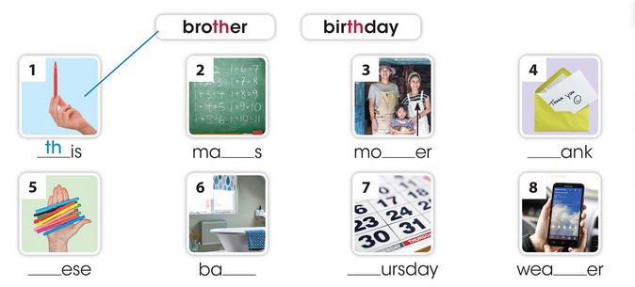
Teacher : Raneem Alashaal

