First SEMESTER
Study booklet
DATE: 23 Oct 2025 GRADE:1
UNIT: 2
*Read the text and answer the following questions with (Yes , it is / No , it isn’t)
Look at the photo. This is a game of marbles. Marbles is my favourite game. It’s fun!
A marble is small. It’s a small ball.

1.Is marbles a game ?

2.Is it fun ?

3.Is marbles a food ?

*Match:
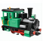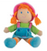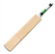
Kite doll bat ball train

*Read and draw:

This is my ball
This is my pencil

*Circle the word that is a toy:
Marble fun favourite

*Remember:
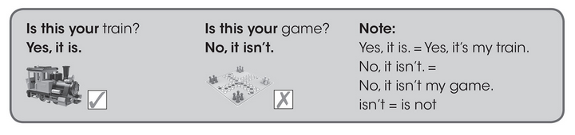
*Circle the correct answer:
Is this your ball ? 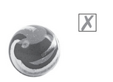 Is this your kite? 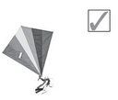
a) Yes, it is a) Yes, it is
b)No, it isn’t b) No, it isn’t

*Write two sentences about things belong to you:
Example: This is my bag
1.
2.

*Write the missing letter:
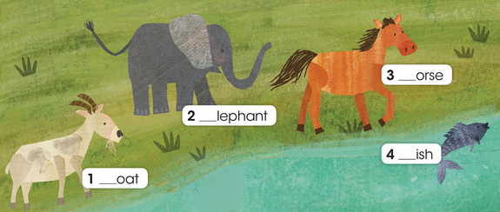

*Write the lower case of each letter:
E __
G __
H __
F __

*Trace, read and draw:
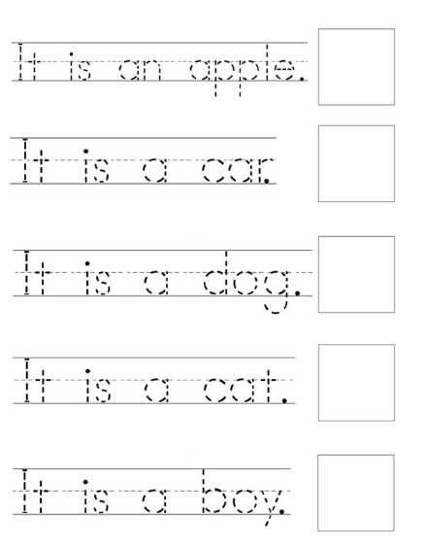
Teacher : Raneem Alashaal

