Worksheet number ( 3 ) / Vocabulary

ed / ing adjectives
- Oct - 2025
Seventh Grade ( A+B )

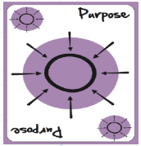
Learning objective: Students should be able to be familiar with the difference between adjectives ending in ed & ing.

Do you know the difference between bored and boring?
Look at these examples to see how adjectives ending in -ed and -ing are used.
-I was really bored in that presentation.
-That was a really boring presentation.

-ed adjectives
Adjectives that end in -ed generally describe emotions – they tell us how people feel.
I was so bored in that lesson, I almost fell asleep.
He was surprised to see Helen after all those years.
She was really tired and went to bed early.

-ing adjectives
Adjectives that end in -ing generally describe the thing that causes the emotion
- a boring lesson makes you feel bored.
Have you seen that film? It's really frightening.
I could listen to her for hours. She's so interesting.
I can't sleep! That noise is really annoying!

Read the following sentences carefully then choose the correct adjective.
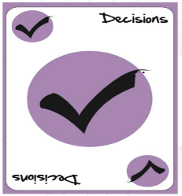
1-You look really _____________. Why don't you go to bed?

tired
tiring
2-Can I call you? I've got some very ______________ news for you!

excited
exciting
3-My neighbour is always playing loud music. It's very _______________.

annoyed
annoying
4-The directions were ________________and we got lost.

confused
confusing
5-I was really __________________that I won the competition.

surprised
surprising
6-She didn't call about the car. I don't think she's ________________ in buying it.

interested
interesting
7-My cats get really ________________ when there's a thunderstorm.

frightened
frightening
8-His exam results were really ___________________.

disappointed
disappointing
9-She's a big dog but you don't need to be __________________.

frightened
frightening
10-The instructions for my new coffee machine are really ________________.

confused
confusing

11-I loved my maths teacher! Lessons with her were never _______________.

bored
boring
12-That shop never has any customers. I'm _______________ it's still there.

surprised
surprising
13-The battery on my phone only lasts about two hours. It's really ____________.

annoyed
annoying
14-I was __________________ that I didn't get the job.

disappointed
disappointing
15-I'm reading a really __________________ book.

interested
interesting
16-The children were so _______________ they couldn't sleep.

excited
exciting

English department

