

Q1: Circle the correct answer:

1. What do input devices do?
a) Enter data b) Print pictures on paper

2. Which device is used to type text and numbers?
a) Microphone b) Keyboard

3. Which device is used to produce sound?
a) Printer b) Speakers

4.Which device is used to display text, numbers, and videos?
a) Monitor b) Printer

Q2: True of False:
1. The printer is used to show information on paper.( )
2. The microphone is used to record sounds. ( )
3. The keyboard is used to display videos on the screen.( )

Q3: Match:
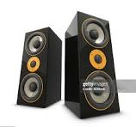 points and clicks

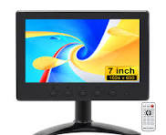 produces sound

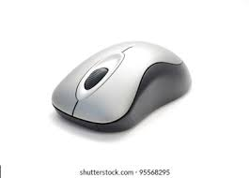 displays text, numbers and videos



Teacher:
Maria Al Zuraikat

