
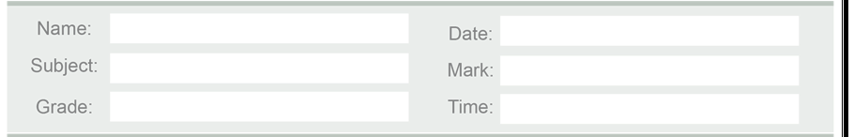

Q1: Match the parts with their functions: (6 marks)

Body part | Function
1. Brain | a. Helps us smell and breathe.
2. Heart | b. Helps us move and run.
3. Blood | c. Controls all parts of our body.
4. Muscles | d. Covers and protects our body.
5. Nose | e. Pumps blood to all body parts.
6. Skin | f. Carries oxygen and food.

Q2: Fill in the blanks: (6 marks)
brain – heart – tongue – eyes – skin – stomach
1- The helps us to see.
2- The controls our body.
3- The helps us taste and speak.
4- The covers and protects the body.
5- The pumps blood around the body.
6- The digests food and gives energy.

Q3: Choose the correct answer: (4 marks)
1- We use our (ears / eyes / tongue) to hear.

2- We use our (nose / heart / skin) to smell.

3- The (muscles / bones / blood) help us move.

4- The (brain / stomach / tongue) sends messages to our body.

Q4 : Write True (T) or False (F): (4 marks)
1- The heart helps us to see. ( )

2- The stomach gives us energy. ( )

3- The brain controls our body. ( )

4- The skin helps us feel things. ( )

Good luck

Teacher:
Maria Al Zuraikat

