Worksheet number ( 3 ) / how plants use food

Science
/ 10 / 2025
5th A,B

Objectives : where do plants store food ?
How plants use food ?
===========================================================================
Q:1 Classify the following plants based on the part that is eaten .
Mango , cabbage, radish, banana, sugarcane, bean, spinach, carrot, apple, turnip, lentils
Fruits | Roots | Leaves | Stem | Seeds

Note : the extra food is stored in the stem , fruits, leaves, roots , or seeds .
Plants use food to:
- Repair damage 2-Make new plant 3-Get energy to grow
- To produce flowers , fruits, seeds , and more leaves .

Q:2 What will happen if an animal eats a portion of a plant ? 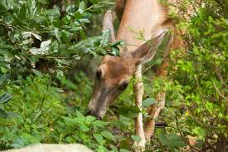
--------------------------------------------------------------------------------------------------------------------------------------------------------------------------------------------

Department of science
Teachers : Suha madanat , Rema maayah

