(6)

English
/ 10 /2025
3

LO: Read a text about Jordan, identify adverbial phrases, imperative verbs, parts of speech, infer meanings, find evidence, and express opinions using information from the text.
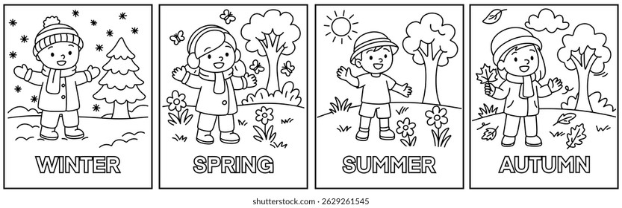
Read the following text, then answer the questions below:
The Four Seasons
Throughout the year, Sam and Rita love watching how the world changes with the seasons.
In spring, the air feels fresh, and tiny flowers bloom everywhere. Early in the morning, they plant new seeds in the garden and water them gently. “Take good care of them,” says their mother, smiling. Birds return to build their nests, and everything seems full of life.
In summer, the days are long and sunny. Sam and Rita ride their bikes to the park and play games under the big oak tree. “Drink plenty of water,” reminds Dad, “and wear your hats!” After lunch, they cool off in the pond and listen to the buzzing bees.
When autumn comes, the trees turn red, orange, and gold. Pick up fallen leaves and make a picture with them. The wind blows softly through the garden, and the air feels crisp.
In winter, stay warm by the fire and drink hot chocolate. Sam and Rita love to build snowmen and have friendly snowball fights. Before bedtime, look outside and admire the sparkling stars in the cold sky.
Each season is special in its own way, bringing new sights, sounds, and adventures to enjoy together.
- What do Sam and Rita enjoy about the seasons?
……………………………………………………………………………………………………………………………………
……………………………………………………………………………………………………………………………………
- What do they do in spring and in winter?
……………………………………………………………………………………………………………………………………
……………………………………………………………………………………………………………………………………
- Find two adverbial phrases in the text. (Hint: They tell when, where, or how something happens.)
…………………………………………………………………………………………………………………………………………
………………………………………………………………………………………………………………………………………..
- Find three command verbs (imperative verbs) in the text. (Hint: These are verbs that give an order or instruction.)
…………………………………………………………………………………………………………………………………………
…………………………………………………………………………………………………………………………………………
- Find one example of each of the following in the text:
  - Noun …………………………………………………
  - Verb …………………………………………………
  - Adjective …………………………………………………
  - Preposition …………………………………………………
- What do you think the word “crisp” means in the sentence “The air feels crisp”? (Infer the meaning from context.)
……………………….…………………………………………………………………………………………………….

- Give a synonym for each of these words from the story:
  - fresh → …………………………………………………

  - happy → …………………………………………………

  - beautiful → …………………………………………………

- Do you think one season is better than the others? Why or why not? (Give your opinion.)
………………………………………………………………………………………………………………………………….
…………………………………………………………………………………………………………………………………

- Give evidence: Which words or sentences in the text show that Sam and Rita enjoy every season? (Find a line from the text to support your answer.)
…………………………………………………………………………………………………………………………………….…..
- Why do you think the writer says each season is special in its own way?
………………..……………………………………………………………………………………………………………………..

Teacher: Maram Moien Dayoub

Answer Key – The Four Seasons
- They enjoy watching how the world changes and doing different activities in each season.
- In spring, they plant new seeds and water them gently. In winter, they stay warm, drink hot chocolate, and build snowmen.
- Throughout the year, Early in the morning.
- Take, Drink, Pick.

  - Noun: flowers
  - Verb: bloom
  - Adjective: fresh
  - Preposition: in
- It means cool, fresh, and clean.

  - fresh → new
  - happy → joyful
  - beautiful → lovely
- (Opinion – answers will vary.) Example: Yes, I think summer is better because it’s warm and fun.
- “Each season is special in its own way, bringing new sights, sounds, and adventures to enjoy together.”
- Because every season has something different and enjoyable.

