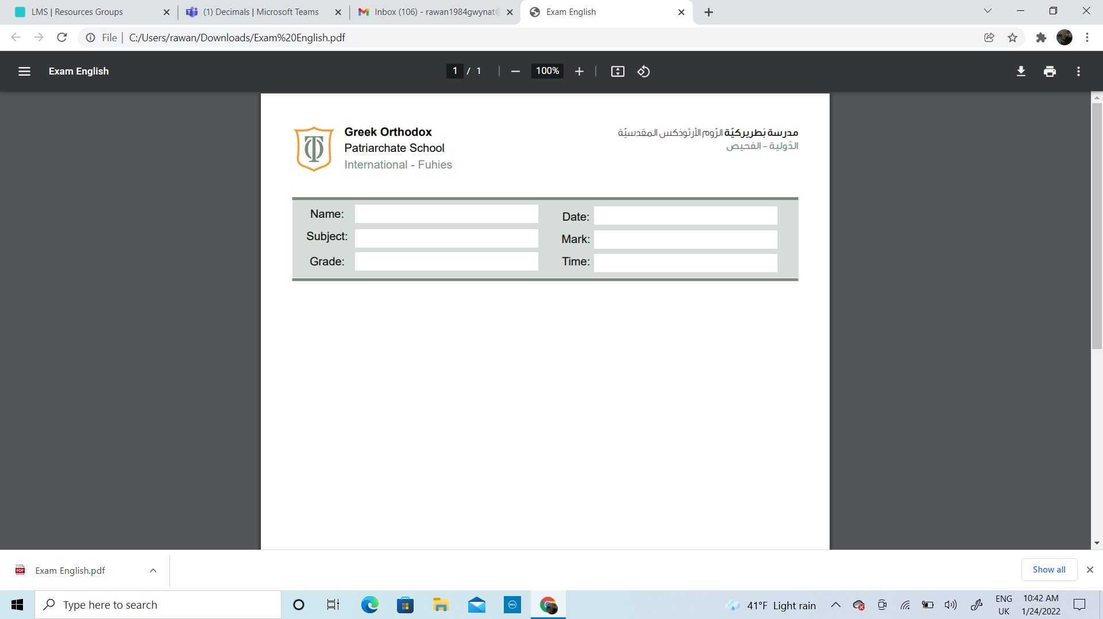

Name:_____________________________ Date______________________
Subject: Math extra worksheet addition
Class: Grade 2 ( A , B ,C)

