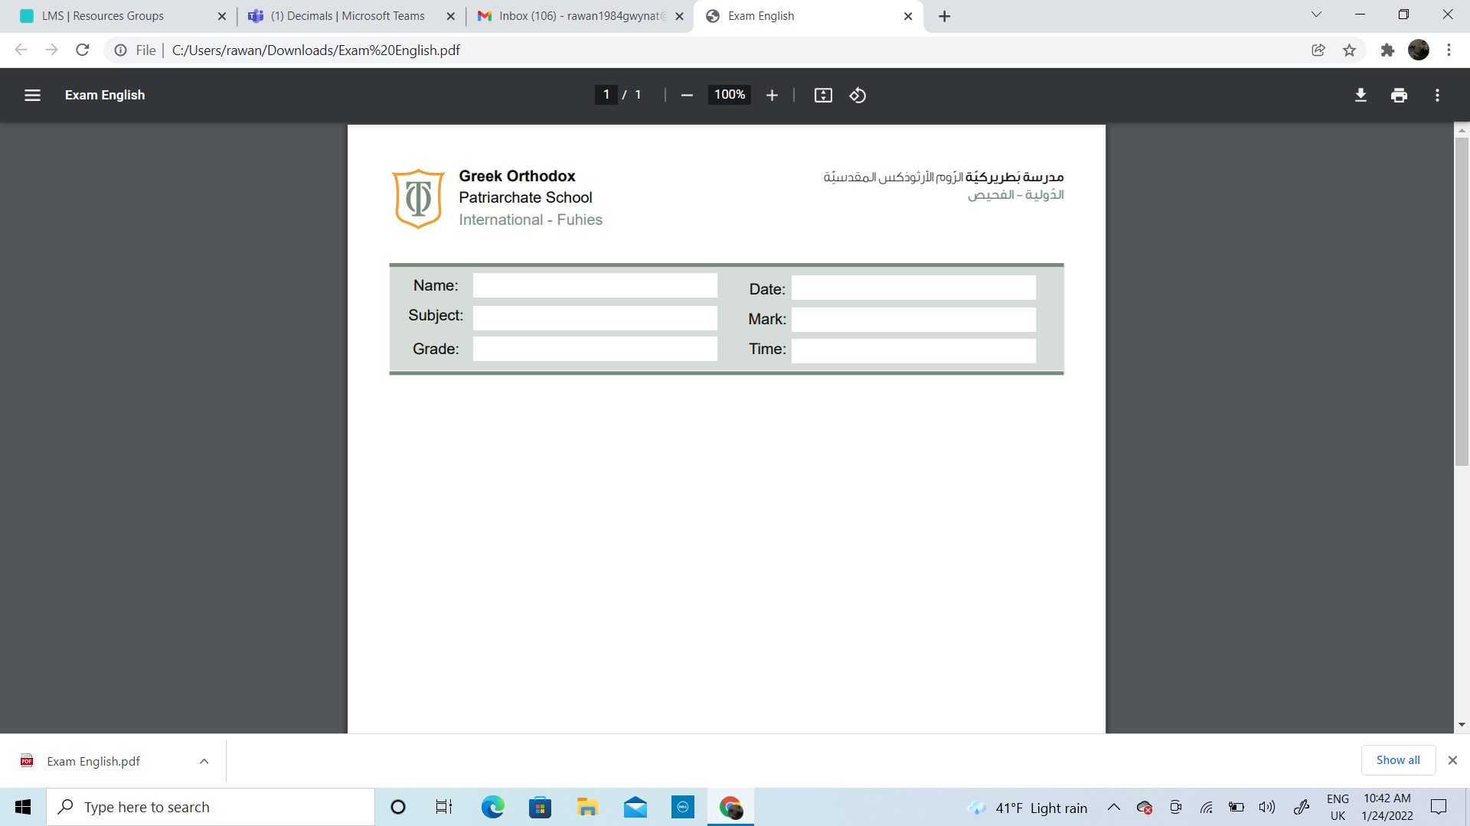

Name:_____________________________ Date______________________
Subject: Math practicing worksheet #3
Class: Grade 2 ( A , B ,C)

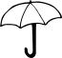
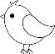
Circle the ten that each number rounds to.

Do these numbers round
up

or
down
?

20

29
9

30

70

7
8

80

40

4
2

50

Oh, it is raining
outside, take

the bird to the
nearest umbrella

Round up / Round down

Round up / Round down

Round up / Round down

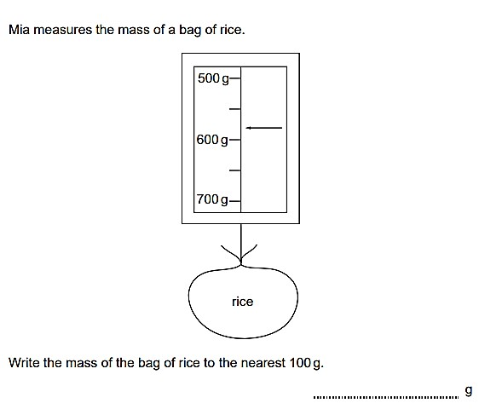

90

95

100

30

32

40

40

46

50

Round up / Round down

Round up / Round down

Round up / Round down

Round the following numbers to the nearest 10. The first one has been done for you.
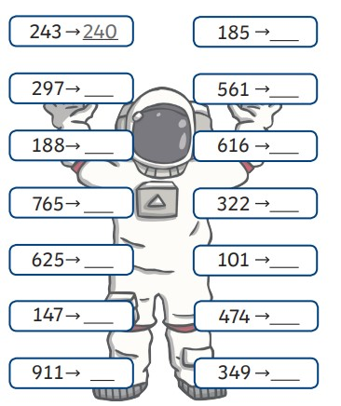

Round the following numbers to the nearest 100.
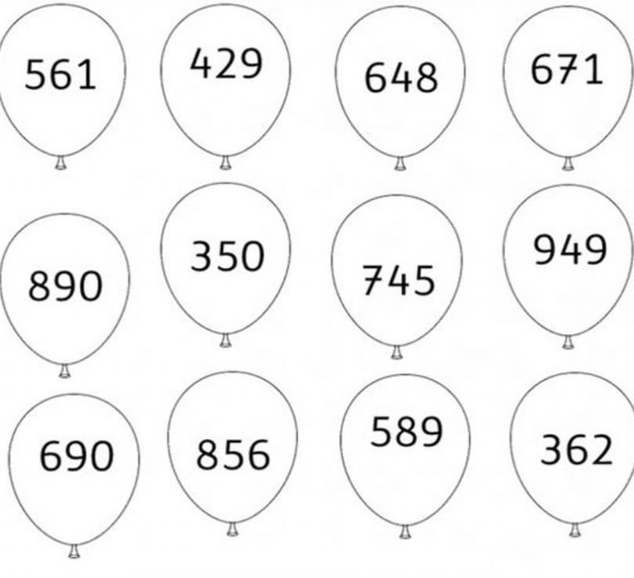

A small book has 148 pages.

- Round the number of the pages to the nearest 100.

____________________________

- Would it be all right if the book was printed with the rounded number of pages? Explain your answer.

_________________________________________________________

_________________________________________________________
Mike chooses some numbers. He rounds them to the nearest 10 The answer is always 260 Write the largest number that Mike could choose.

_______________________________________________

