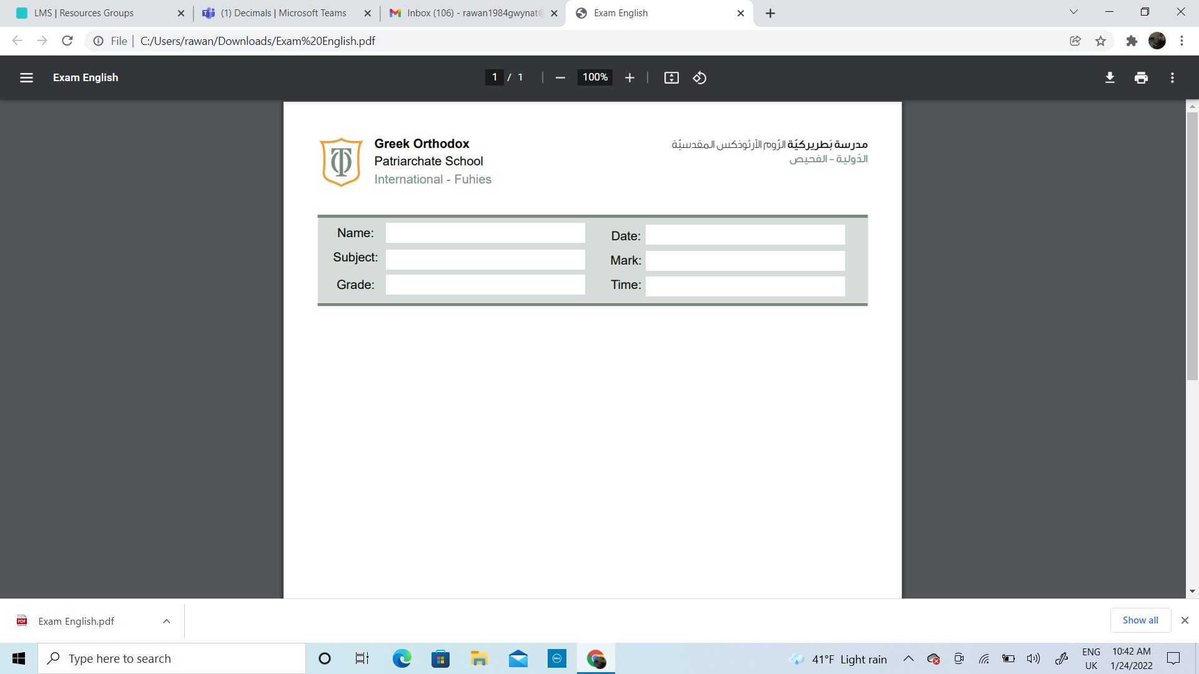

Name:_____________________________ Date______________________
Subject: Math practicing worksheet #3
Class: Grade 2 ( A , B ,C)

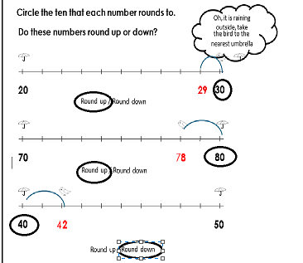
O

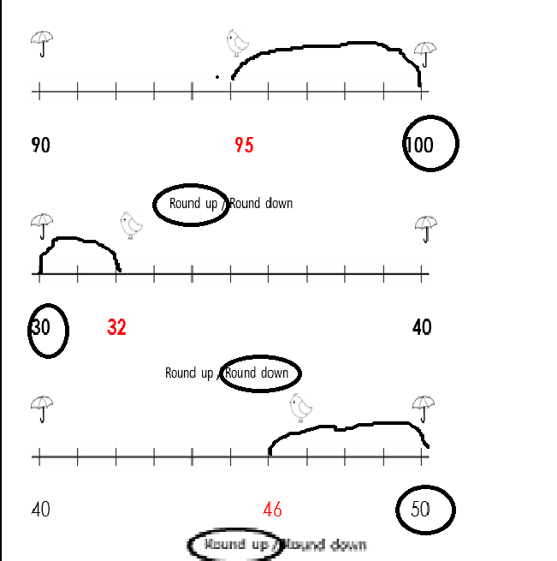

Round the following numbers to the nearest 10. The first one has been done for you.
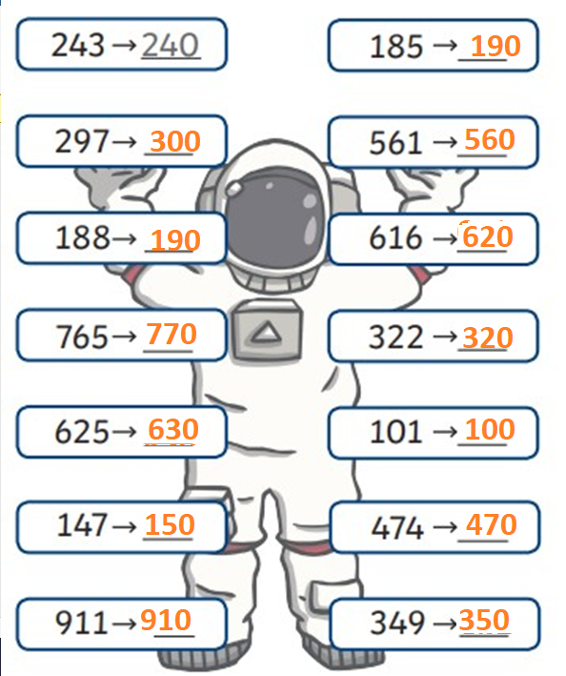

Round the following numbers to the nearest 100.

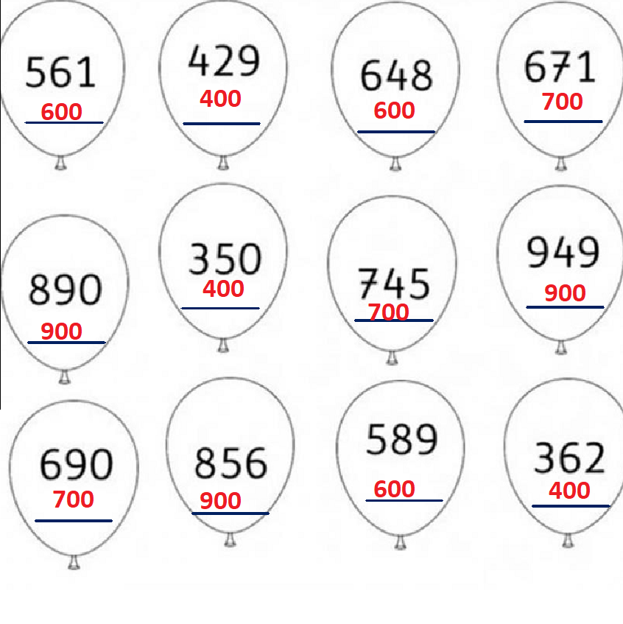

A small book has 148 pages.

- Round the number of the pages to the nearest 100.

____100________________________

- Would it be all right if the book was printed with the rounded number of pages? Explain your answer.

No, it would not be all right if the book was printed with the rounded number of pages, because rounding changes the actual number. The book really has 148 pages, but rounding to the nearest hundred gives 100, which is much less and would leave out many pages of the book.

