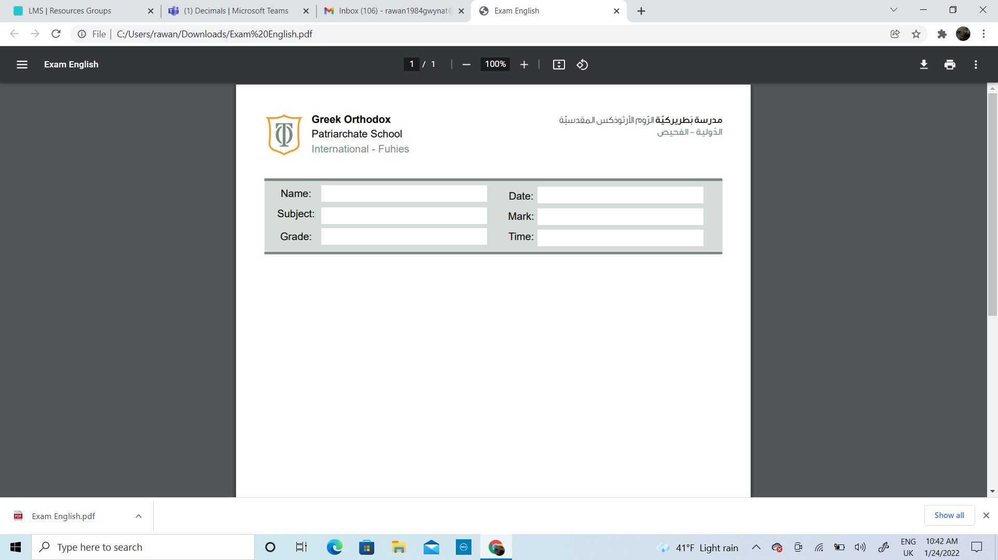
Name:_____________________________ Date______________________
Subject: Math practicing worksheet #4
Class: Grade 2 ( A , B ,C)

Calculate the answer of the following.

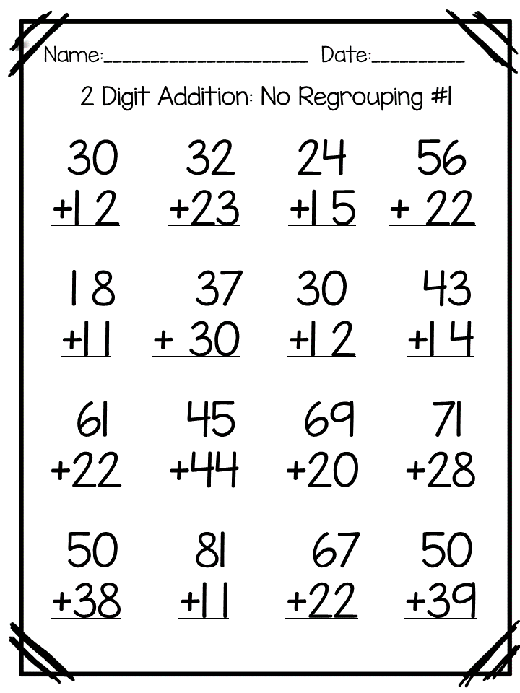

Calculate the answers of the following.
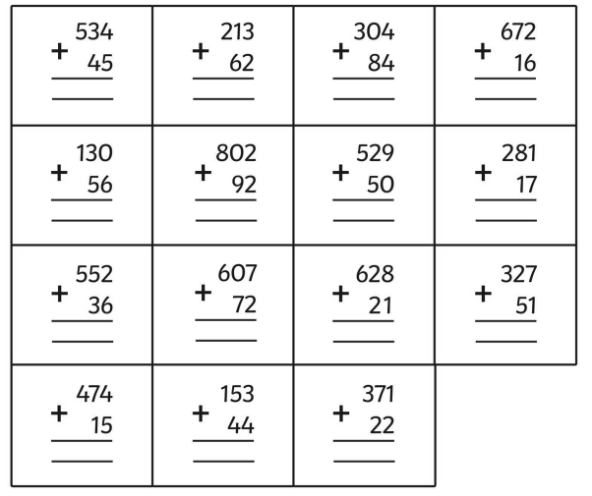

Calculate the answers of the following.
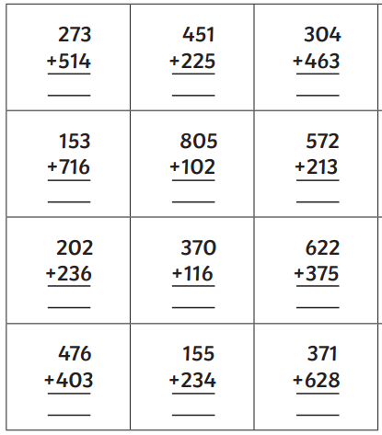

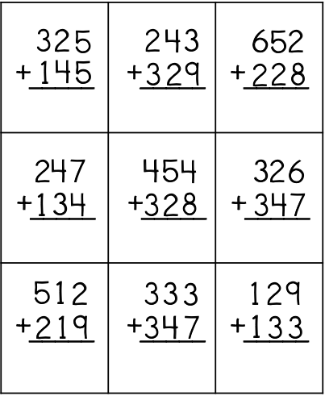
Calculate the answers of the following.

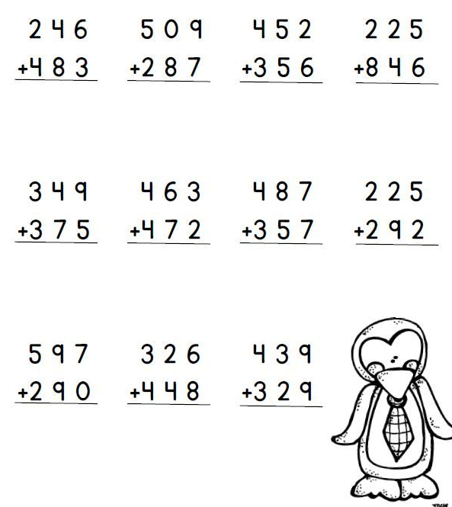
Calculate the answers of the following.

Calculate the answers of the following.
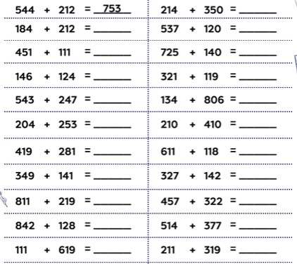

Calculate the answers of the following.

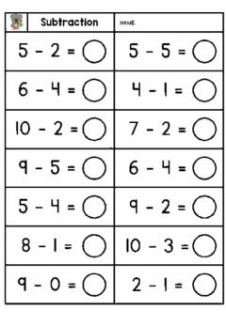

Calculate the answers of the following.
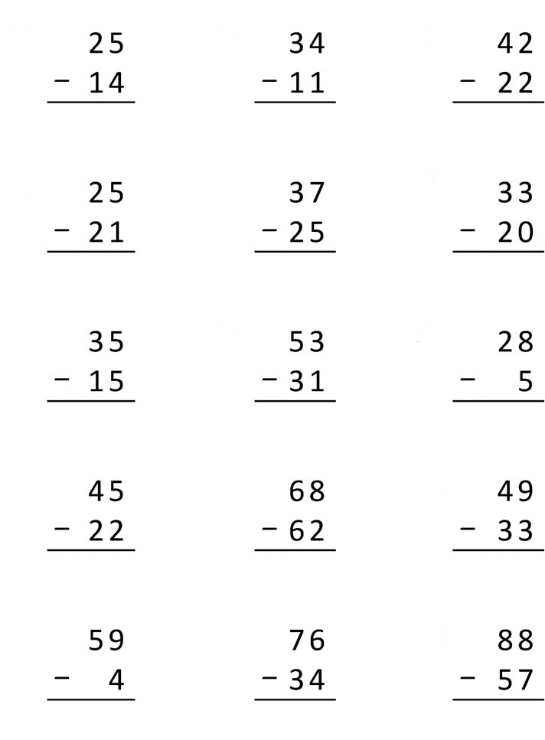

Calculate the answers of the following.


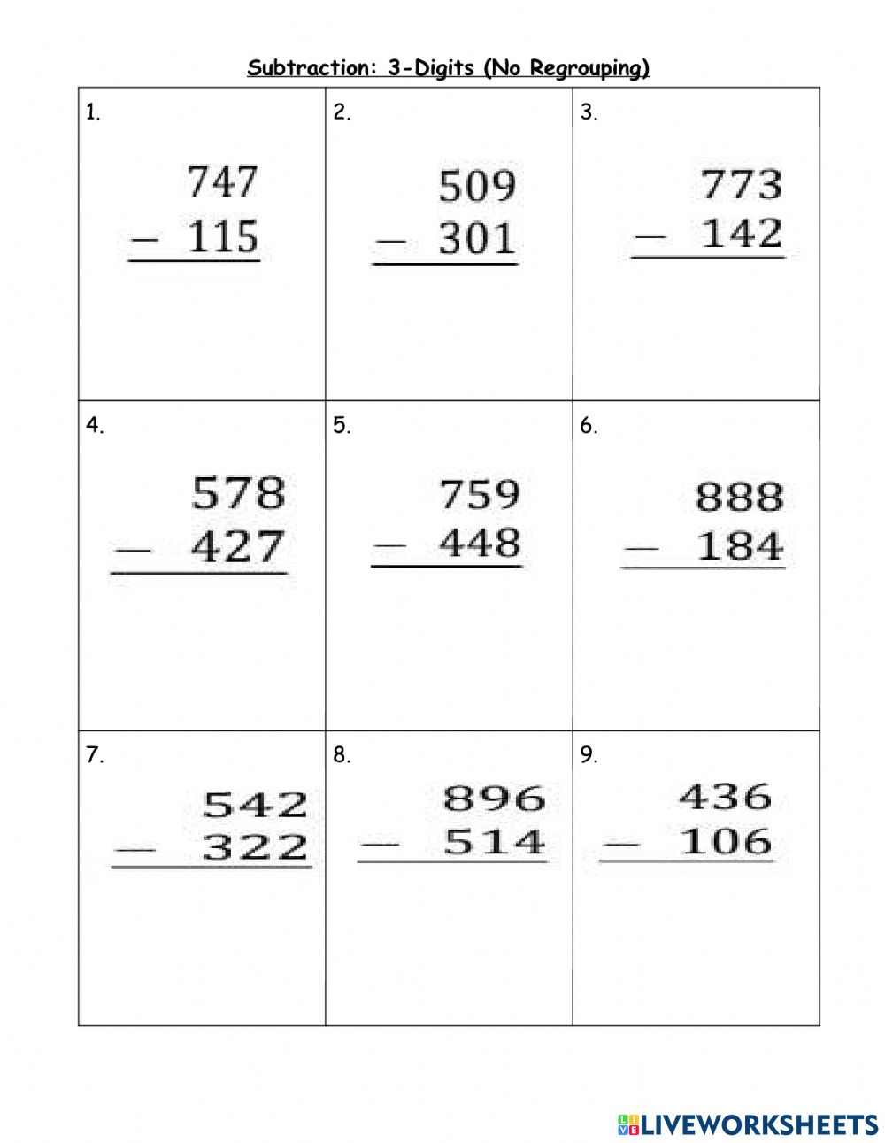

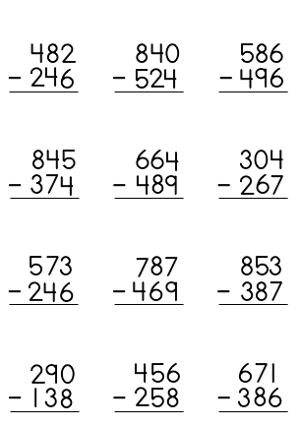
Calculate the answers of the following.

Calculate the answers of the following.
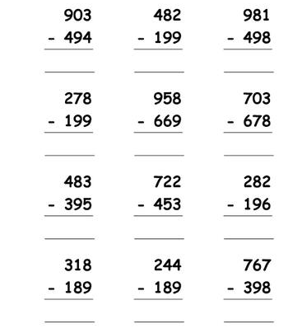
Calculate the answers of the following.

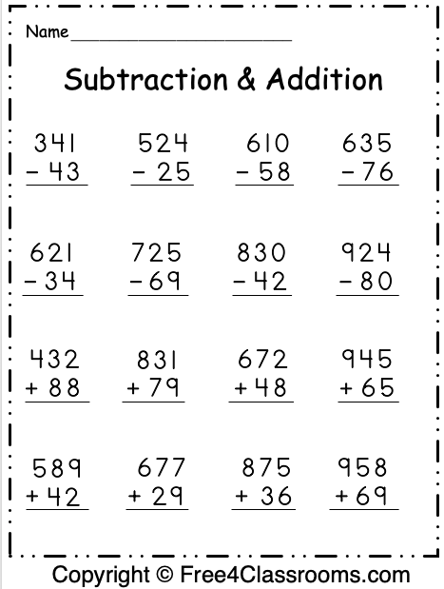

Calculate the answer of the following.
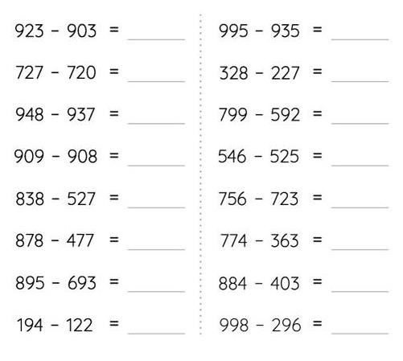

Calculate the answers of the following.

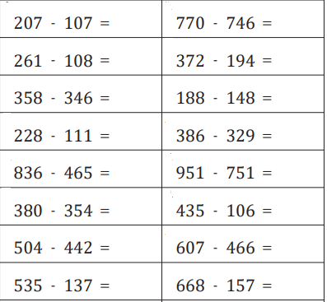

*Solve the following words problems. (Show your work)

1- There are 108 paper cups in a box. Saif uses19 cups. How many cups are left in the box?

................... Cups

2- In a school there are 345 boys and 243 girls. How many students are there?

……………………. Students


3) Danniel has 950 grams of rice in a bag. He uses 250 grams of rice. How much rice is left in the bag?

................... Grams of rice

4) George bought 515 gummy bears, he gave his sisters 75 of them, how many gummy bears are left with him?

………………………… gummy bears

5) Sanad scored 135 points on a computer game, Meera scored 123 more points than him.
How many points did she score?



……………………………points

6) A bakery shop cooked 321 cupcakes, 125 of them are chocolate cupcakes and the rest are vanilla. How many vanilla cupcakes it cooked?


…………………………vanilla Cupcakes

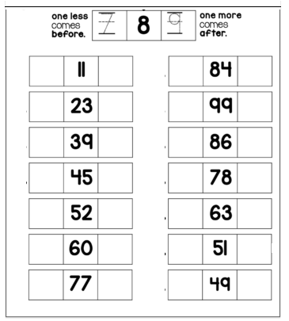
look at the number. Write the number that is 1 less and 1 more.
*look at the number. Write the number that is 10 less and 10 more.

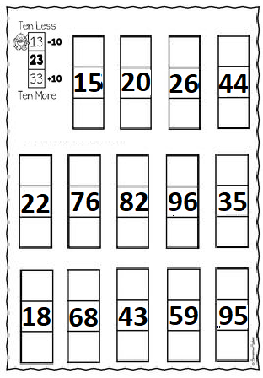
Write the number that is 10 less ,10 more ,1 less and 1 more .
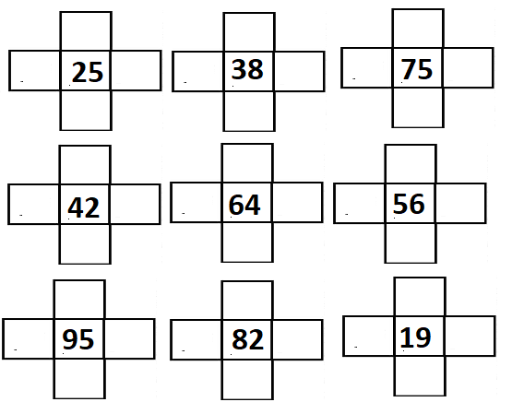

Fill in with the missing numbers.

1 less | Number | 1 more
 | 856
 | 201
 | 390
 | 700
 | 129
 | 659
 | 587

*There are 752 roses in the garden, the gardener planted 10 more.
How many roses are there now?
__________________________
*Sally and Kareem went spider hunting, Sally found 574 spiders, Kareem found 10 less.
How many spiders Kareem found?
___________________________

Fill in with the missing numbers.

100 less | Number | 100 more
 | 152
 | 287
 | 523
 | 120
 | 872
 | 329
 | 852
 | 900

Find the key word to solve the following.
Teresa made 467 bracelets; Gabby made 100 less.
How many bracelets gabby made?
___________________________
Daniel sold 321 cookies; Shahem sold 100 more cookies.
How many cookies did Shahem sell?
___________________________

