
12
4
16
8
, , , , , , ………
Q1)The sequence continues in the same way.
Complete the sequence, then answer the following questions.
a) Write down the 1st term of the sequence……………..
b) Write down the 5th term of the sequence……………..
c) Write down the 6th term of the sequence……………..
d) Write down the 10th term of the sequence……………..
e) Write down the 20th term of the sequence……………..
f) What is the term-to-term rule?..................................
g) What is the position to term rule?...............................

Q2) Complete the following sequences:
5, 0, -5, ___, ____, ____, _____. Term to term rule _______
20, 10, 0, ___, ____, ____, _____. Term to term rule _______
7, 5, 3, ___, ____, ____, _____. Term to term rule _______
11, 8, 5, ___, ____, ____, _____. Term to term _______
4, 2, 0, ___, ____, ____, _____. Term to term _______

Q3) A sequence starts at 16.

5 is subtracted each time.

What is the first number in the sequence that is less than zero?

Tip: You might find the number line helpful.

Q4) Look at the sequence below. The number of dots in each pattern is written below it.

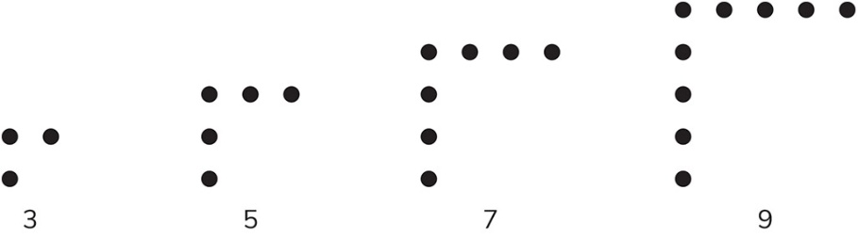

- Write down the next four numbers in the sequence.

3, 5, 7, 9, , , ,

- What is the term-to-term rule?

Tip: Look at how you get from one term to the next.

Q5) Look at this sequence of patterns.

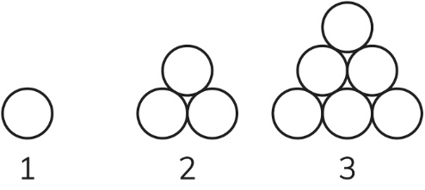
- Draw the next pattern in the sequence.

- Complete the table for the sequence.
Pattern number | Number of circles
1 | 1
2 | 3
3 | 6
4
5
6
- What is the name for this sequence of patterns?

Tip: Think about the shape of the patterns.

Q6) Write the same number in both boxes to make this statement correct.

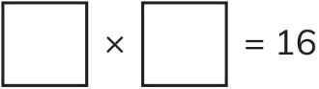

Q7) Here is a part of a sequence.
10
20
15
5

The sequence continues in the same way.
Complete the sequence, then answer the following questions.
a) Write down the 5th term of the sequence……………..
b) Write down the 8th term of the sequence……………..
c) Write down the 10th term of the sequence……………..
d) Write down the 20th term of the sequence……………..
e) Lily says that the number 520 will be in the sequence,
Do you think she is right?
Yes No
Explain your answer.

Q8) Write the sequence of square numbers. (1-144).

Q9) Write the sequence of triangular numbers. (1-55)

Q10) Write the sequence of the cube numbers. (1-125)

Q12) Circle all the cube numbers.
1 4 8 25 16 27 49 64 100 125

Q13) Write a square number in each box to make the statement correct.
+ =
Factors and multiples
Q1) Find the factors of each number.
a) 9

b) 10

c) 18

- 24

e) 36

2) Write all the factors of the following numbers and decide if the number is a
prime or composite.
a) 27: ……………………………………………..
b) 25: ……………………………………………..
c) 17: ……………………………………………..
d) 12: …………………………………………….
e) 7: ………………………………………………

Q3) Find all the factors of the following numbers.
- 15
____, ____, ____, ____
- 24
____, ____, ____, ____, ____, ____, ____, ____
- 30
____, ____, ____, ____, ____, ____, ____, ____
- 12
____, ____, ____, ____, ____, ____
Q4)
- Find all the common factors of 12 and 15
________
Find the GCF (Greatest common factor) of 12 and 15.

________

- Find all the common factors of 15 and 30

________
Find the GCF (Greatest common factor) of 15 and 30.

________

- Find all the common factors of 6 and 9

________
Find the GCF (Greatest common factor) of 6 and 9.

________
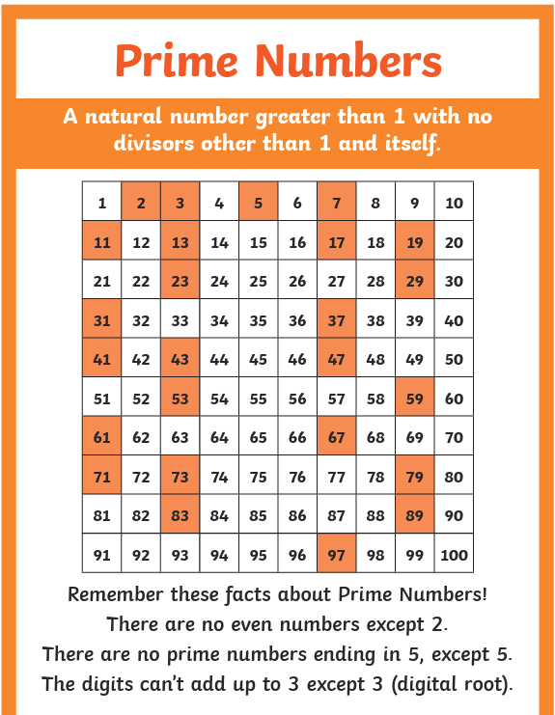
Prime numbers are the numbers that has only 2 factors 1 and the number itself.

Composite numbers: the numbers that has more than 2 factors.
Q3) Circle all the prime numbers
1 2 6 8 9 10 11 15 17 36 37
Q4) a) Find the first three common multiples of 4 and 5.
Multiples of 4: ____, ____, ____, ___, ___, ____, ____, ____, ___, ____
Multiples of 5: ____, ____, ____, ___, ___, ____, ____, ____, ___, ____
The first common multiple: __________
The first three common multiples: ____, _____, ____,
****Important note: to find the first n common multiples first we list the first 10 multiples then we find the first common multiple and count by the first common multiple.
b) Find the first three common multiples of 3 and 7.
Multiples of 3: ____, ____, ____, ___, ___, ____, ____, ____, ___, ____
Multiples of 7: ____, ____, ____, ___, ___, ____, ____, ____, ___, ____
The first common multiple: __________
The first three common multiples: ____, _____, ____,

- Find the first three common multiples of 6 and 10.
Multiples of 6: ____, ____, ____, ___, ___, ____, ____, ____, ___, ____
Multiples of 10: ___, ____, ____, ___, ___, ____, ____, ____, ___, ____
The first common multiple: __________
The first three common multiples: ____, _____, ____,

