
Electrical conductors and insulators

What Is an Electrical Conductor?

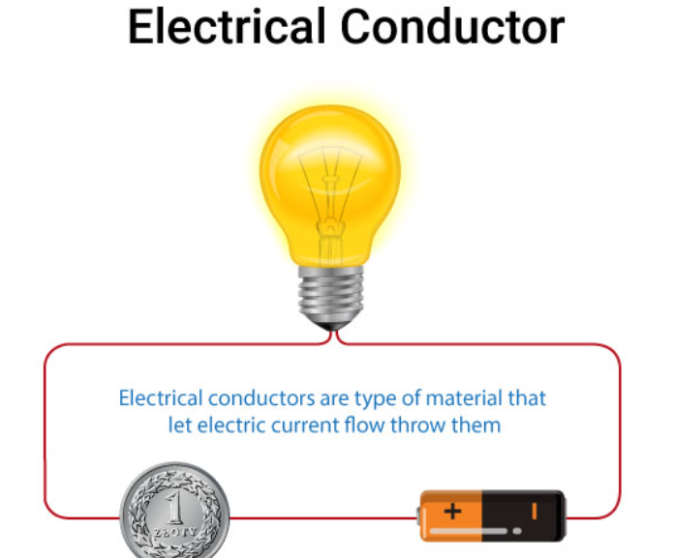
We can define electrical conductors as a type of material or objects that let charge or electric current flow throw them easily in one or more than one direction.

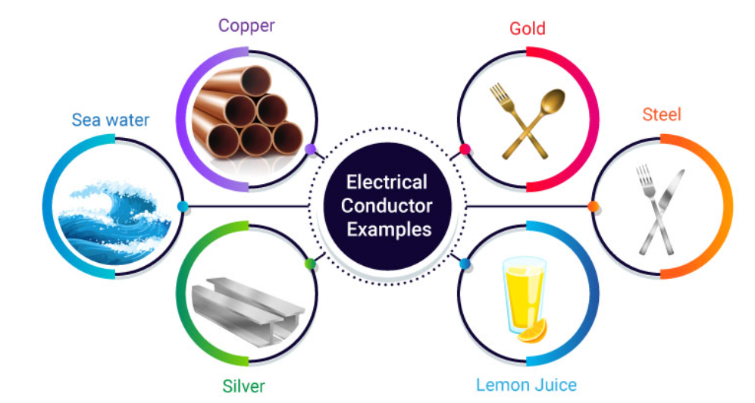
Electrical Conductor Examples

What Is an Electrical Insulator?
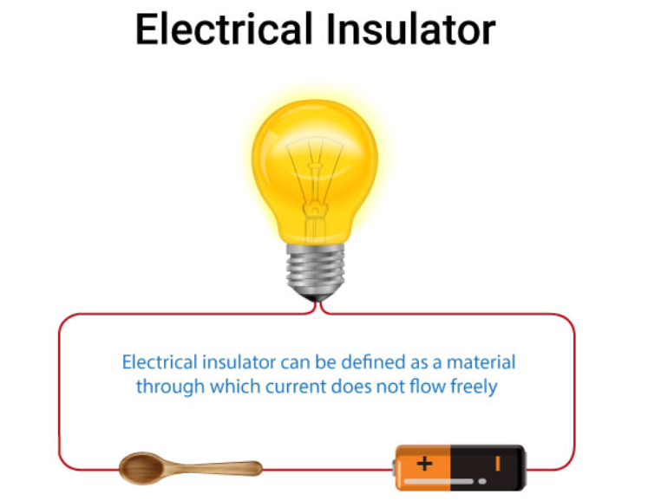
An electrical insulator can be defined as a material through which current does not flow freely.

Examples of Insulator
