
Fifth Grade

Thermal conductors and insulators

What Is a Thermal Conductor?
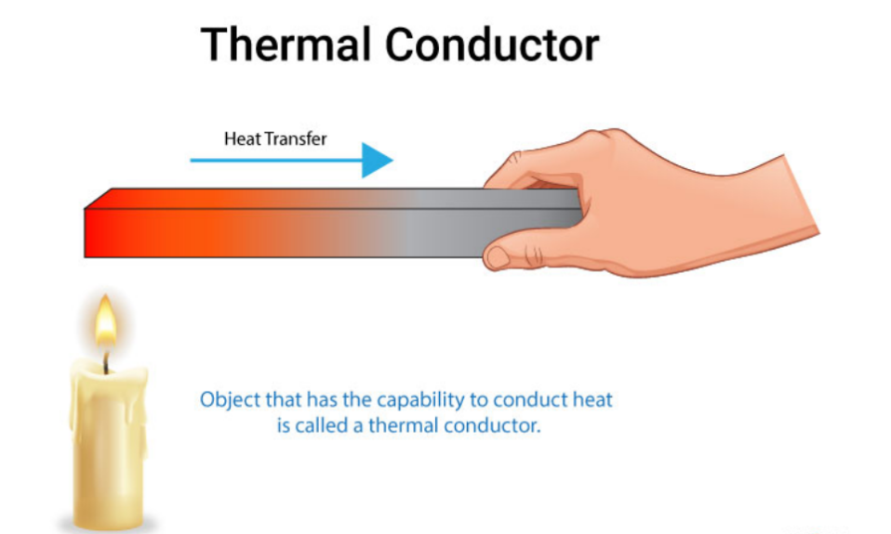
Thermal conductivity can be defined as the measure of the ability of a material to conduct heat. Any material or object that has the capability to conduct heat or let heat pass through it is called a thermal conductor.

Thermal Conductor Examples
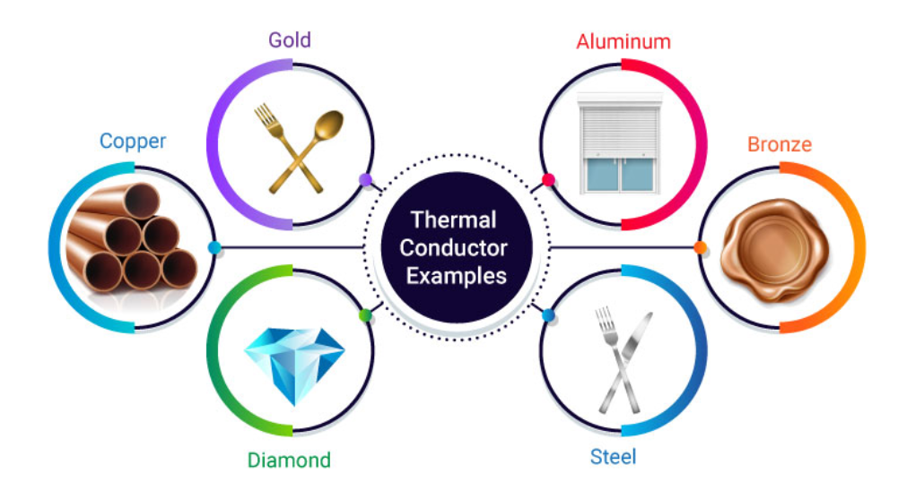

What is a thermal insulator?
Thermal insulators are materials that resist the transfer of heat. (Heat cannot pass through it easily).
