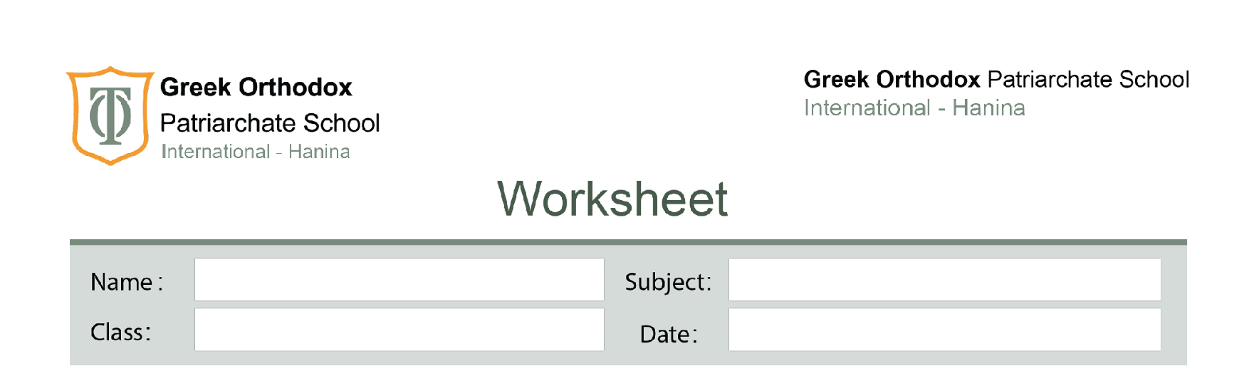
Fifth Grade

Lerner’s book page 45

The answers to the questions on page 45 of the learner’s book.
Q1: A thermal conductor is a material or substance that allows heat to pass through it easily.
Q2: Metals are good conductors of heat, so the heat from the stove passes easily through the metal to the food in the pot or pan.
Q3: Plastic is not a good conductor of heat, so the heat from the hot pan does not pass easily to your hand when you hold the handle.
Q4: A polystyrene foam cup. It is a poor thermal conductor, so that the heat from the tea cannot be transferred easily from the cup into the surroundings.
Q5: Thermal insulators.

