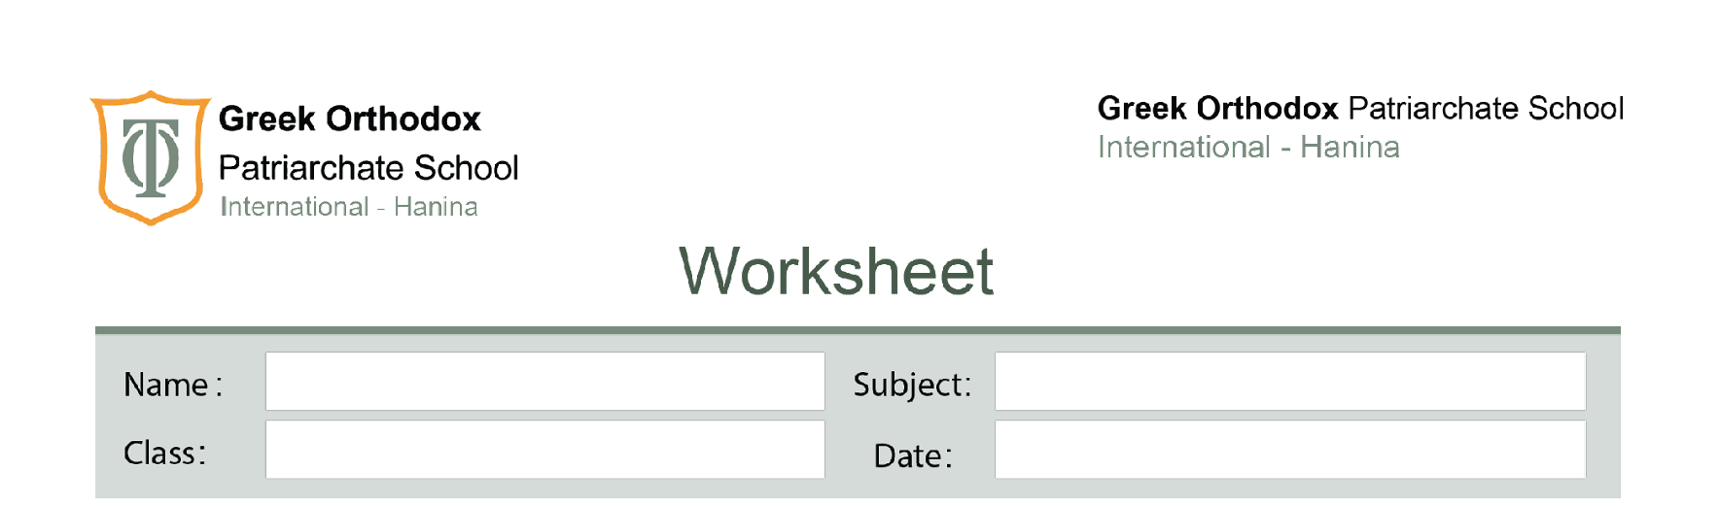
Sixth Grade
Atoms and elements study sheet
Atoms and elements

*All materials have both physical and chemical properties.
-Physical properties: The property that can be observed or measured without changing the basic nature of the substance.
-Examples of physical properties are:
Mass, hardness, boiling point, melting point, electrical conductivity, thermal conductivity, solubility and density.
-Chemical properties: The property that is seen when a substance take part in a chemical change.
-Examples of chemical properties are:
Reactivity: This is how a substance will undergo a chemical reaction.
Flammability: The ability to catch fire.
Ex: Hydrogen is very flammable it will catch fire easily but iron or nitrogen are very non-flammable.
*Everything in the universe is made up of atom. Atoms are very small.
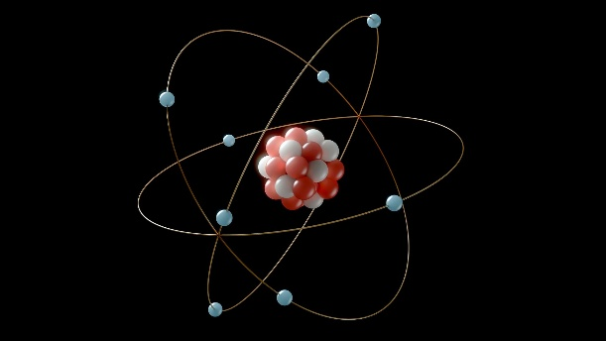

-Atoms: a particle from which all substances are made (cannot be divided).
-Element: a substance made of one type of atoms.
-Substance: is any form of matter such as solid, liquid or gas. Substances can be made of the atoms of one element or more than one element joined together.
-Compounds: are a group of atoms of two or more elements joined together.

