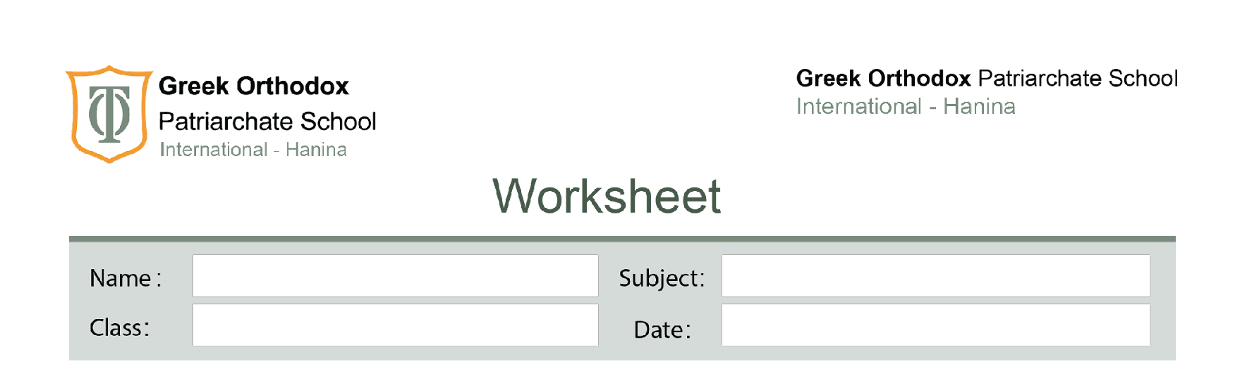
The Reproductive System
Fifth Grade

*Reproduction: is the production of offspring(young).
*Animals and humans need female and male to reproduce.
*The reproduction process happens after you reach the puberty stage.
*Puberty: The age at which a person becomes able to reproduce.
*Puberty starts at different ages in boys and girls.
* In boys, puberty usually starts when they are about 13 years old.
*In girls, puberty usually happens from the age of 11.
*Hormones: Chemical in the body that cause the body changes that happen during puberty.
Puberty Signs in boys and girls
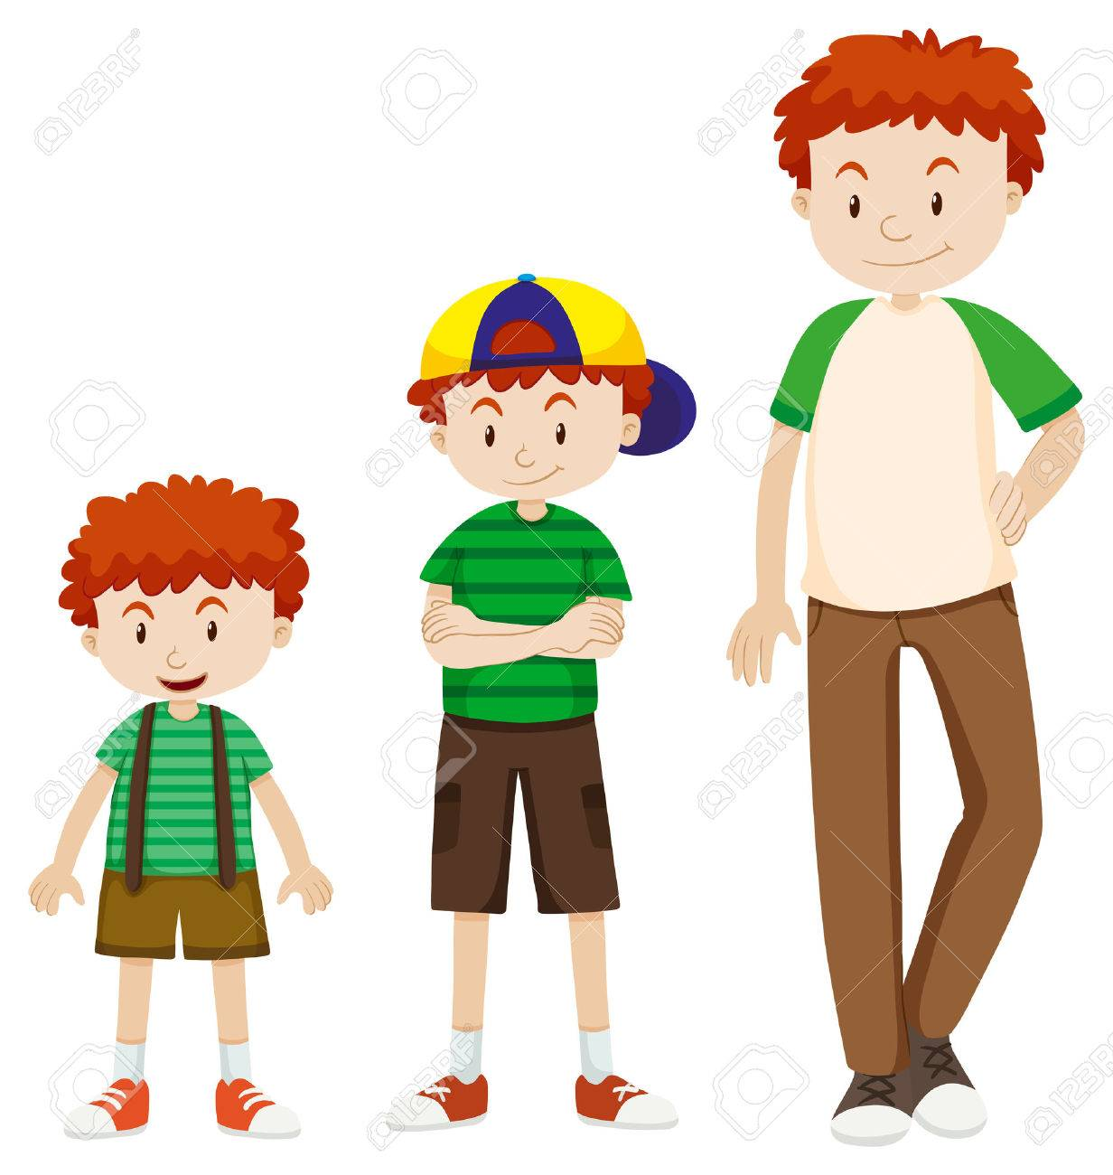
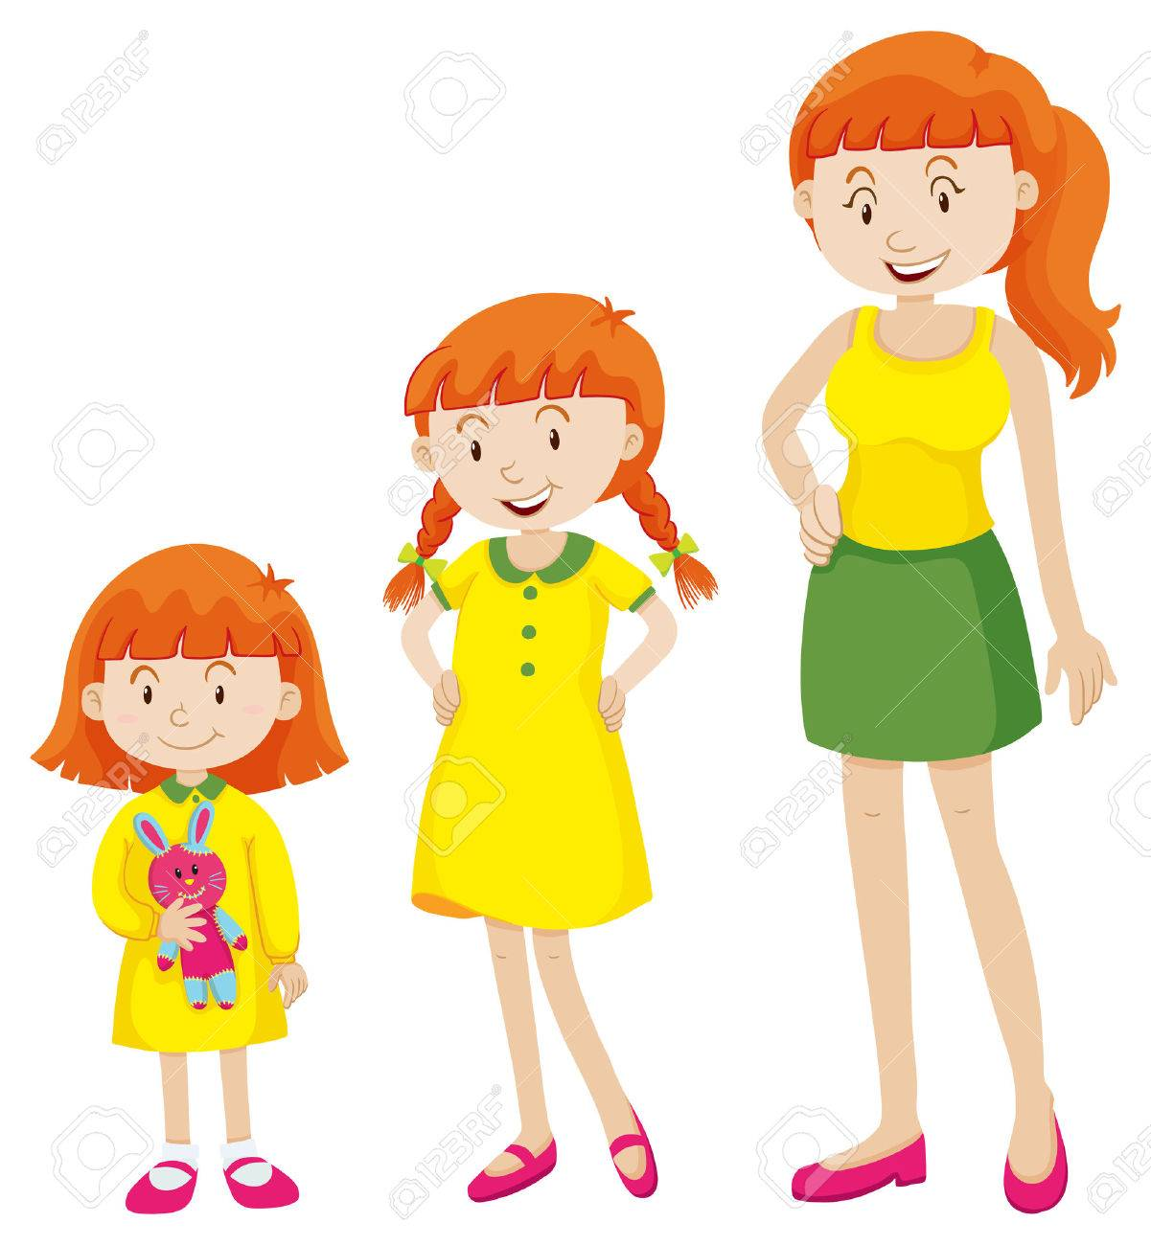

Puberty signs in boys | Puberty signs in girls
Can easily grow 10 cm in a year. | Can grow up to 12 cm in a year.
Hair begins to grow on the face, armpits and other body parts. | Hair begins to grow in the armpits and other body parts.
Skin can get oily. | Skin can get oily.
Pimples | Pimples
Shoulders and chest will get broader ss body muscles develop. | Hips will get wider.  Develop breasts.
Voice will change and become deeper. | Voice will become a little deeper.
Boy’s body starts to make sperm. | Ova starts to develop.  The Menstruation starts about a year after puberty begins.

Changes in the reproductive system
*Reproductive system: The parts of the body that make the sex cells and allow living things to have young.
The main function of the reproductive system is to make special cells called sex cells that are needed for reproduction.
*In males, the sex cells are called sperm.
*In females, the sex cells are called eggs or ova(one egg is called an ovum).
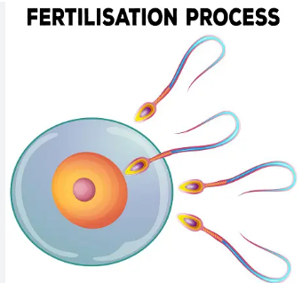
During reproduction, a sperm and an egg join together to form a new living being that will grow into a baby. This process is called fertilisation.

Sperm
Egg

