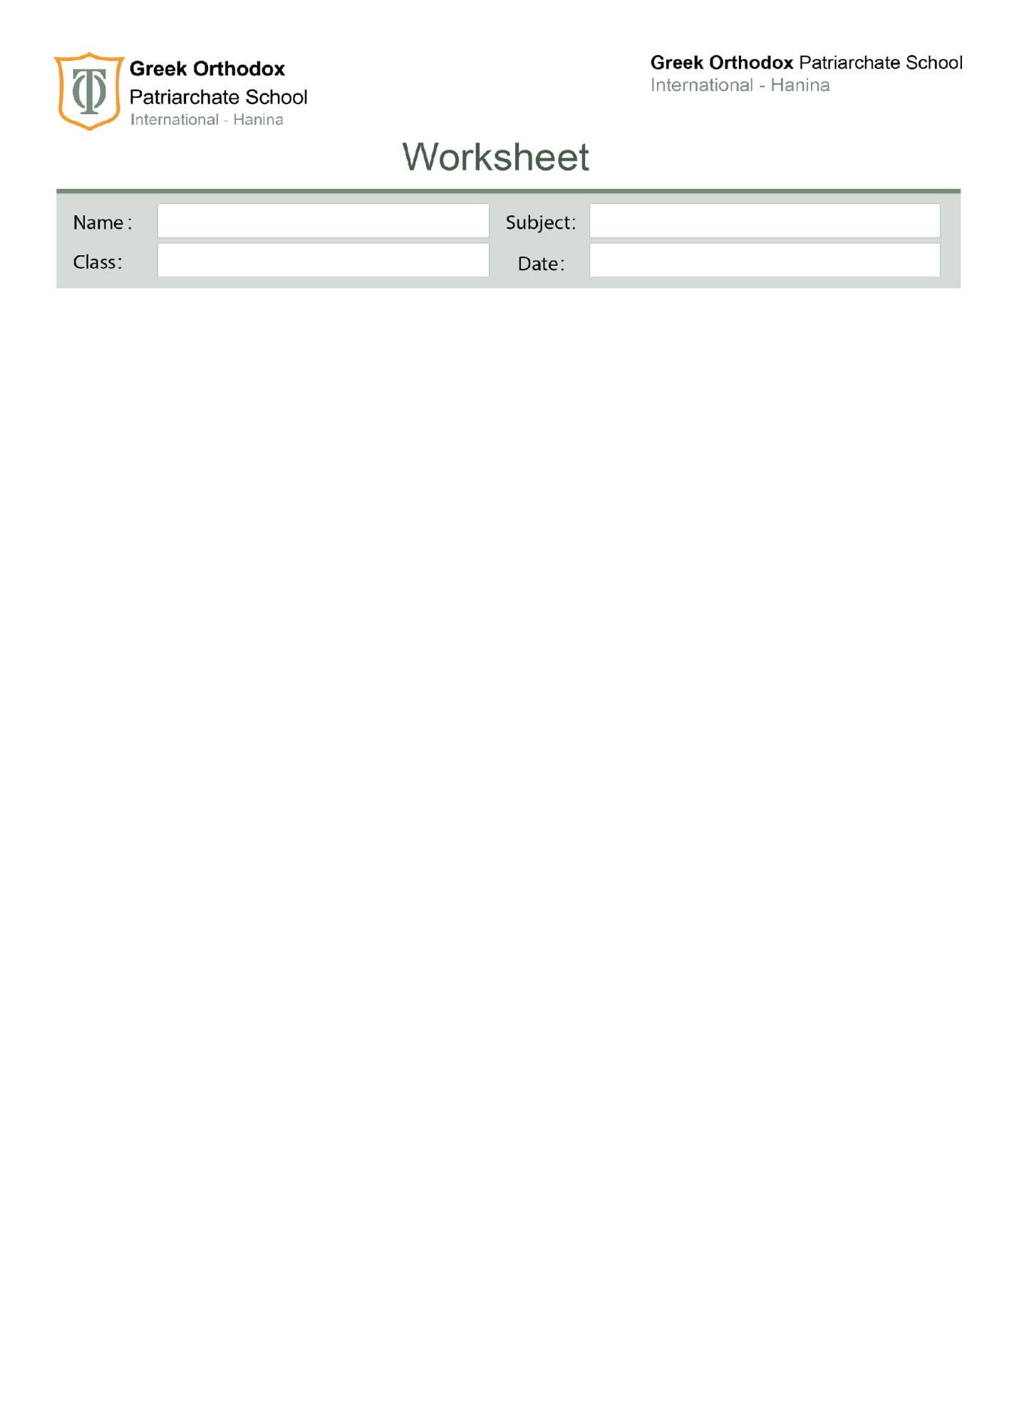
Fourth Grade
Types of pollution
Study sheet

*Pollution: Something that is introduced into the environment that is dirty, unclean or is harmful; such as car exhaust fumes, litter, oil spills.
There are different types of pollution
1-Watre pollution: Harmful substances that make water un safe to drink.
*Examples on water pollution:
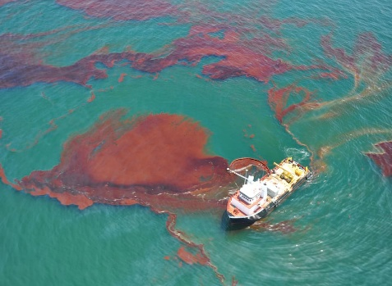
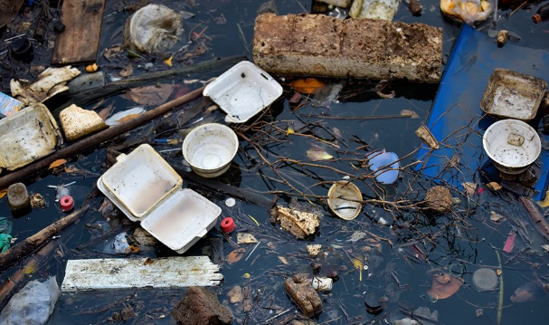
oil spills sewage Marin dumping
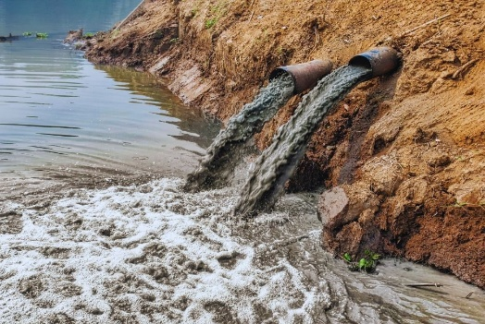

2-Air pollution: Occurs when gases, dust and smoke get into the air and make it unclean.
*Examples on air pollution:
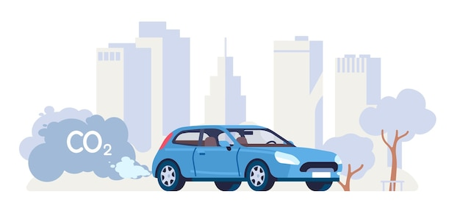
Gases that comes from cars.

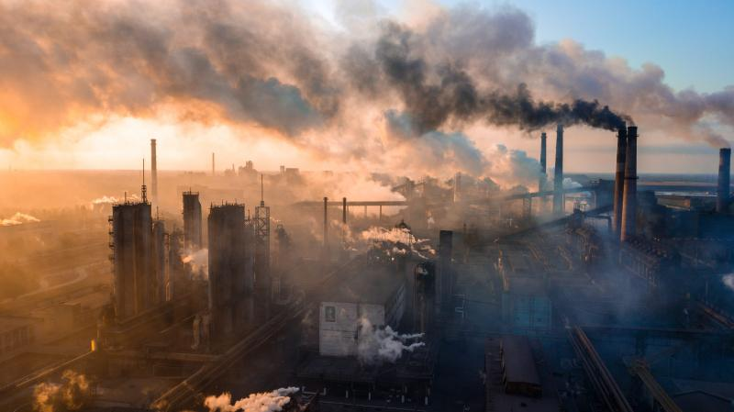
Gases from factories

3-Soil/land pollution: when there are harmful changes in the soil due to adding or dumping harmful substances in the soil.
*Examples of air pollution :
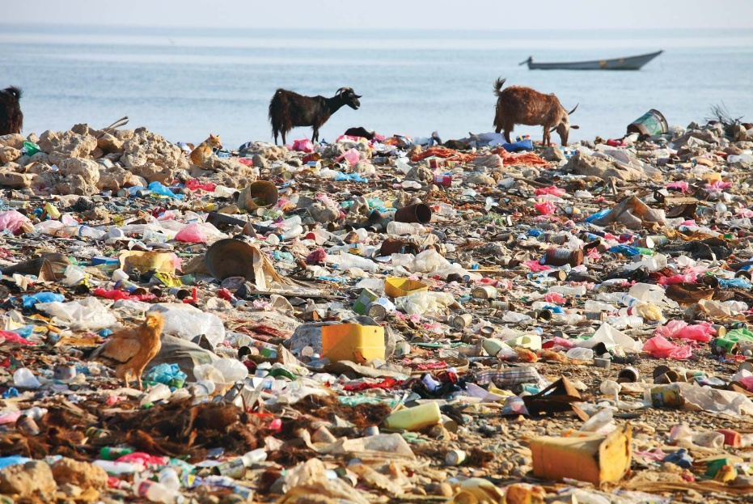
Industrial waste

Toxic chemical such as pesticides (chemicals that farmers use to kill insects).
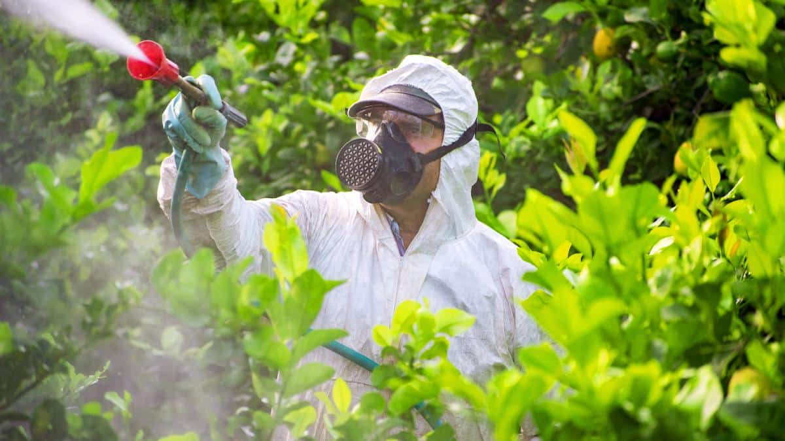

4-Sound/noise pollution: any unwanted or disturbing sounds.
*Examples on sound pollution:

Fireworks Car horns


5-Light pollution: when we over-light or use wrong colour of light.

*Examples on light pollution:
Street sign (using neon colours)
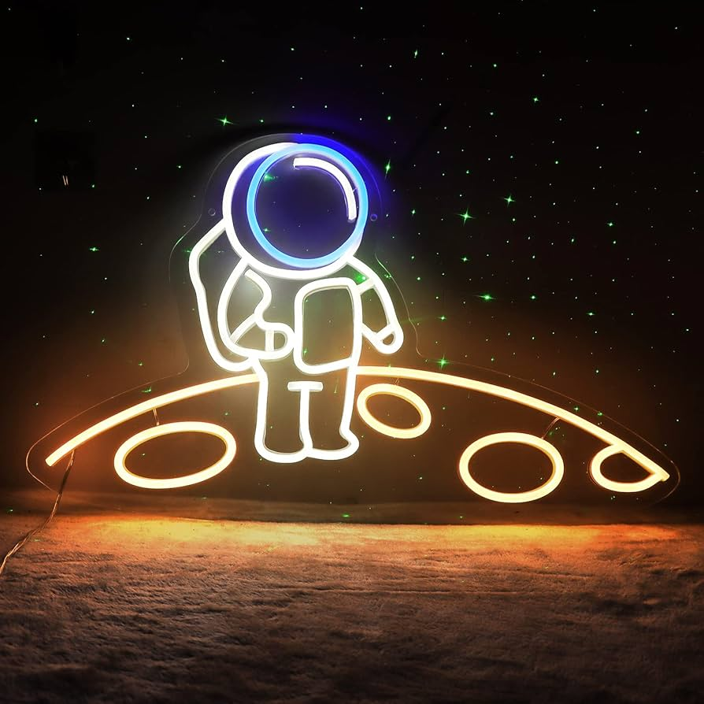

How to prevent pollution?

Follow 3Rs: Reduce, Reuse, and Recycle
- Don't use too much of things like plastic bags and toys.
- Use things again instead of throwing them away.
- Put things like paper and bottles in special bins so they can be made into new things.

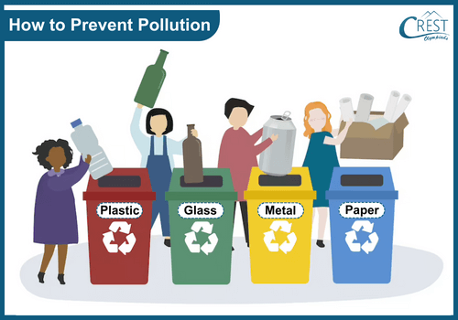

a-We should not throw trash in rivers or oceans and keep water clean.
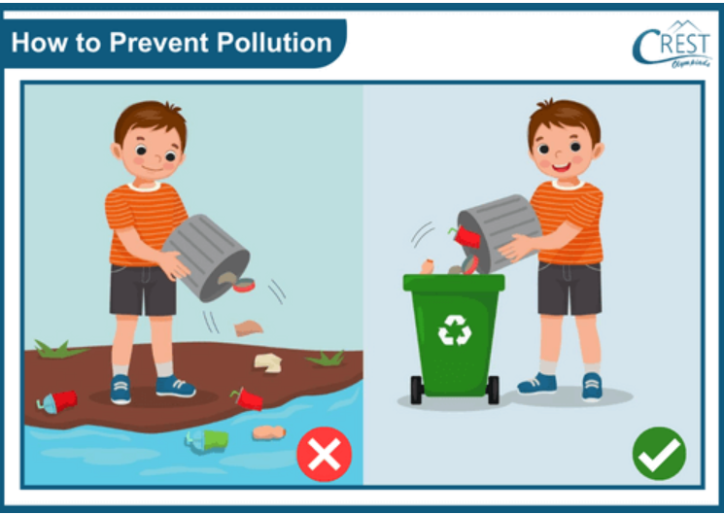

b-Instead of using cars all the time, use buses or trains. They are better for the air.
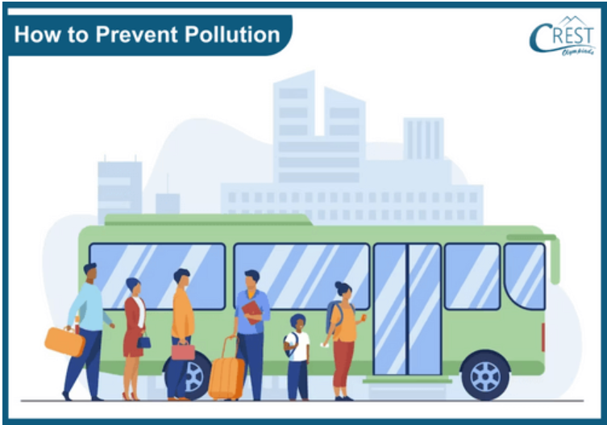

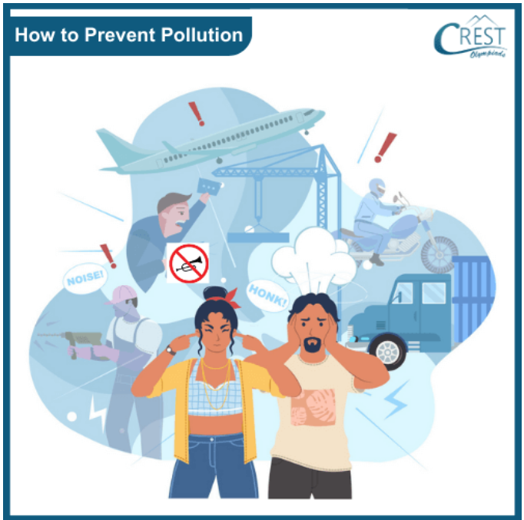
c-Avoid making too much noise with gadgets and don't honk too much.

