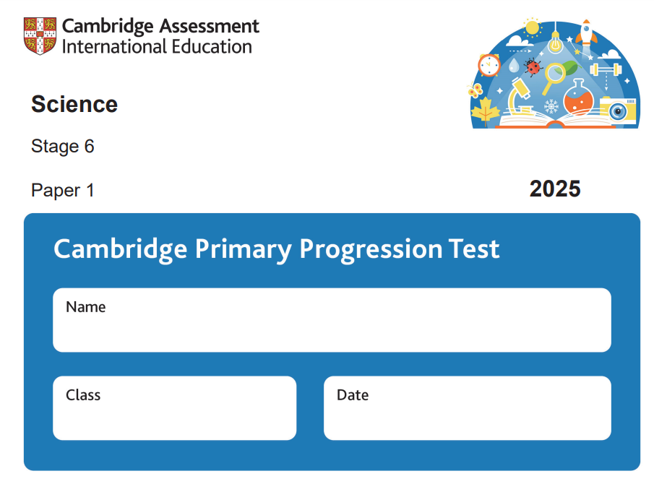

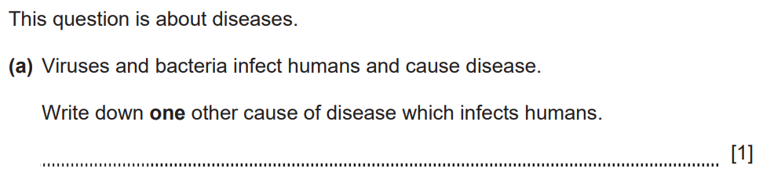
1-

Parasite, fungus or fungi
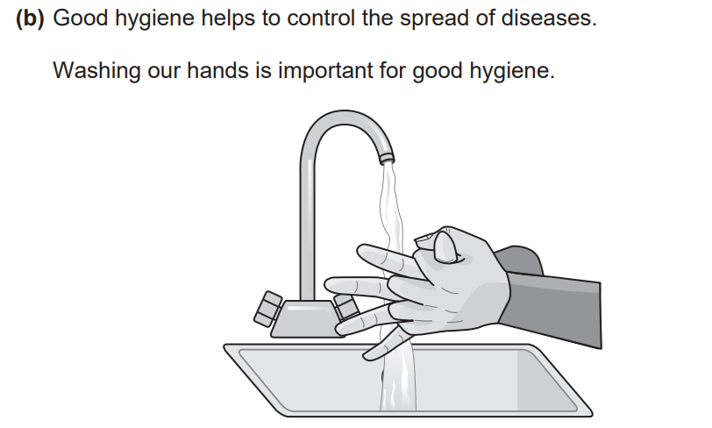

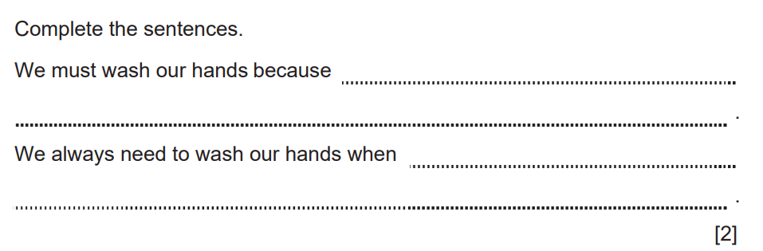
Washing removes bacteria or viruses or parasites or fungi from our hands

touching food or using the toilet or
looking after someone who is sick or blowing your nose or touching an animal

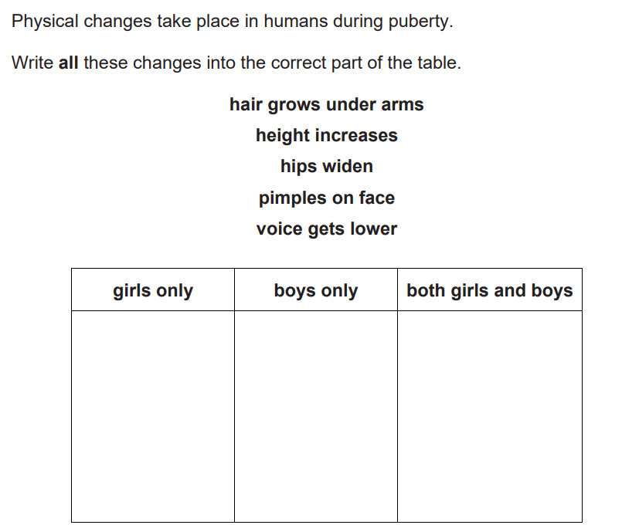
2-

Hips widen
Pimples on face.
Hight increases.
Hair grows under arm.
Voice gets lower

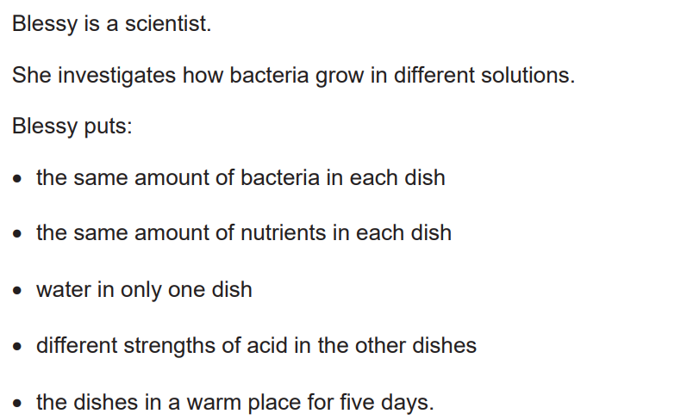
3-

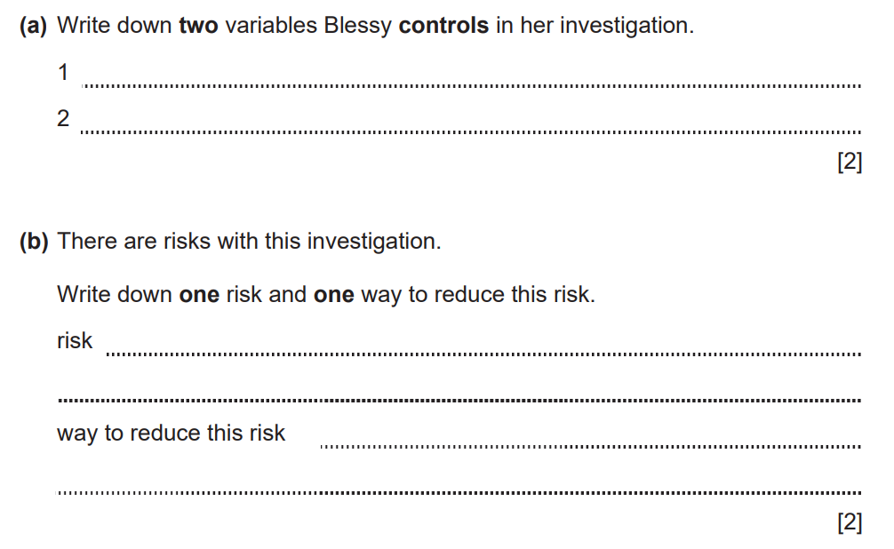
Amount of bacteria/amount of nutrients
Temperature or warmth/time or 5 days

bacteria may get out of the dished

seal the dishes or use lids on the dishes

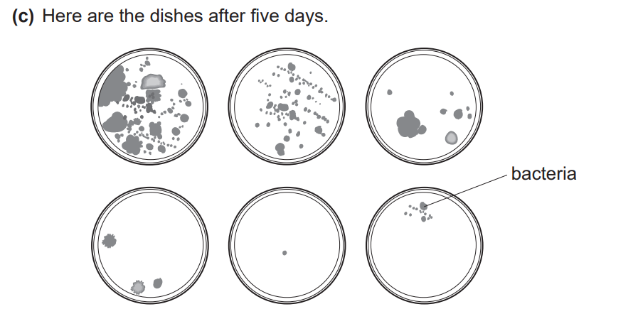
W

A

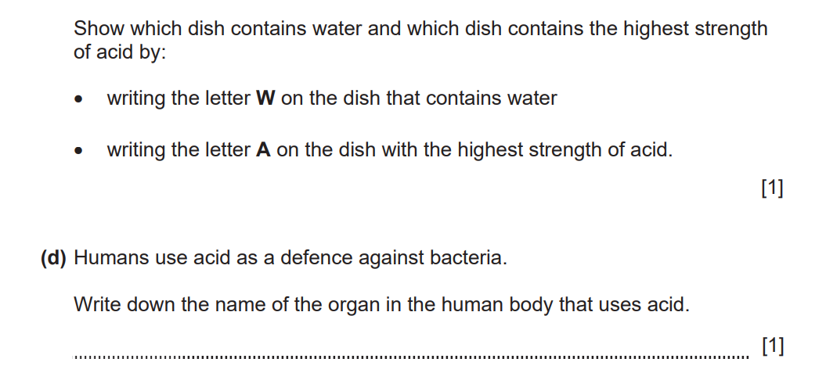

Stomach
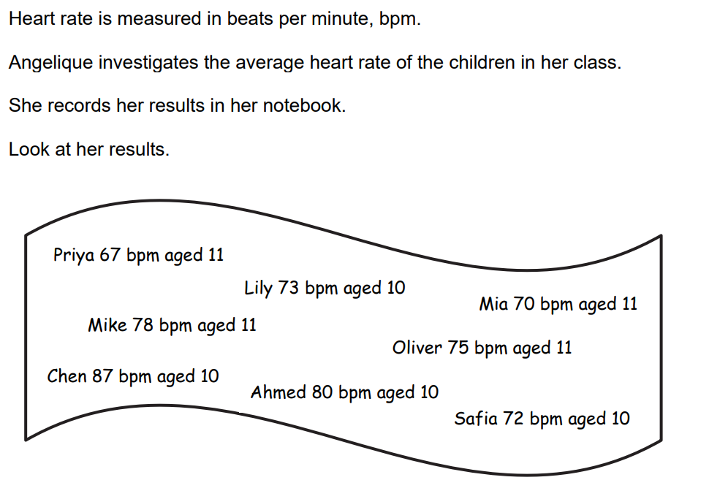
4-

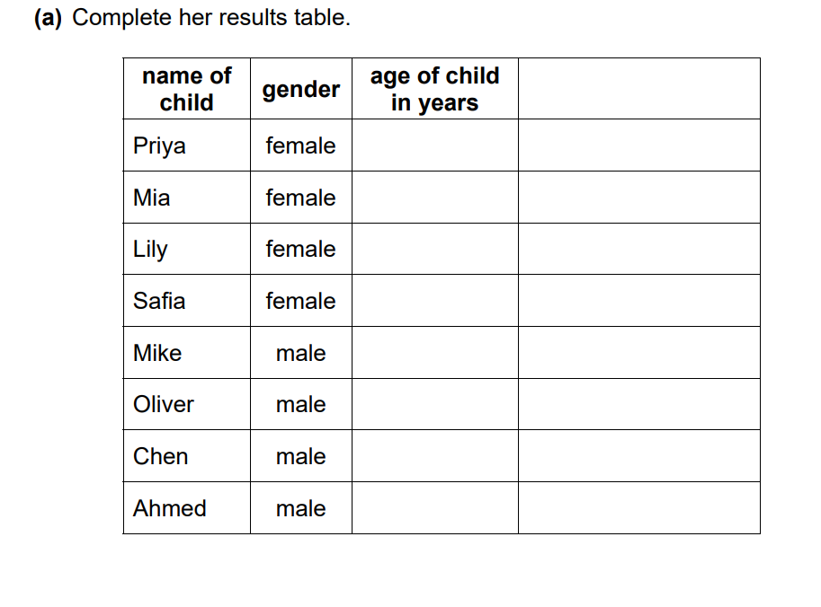

BPM
11 67
11 70
10 73
10 72
11 78
11 75
10 87
10 80

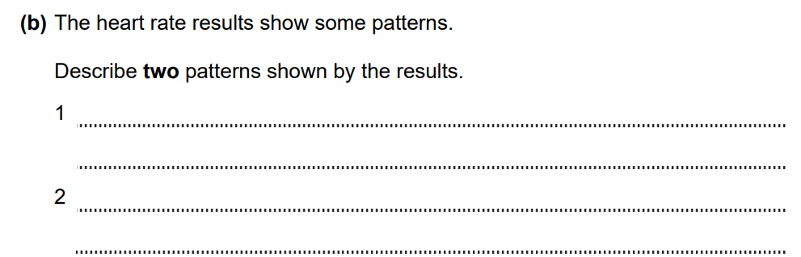
Boys have a higher heart rate
Younger boys have a higher heart rate
Younger girls have a higher heart rate

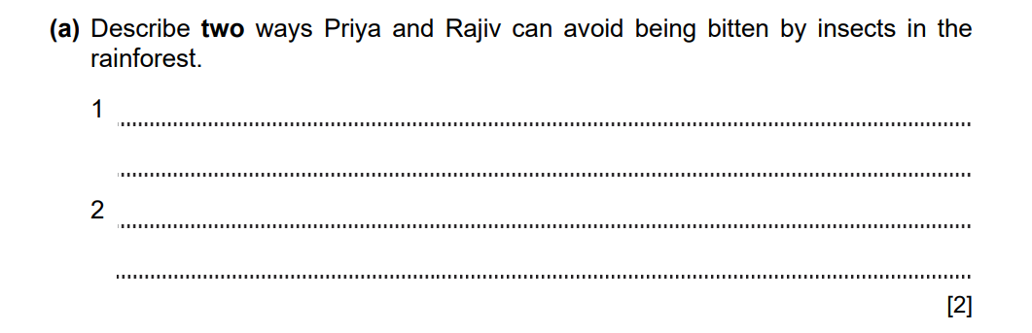
5-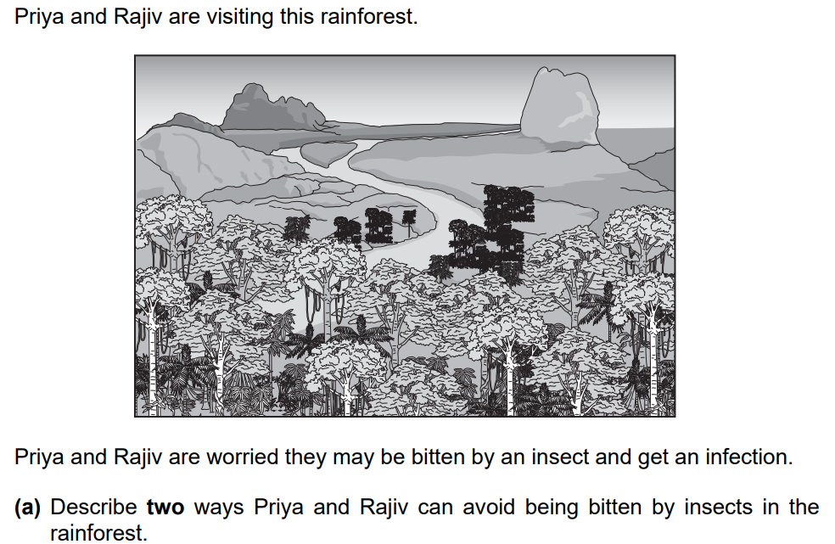
Use insect repellant/cover up skin with clothes /sleep under a net /wear light-colored clothes/avoid long grass /keep to foot paths
Avoid times of day when insects are more active
Avoid insect breeding sites.

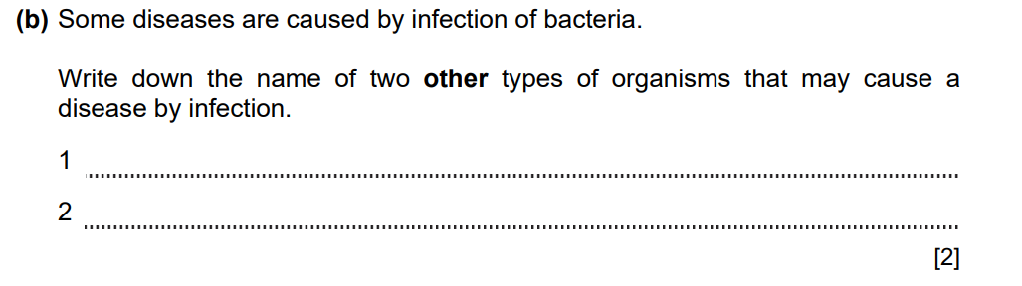
Virus
Parasite/fungi

