Grammar
12th grade

Cleft Sentences – Grammar

1. What is a cleft sentence?
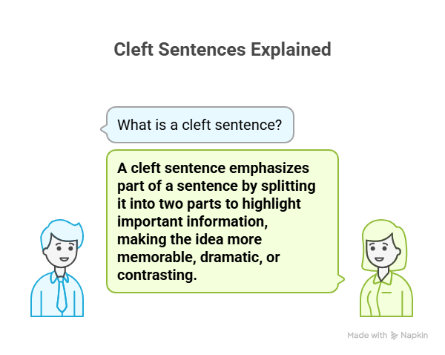
A cleft sentence is a way to emphasise part of a sentence.
We “split” the sentence into two parts to make the important information stand out.
This makes the idea more memorable, dramatic, or contrasting.

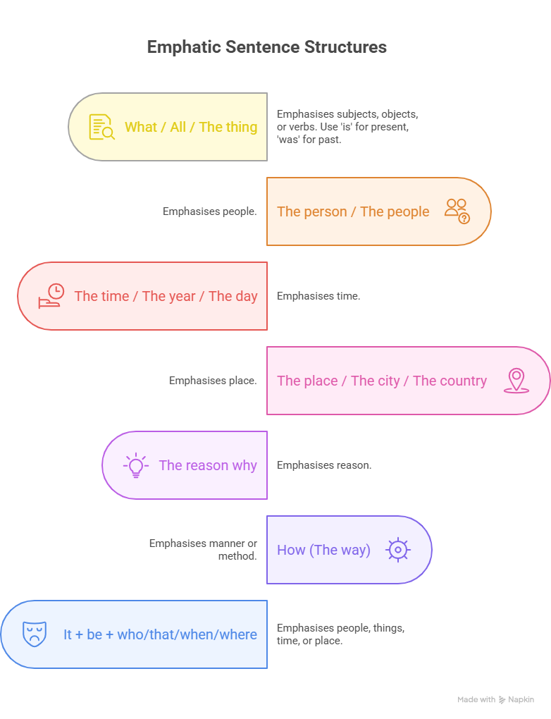
2. Common Patterns

A) What / All / The thing + be
Used to emphasise subjects, objects, or verbs.
- What annoys me when I’m travelling is being away from home. (subject)
- What I didn’t enjoy yesterday was the journey on the crowded train. (object)
- What people did was begin to scream. (verb with do support)
Use is for present, was for past.

B) The person / The people + who + be
Emphasises people.
- The person who I saw at the station was Ali.
- The people who lent me the money were my neighbours.

C) The time / The year / The day + when + be
Emphasises time.
- The year when we got married was 2021.
- The day when he arrived was Sunday.

D) The place / The city / The country + where + be
Emphasises place.
- The city where we got married was Amman.
- The country where I was born was Jordan.

E) The reason why + be
Emphasises reason.
- The reason why he left early was to catch the train.
- The reason why he was late was that his car broke down.

F) How (The way) + be
Emphasises manner / method.
- How he achieved his goal was by studying hard.

G) It + be + who/that/when/where
Very common in English to emphasise people, things, time, or place.
- It was Ali who I saw at the station. (person)
- It was the story that Elias Farkouh published. (thing)
- It was in Amman where he published the story. (place)
- It was in 2020 when he published the story. (time)

3. Examples to Practise
- I wanted to buy a new dishwasher.
→ What I wanted to buy was a new dishwasher.
- Mary’s beauty impressed us.
→ The thing that impressed us was Mary’s beauty.
- People began to scream.
→ What people did was begin to scream.
- I saw Ali at the station.
→ It was Ali who I saw at the station.
- We got married in Amman in 2021.
→ It was in Amman where we got married.
→ It was 2021 when we got married.

Main Structures Summary
- What / All / The thing + be
  - What annoys me is being away from home.
  - What people did was begin to scream.
- The person / people + who + be
  - The person who helped me was Ali.
- The time / day / year + when + be
  - The year when we met was 2021.
- The place / city / country + where + be
  - The city where I was born was Amman.
- The reason why + be
  - The reason why he was late was that his car broke down.
- How (the way) + be
  - How he succeeded was by working hard.
- It + be + who/that/when/where
  - It was Ali who I saw.
  - It was 2020 when we moved to Amman.

Exercises

A) Rewrite using What / All / The thing
- I wanted to buy a new computer.
→ ……………………………………………………………
- The food in the restaurant impressed us.
→ ……………………………………………………………
- She really needs a long holiday.
→ ……………………………………………………………

B) Rewrite using do-support (verb emphasis)
- They cleaned the house before the guests arrived.
→ ……………………………………………………………
- The children played video games all evening.
→ ……………………………………………………………

C) Rewrite with person emphasis
- I met Leila at the library.
→ ……………………………………………………………
- My uncle gave me this watch.
→ ……………………………………………………………

D) Rewrite with time/place emphasis
- We travelled to Paris in 2019.
→ ……………………………………………………………
- They held the party in my house.
→ ……………………………………………………………

E) Rewrite with reason/manner emphasis
- He left early to catch the train.
→ ……………………………………………………………
- She passed the test by studying very hard.
→ ……………………………………………………………

Choose the correct answer.
- 1-Alkaramah Battle occurred in 1968. The sentence which emphasises the underlined word is
a-The year when Alkaramah Battle occurred was in 1968.
b- It is 1968 when Alkaramah Battle occurred.
c-The year that Alkaramah Battle occurred was 1968.
d- The year when Alkaramah Battle occurred was 1968.
- 2-Alkaramah Battle occurred in 1968. The sentence which emphasises the underlined word is
a-The year when Alkaramah Battle occurred is 1968.
b- It is 1968 when Alkaramah Battle occurred
c- It was 1968 when Alkaramah Battle occurred.
d- What occurred in 1968 was Alkaramah Battle.
- 3-I don't like the weather here. The sentence which emphasises the underlined word is
a- What I don't like here was the weather.
b- It was the weather that I don't like here.
c- What I don't like here is the weather.
d- The thing that I don't like here was the weather.
- 4-I don't like the weather here. The sentence which emphasises the underlined word is
a- What I don't like here was the weather.
b- It was the weather that I don't like here.
c- The thing that I don't like here is the weather.
d- It is the weather when I don't like here.
- 5-I don't like the weather here. The sentence which emphasises the underlined word is
a- What I don't like here was the weather.
b- It was the weather that I don't like here.
c- It is the weather that I don't like here.
d- The thing that I don't like here was the weather.
- 6-I need a good night's sleep. The sentence which emphasises the underlined word is
a- It was a good night's sleep that I need.
b- What I need was a good night's sleep.
c- All I need is_a good night's sleep.
d- The thing that I need was a good night's sleep.
- 7-My little brother broke the window. The sentence which emphasises the underlined word is
a- It is my little brother who broke the window
b- What broke the window was my little brother.
c- Who broke the window was my brother?
d- The person who broke the window was my brother.
- 8-My little brother broke the window. The sentence which emphasises the underlined word is
a- It was my little brother where broke the window.
b- What broke the window was my little brother.
c- Who broke the window was my brother.
d- The person who broke the window is my brother.
- 9-My little brother broke the window. The sentence which emphasises the underlined word is
a- It was my little brother who broke the window.
b- What broke the window was my little brother.
c- Who broke the window is my brother.
d- The person who broke the window is my brother.
- 10-He left in order to avoid the embarrassment. The sentence which emphasises the underlined word is
a- What he left was to avoid the embarrassment.
b- The reason why he left was to avoid the embarrassment.
c- The thing that he left was to avoid the embarrassment.
d- Who he left was to avoid the embarrassment.

- 11-Engaging in physical exercise can indeed help clear one's head.
a- What can indeed help clear one's head was engaging in physical exercise.
b- What can indeed help clear one's head is engaging in physical exercise.
c- All that can indeed help clear one's head was engaging in physical exercise.
d- It was engaging in physical exercise that can indeed help clear one's head.
- 12-I managed to keep a clear head by engaging in physical exercises. How.
a- Who I managed to keep a clear head was by engaging in physical exercises.
b- How I managed to keep a clear head was by engaging in physical exercises.
c- What I managed to keep a clear head was by engaging in physical exercises.
d- It is by engaging in physical exercises that I managed to keep a clear head.
- 13-I wanted to go home and sleep.
a- All I wanted to do was go home and sleep.
b- All I wanted to do is go home and sleep.
c- All I wanted was going go home and sleep.
d- All I wanted to doing was go home and sleep.
- 14-I studied in Amman. Emphasise the underlined words. (Cleft sentence)
a- The city where I studied was in Amman.
b- The city where I studied is Amman.
c- The city Amman where was I studied.
d- The city where I studied was Amman.

Haneen Mazahreh

Answer Key
Q1.
- What I wanted to buy was a new computer.
- What impressed us was the food in the restaurant.
- All she really needs is a long holiday.
- What they did was clean the house before the guests arrived.
- What the children did was play video games all evening.
- It was Leila who I met at the library.
- The person who gave me this watch was my uncle.
- It was in 2019 when we travelled to Paris.
- It was my house where they held the party.
- The reason why he left early was to catch the train.
- How she passed the test was by studying very hard.

Q2. 1-d 2-c 3-c 4-c 5-c 6-c 7-d 8-c 9-a 10-b 11-b 12-b 13-a 14-d

