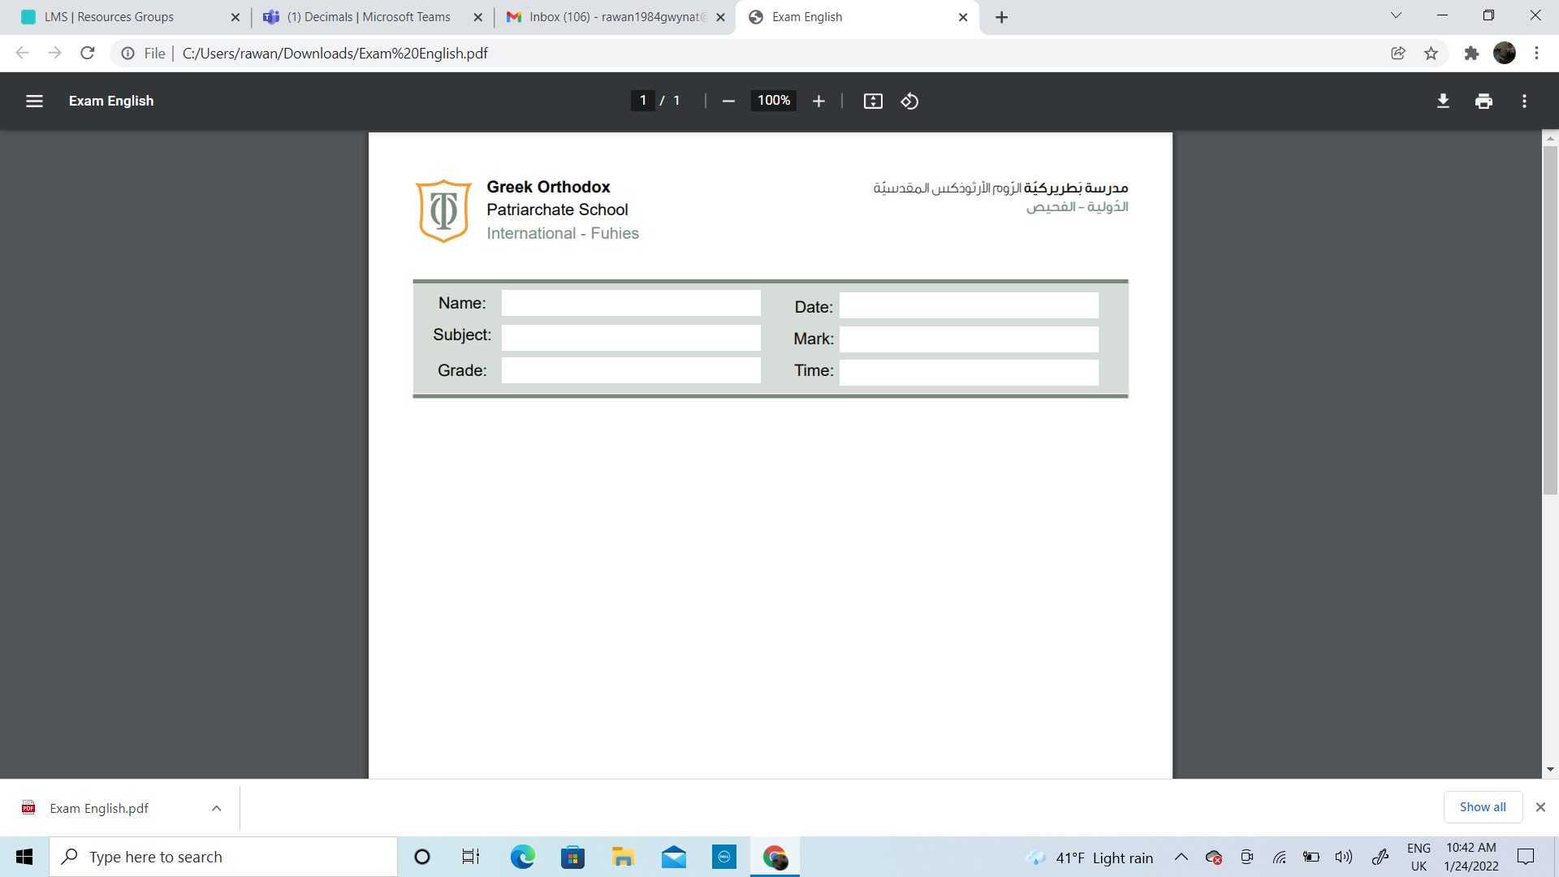
Name: _____________________________ Date: ______________________
Subject: Math Worksheet #3
Class: Grade1 (A, B, C) Teacher: Nancy Alfarah

Objectives:
- Write numbers from 1-10 in word form
- Understand addition as counting on using 2 digits and single digits.
- Understand adding small numbers
- The student should know how to solve the subtraction problems
- Recognise the complements of 10,20,100
- Understand and explain the relationship between addition and subtraction.

- Fill in the blanks with correct answer
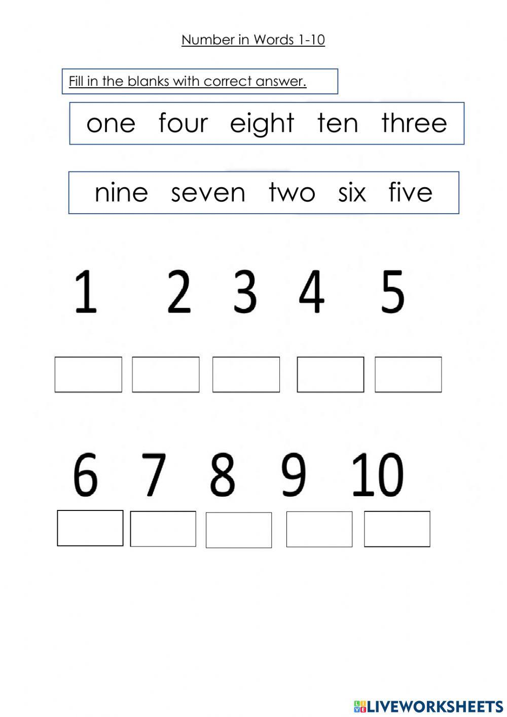

- Calculate the following.

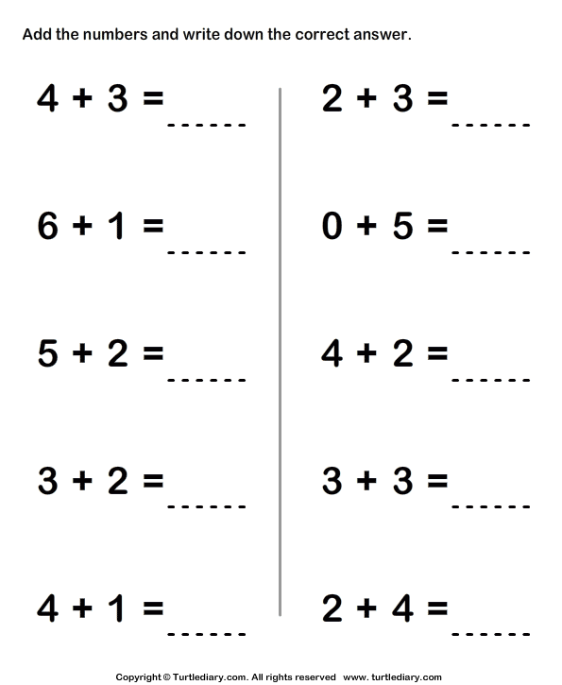
- Calculate the following.

13 + 8 = | 17 + 1 = | 10 + 8 =
15 + 3= | 13 + 5 = | 11 + 5 =
18 + 2 = | 12 + 2 = | 17 + 2 =
11 + 5 = | 14 + 5 = | - + 3=

- Calculate the following.

8 + 2 + 6 = | 4 + 5 + 6 = | 1 + 2 + 9 =
7 + 1 + 3 = | 5 + 3 + 5 = | 5 + 5 + 6 =
- + 5 + 6 = | 3 + 2 + 7 = | 8 + 2 + 1 =
5 + 5 + 6 = | 2 + 8 + 6 = | - + 4 + 1 =

- Calculate the following.

1 + 3 + 9 + 3= | 5 + 3 + 5 + 3=
2 + 4 + 8 + 4= | 6 + 1 + 4 + 1=
3 + 5 + 7 + 5= | 7 + 2 + 3 + 2=
4 + 2 + 6 + 2= | 8 + 1 + 2 + 1=

6)Answer the following problems.

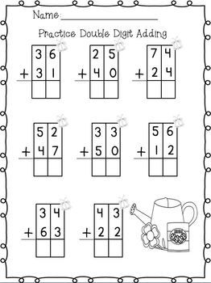

7)Find the answer of the following.

25 + 14 = | 12 + 25 =
23 + 24 = | 15 + 62 =
36 + 12 = | 63 + 22 =
54 + 23 = | - + 24 =

8)Subtract the following numbers.

15 - 4 = | 66 - 4 =
38 - 2 = | 98 - 3 =
14 - 3 = | 24 - 3 =
27 - 5 = | 59 - 8 =

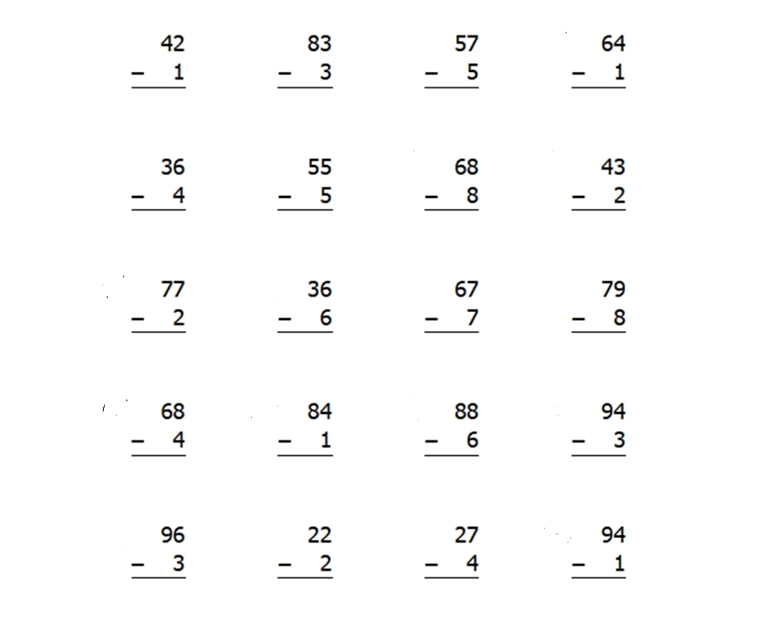
9)Subtract the following numbers.

10)Subtract the following numbers.

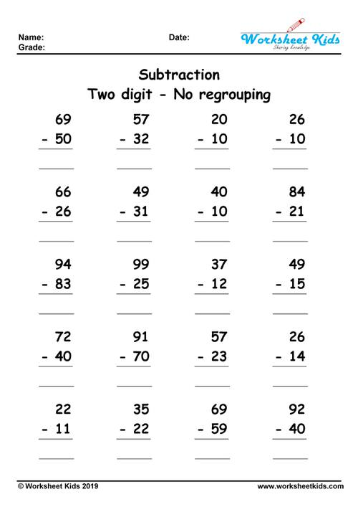

11)Find the missing number in each of the following number bonds.

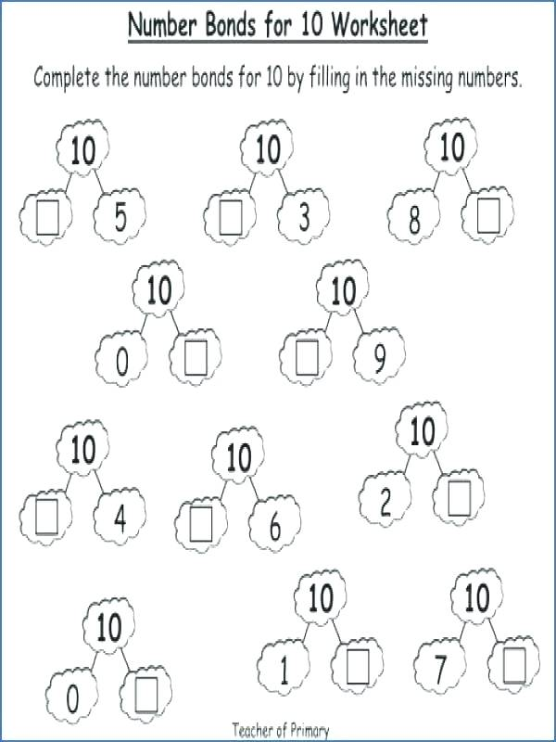

12)Match the pairs of numbers that make 20.
1 | 18
2 | 16
3 | 15
4 | 19
5 | 17
13) Write the missing number in each of the following number bonds of 20.
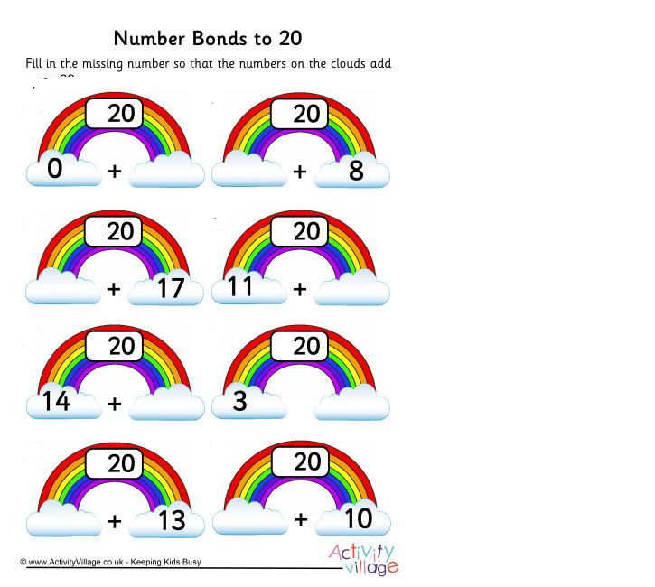

- Match to make 100.
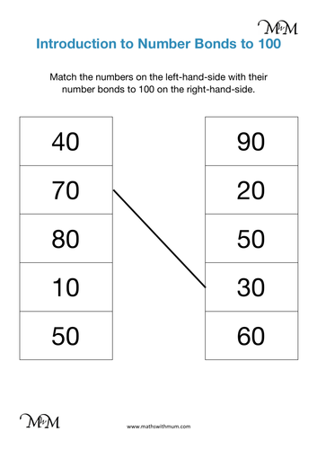

15)Write the four different facts for the following numbers.

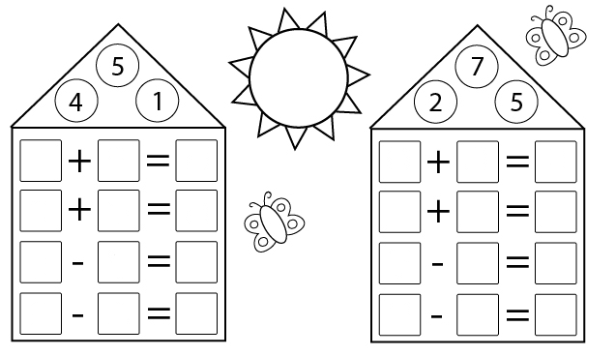

16)Write the four different facts for the following numbers.

