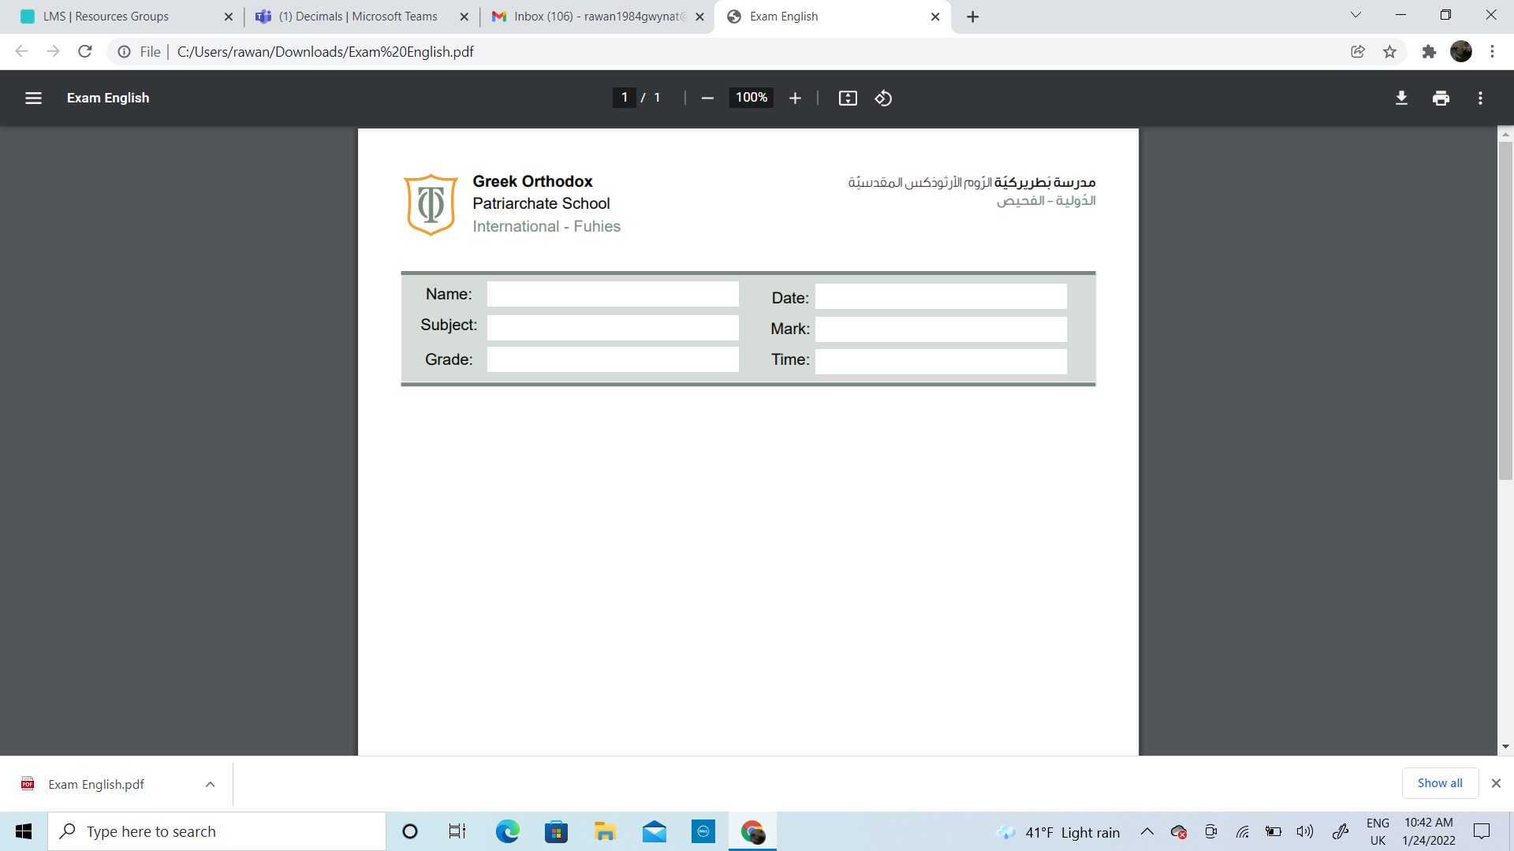

Name:_____________________________ Date______________________
Subject: Math practicing worksheet #3
Class: Grade 2 ( A , B ,C)

Objectives :
- The student should be able to round to the nearest 10 and 100
- The student should be able to define the number bonds of 10,20,100 and 1000


- The student should be able to know how to place numbers on a number line.
Circle the ten that each number rounds to.

Do these numbers round
up

or
down
?

20

29
9

30

70

7
8

80

40

4
2

50

Oh, it is raining
outside, take

the bird to the
nearest umbrella

Round up / Round down

Round up / Round down

Round up / Round down

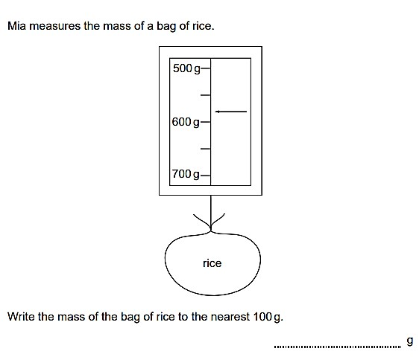

90

95

100

30

32

40

40

46

50

Round up / Round down

Round up / Round down

Round up / Round down

Round the following numbers to the nearest 10. The first one has been done for you.
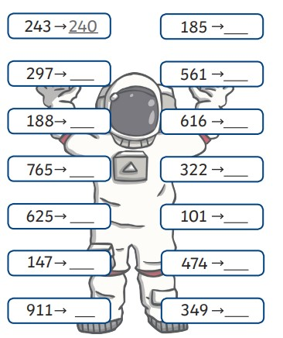

Round the following numbers to the nearest 100.
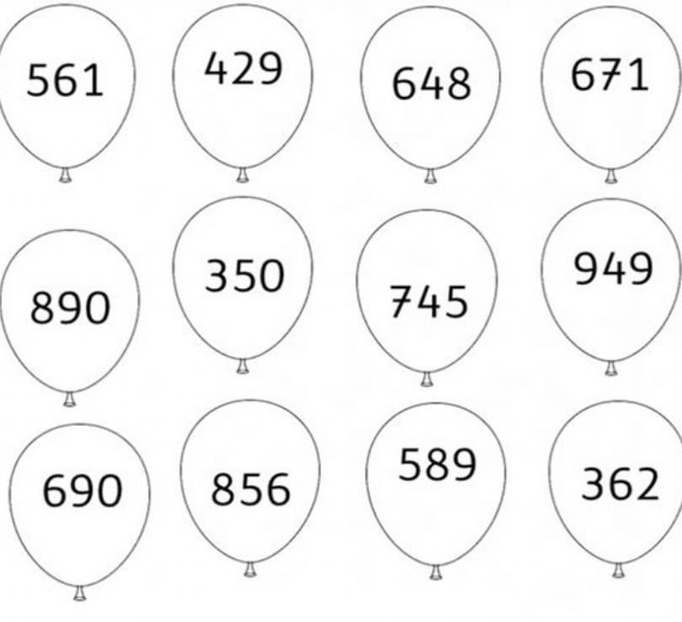

A small book has 148 pages.

- Round the number of the pages to the nearest 100.

____________________________

- Would it be all right if the book was printed with the rounded number of pages? Explain your answer.

_________________________________________________________

_________________________________________________________
Mike chooses some numbers. He rounds them to the nearest 10 The answer is always 260 Write the largest number that Mike could choose.

_______________________________________________

Number bonds of ( 10,20,100,1000)
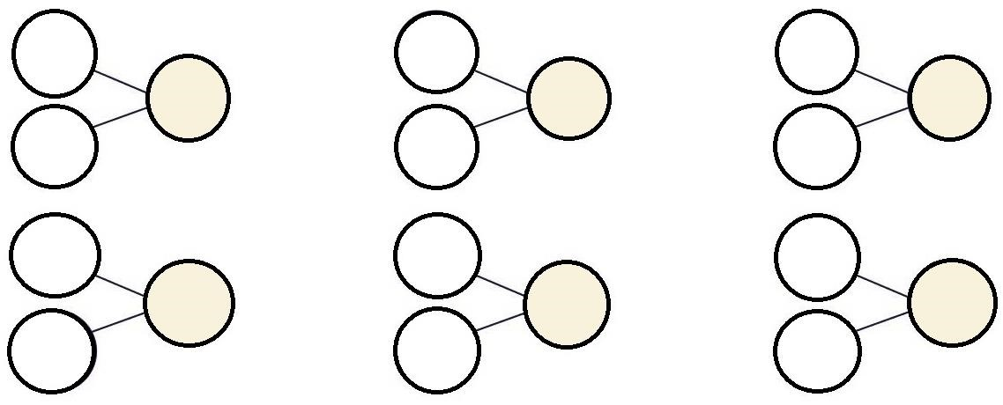
Make number bonds of number 10

Make number bonds of number 20
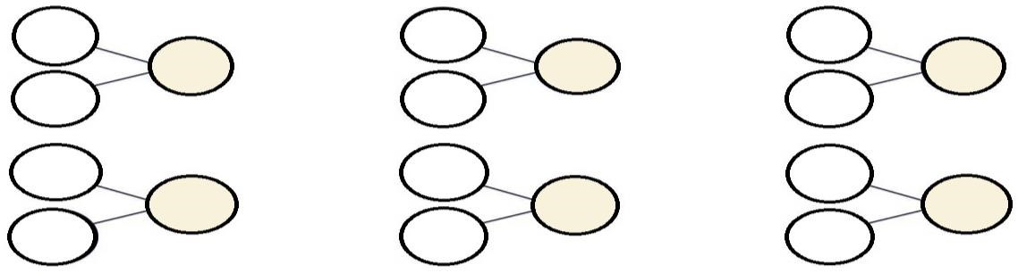
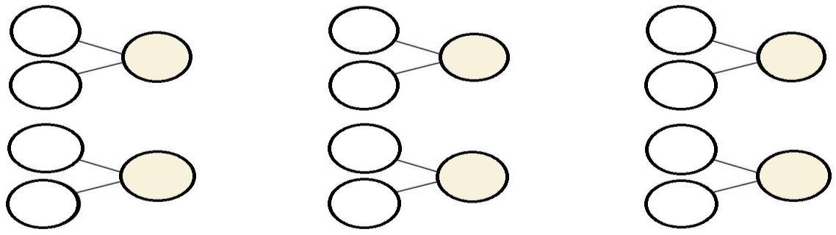
*- Draw an arrow (↓) to show 10 on the number line.
Let's make number bonds of number 10.

Make number bonds of number 10
0.

Make number bonds of number 1000

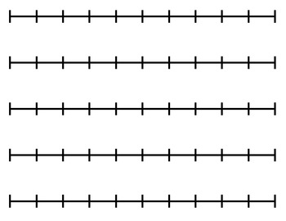
100
0

*- Draw an arrow (↓) to show 60 on the number line.

100
0

*- Draw an arrow (↓) to show 300 on the number line.

1000
0

*- Draw an arrow (↓) to show 700 on the number line.

1000
0

*- Draw an arrow (↓) to show 900 on the number line.

1000
0

*- Draw an arrow (↓) to show 500 on the number line.

1000
0

*- Place these numbers 75, 35, 55, 45, 65 on the number line.

80
70
60
50
40
30

*- Place these numbers 750, 350, 550, 450, 650 on the number line.

800
700
600
500
400
300

*- Place number 250 on the number line.

600
500
400
300
200
100

*- Place number 650 on the number line.

800
700
600
500
400
300

