
- Write the numbers represented by each base ten blocks.
Math- practice sheet #1 place value
Grade 2
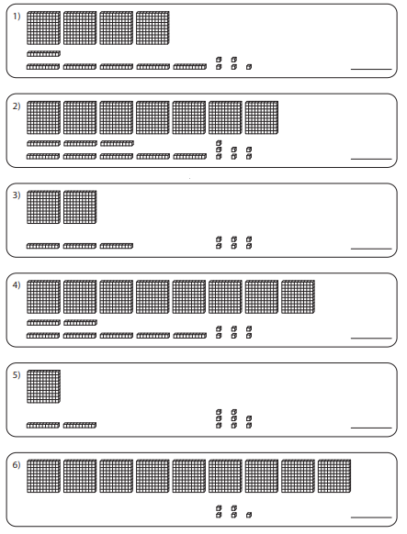

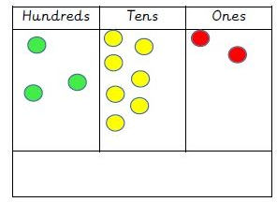
_____________
- Write the missing numbers from 900-1000.
901 |  | 903 |  |  |  |  |  | 909
 | 912 |  |  |  | 916 |  |  |  | 920
 |  | 923 |  |  |  |  |  | 929
 | 932 |  |  |  |  | 937
 |  |  | 944 |  |  |  | 948
951 |  |  |  | 955 |  |  |  | 959
 | 962 |  |  |  | 966 |  | 968 |  | 970
971 |  |  |  | 975
 | 982 |  |  |  | 986 |  |  | 989
991 |  |  |  |  |  | 997
- Write the following numbers in word form.
752
…………………………………………………………………
871
…………………………………………………………………

- Write down the following numbers in word form.
723
………………………………………………………………………
581
………………………………………………………………………
357
………………………………………………………………………
- Draw a line to match the number to the correct word form.
296 three hundred and seventy-one
121 eight hundred and one
814 two hundred and ninety-six
371 one hundred and twenty-one
801 eight hundred and fourteen
- Write each of the following in standard form:
Five hundred and seventy-one …………...
One hundred and sixty-five ……………
Eight hundred and five ……........
Six hundred and nine …………….
Six hundred and ninety …………
Six hundred and ninety-three ………

- Write down the value of each digit in the following numbers. (Decompose: to break the number into parts.)
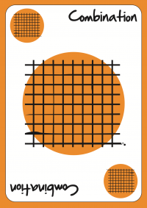
489= _____ + _____ + _____
779= _____ + _____ + _____
200= _____ + _____ + _____
399= _____ + _____ + _____
159= _____ + _____ + _____
489= __ hundreds + __ tens + __ units
779= __ hundreds + __ tens + __ units
200= __ hundreds + __ tens + __ units
399= __ hundreds + __ tens + __ units
159= __ hundreds + __ tens + __ units
- Decompose the following numbers.
539= _____ + _____ + _____
978= _____ + _____ + _____
888= __ hundreds + __ tens + __ units
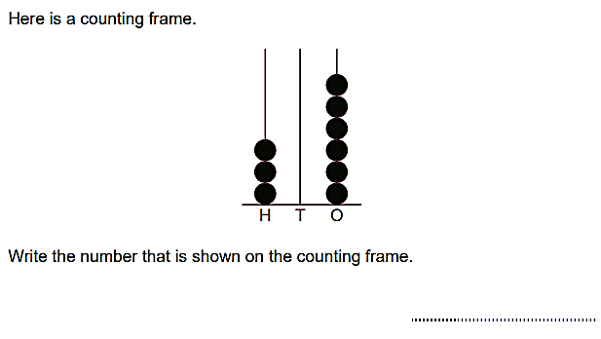
370= __ hundreds + __ tens + __ units
- Circle all the EVEN numbers.
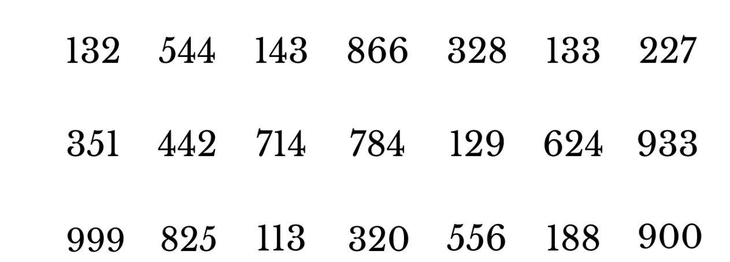
- Circle all the ODD numbers.
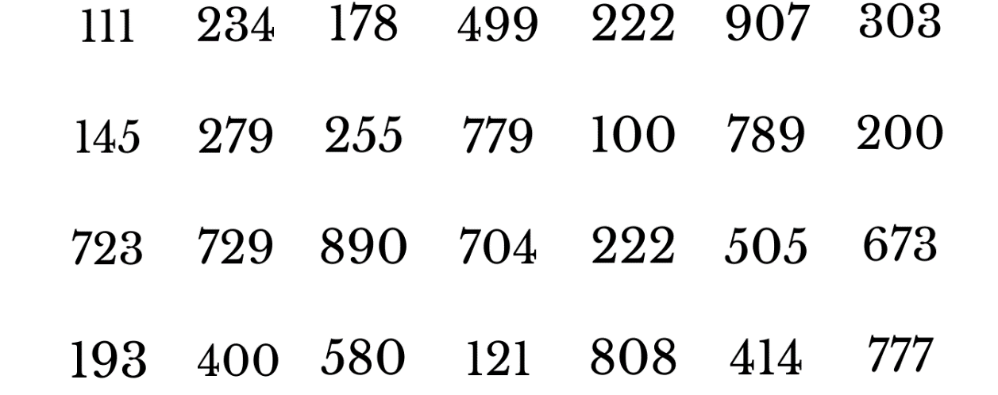
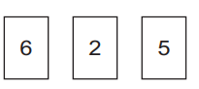
- Ron and Eva make 3-digit numbers from the following cards using each card once.

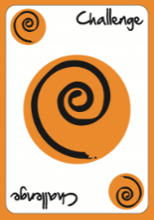
Ron makes the largest even number possible.
Eva makes the smallest odd number possible.
Write the numbers each of them makes.
Ron ________
Eva ________

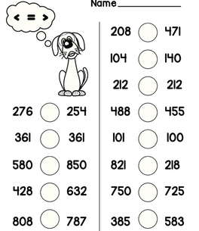
- Choose the correct sign to compare the following <, >, =.

The end
Math Department
(these questions are from Learner’s book and workbook to cover
All the material for the first assessment )
Q1
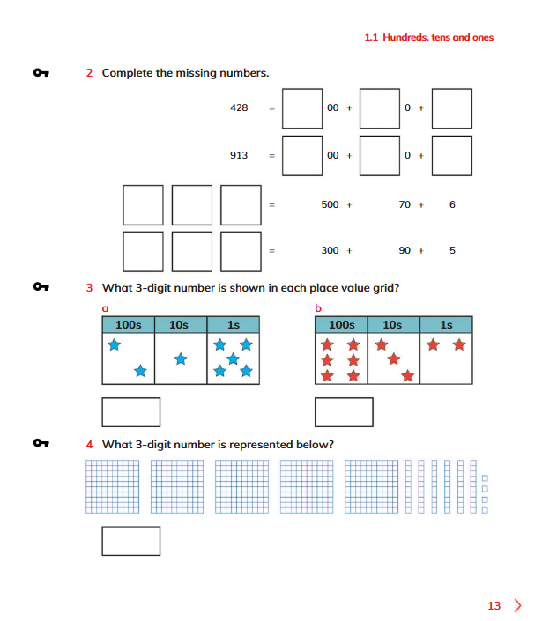
Q2
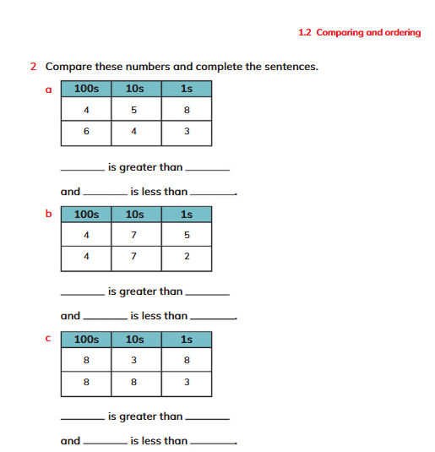

Q3

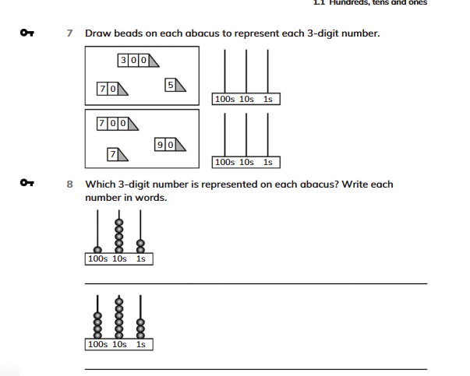

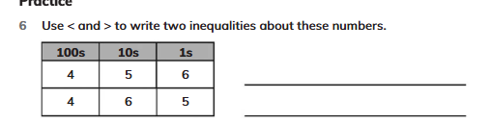

Q4

