(3)

English
/ /2025
3

Read the following story, then answer the questions below:

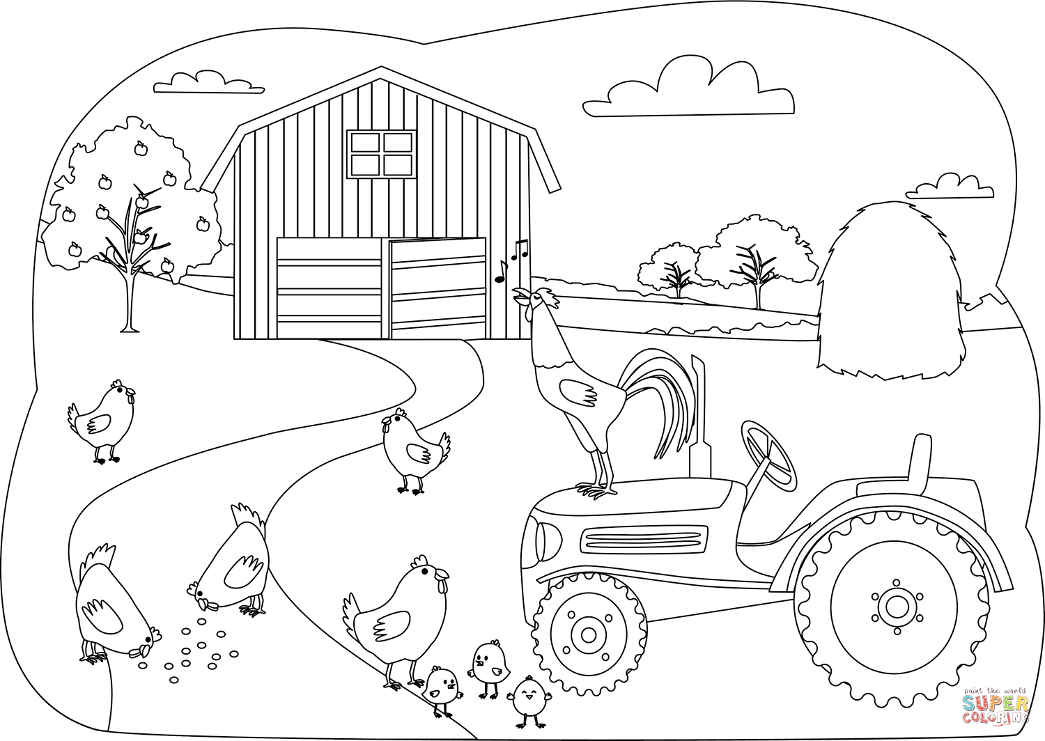
A Day at the Farm

Liam and his sister Mia went to visit their uncle’s farm last weekend. They woke up early and helped feed the chickens. The chickens clucked loudly and pecked at the grains on the ground.
After that, they helped collect eggs from the henhouse. Liam counted ten eggs, and Mia counted twelve. They carried the eggs carefully to the kitchen.
Later, they went to the barn to see the cows. The cows were big and brown. One of the cows, named Bessie, mooed loudly when she saw them. Liam and Mia fed Bessie some fresh hay.
Before leaving, they picked some apples from the orchard. The apples were red and shiny. They made a basket full of apples to take home.
Liam and Mia were tired but very happy. They had a fun day at the farm.

Question 1:
a) Who went to visit the farm?
………………………………………………………………………………………………………………………
b) How many eggs did Liam count?
……………………………………………………………………………………………………………………….
c) What color were the cows?
………………………………………………………………………………………………………………………..
Question 2
a) What does “clucked” mean in the story? …………………………………………………………….
b) What is an “orchard”?.......................................................................................................................

Question 3:
a) Why do you think Liam and Mia carried the eggs carefully?
…………………………………………………………………………………………….…………………………
b) How do you think Liam and Mia felt at the end of the day?
………………………………………………………………………………………………………………………..

Question 4:
a) Find an adverbial phrase in the story. (Hint: Look for a group of words that tells when, where, or how something happens.
………………………………………………………………………………………………………………………..

Teacher Maram Moien Dayoub

Answers
Question 1:
a) Who went to visit the farm?
Answer: Liam and his sister Mia
b) How many eggs did Liam count?
Answer: Ten
c) What color were the cows?
Answer: Brown

Question 2:
a) What does “clucked” mean in the story?
Answer: The sound chickens make (a noise they make by calling out).
b) What is an “orchard”?
Answer: A place where fruit trees grow, like apple trees.

Question 3:
a) Why do you think Liam and Mia carried the eggs carefully?
Answer: Because eggs are fragile and could break easily.
b) How do you think Liam and Mia felt at the end of the day?
Answer: They felt happy and tired.

Question 4:
a “last weekend” (when)
- “carefully to the kitchen” (how)
- “from the orchard” (where)

