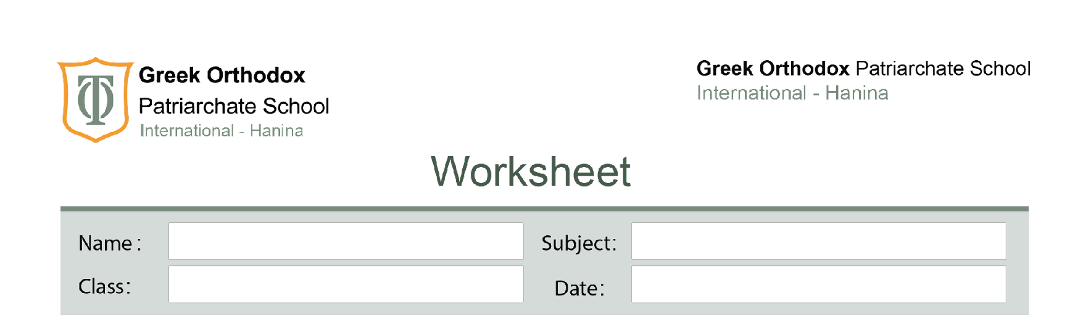
Unit 4/ Maintaining life/ Mark scheme

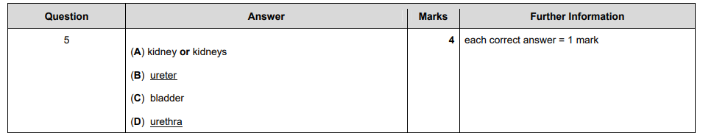
1

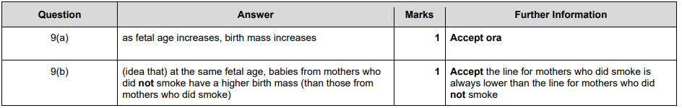
2(a)
2(b)

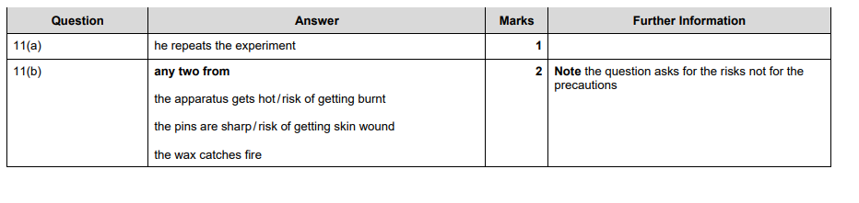
3(a)
3(b)

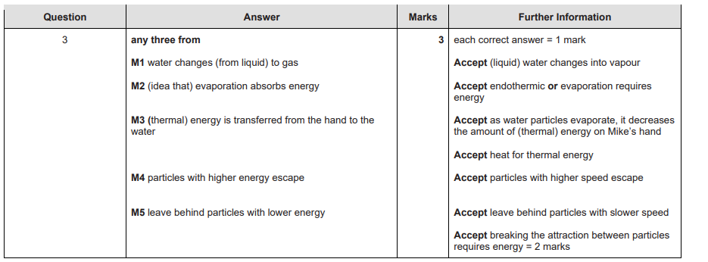

4

