
Unit 1/ Photosynthesis and the carbon cycle/ Markscheme

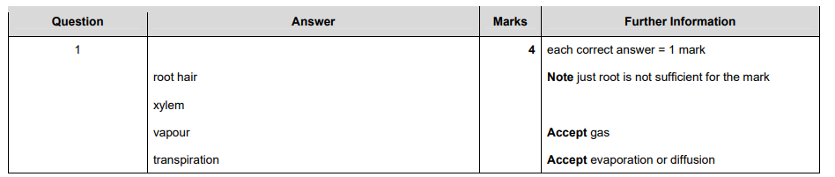

1

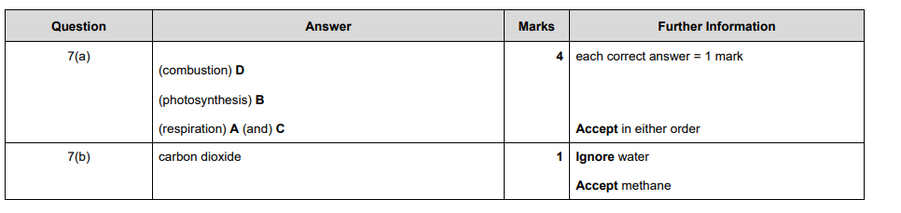
2 (a)

2 (b)

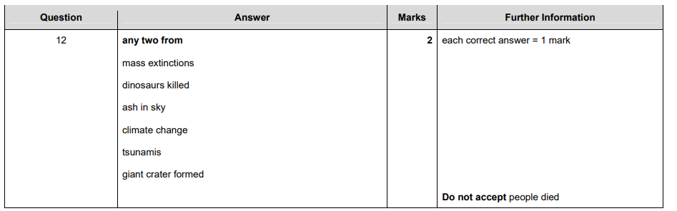

3

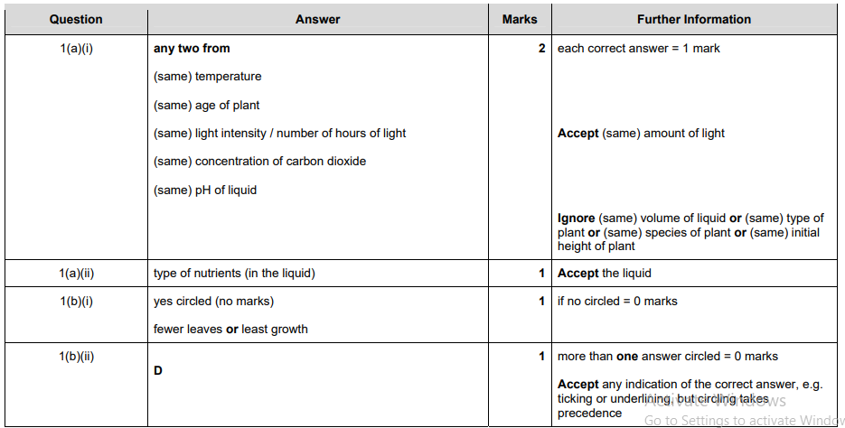
4 (a)(i)

4 (a)(ii)
4 (b)(i)
4 (b)(ii)

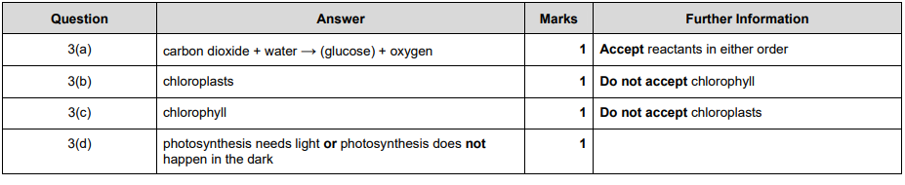
5 (a)
5 (b)
5 (c)
5 (d)

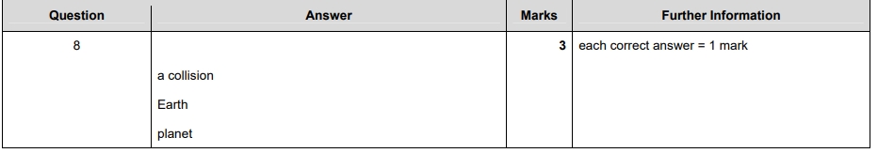
6
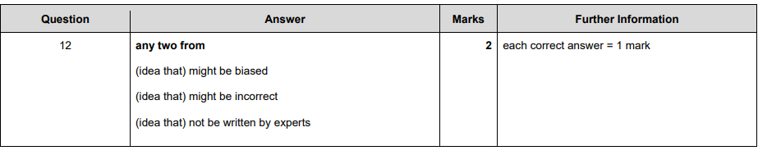
7

