Unit two (Properties of materials)
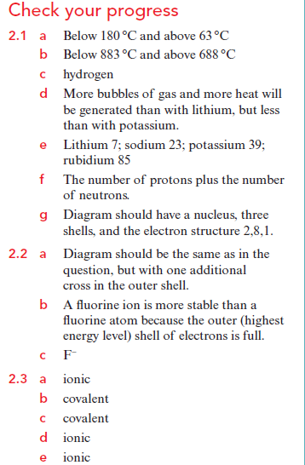
Learner’s book Check your progress answers page 82 and 83

