Unit one (Photosynthesis and the carbon cycle)
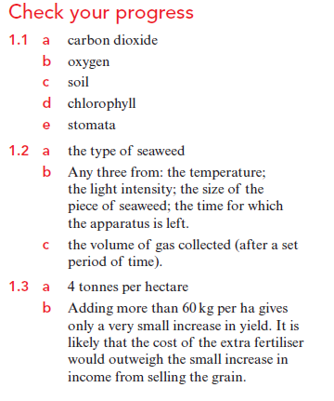
Learner’s book Check your progress answers page 45, 46 and 47

