Worksheet number ( 2 ) / Unit Three

Raghad
Fit as a fiddle
9th Grade
/ Nov /2025

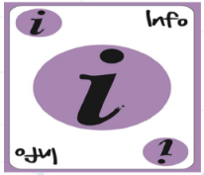

ASSIGNMENT 2

Answer the following questions then send them on LMS...

1. Do you think keeping fit is important for people of all ages?
Give me 2 reasons.
A Yes its very important
Because I think it’s a good way to meet people with similar interests(Helps build friend ship)

B. Being active helps your body settle down at night
(Better sleep)

2. How can a person be healthy and fit?

A. Eat balanced meal
B. Get enough sleep
C. Move regularly
D. Drink enough water during the day

3. What you do...

- if you feel stressed and need to relax _Talk to someone I trust or go on a walk _________________________
____________________________________________________________
- if you feel ill or get hurt _Tell my parents and see a doctor______________________________________
____________________________________________________________

English Department.

