Worksheet number ( 2 ) / Unit Three

Fit as a fiddle
/ Nov /2025
9th Grade

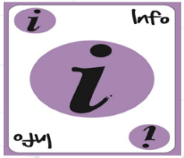

ASSIGNMENT 2

Answer the following questions then send them on LMS...

1. Do you think keeping fit is important for people of all ages?
Give me 2 reasons.
- it lowers the risk like heart desease

B. it improves mood and energy level, sleep

2. How can a person be healthy and fit?

A. regular physical activity
B. play sport you enjoy
C. manage stress
D. limit alcohol

3. What you do...

- if you feel stressed and need to relax _spend a day in natural take a deep breath walking in the nature with someone you like or listen to music __
________
- If you feel ill or get hurt ____tell my parents to go to the hospital or drink herbs eat healthy food like soup and salad ______

English Department.

