Worksheet number ( 2 ) / Unit Three

/ Nov /2025
9th Grade

Fit as a fiddle

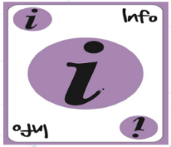

ASSIGNMENT 2

Answer the following questions then send them on LMS...

1. Do you think keeping fit is important for people of all ages?
Give me 2 reasons.

- Staying fit keeps your memory

B .Fitness helps people stay more creative

2. How can a person be healthy and fit?

- A.Spending time in nature.
- Laughing more often.
- Doing balance exercises.
- Keeping the mind active.

3. What you do...

- if you feel stressed and need to relax
I listen to soft music and take a short walk outsid
____________________________________________________________
- if you feel ill or get hurt _Irest drink warm tea and ask someone for help if ineed it ______________________________________
____________________________________________________________

English Department.

