My Favorite Sport

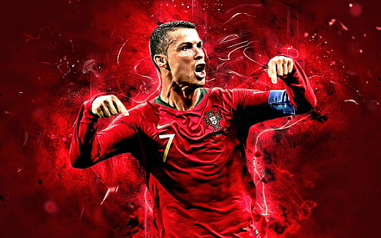

s
occer, the beautiful game, has always been my favorite sport. The fast-paced action, the skillful players, and the roar of the crowd create an electrifying atmosphere. I love the strategic plays and the teamwork involved in every match. Nothing beats the feeling of seeing your favorite team score a goal. The World Cup is the pinnacle of the sport, bringing together the best teams from around the globe. It's a sport that unites people and provides endless excitement.

