MY FAVOURITE SPORT
My favourite sport is actually football (soccer) I like it a lot because its fun and I play for years for now.I like to play with my brother cousins and my friends.and when I grow up I want to be a football player and be famous.

Next page is pictures about my favourite sport , player and team.

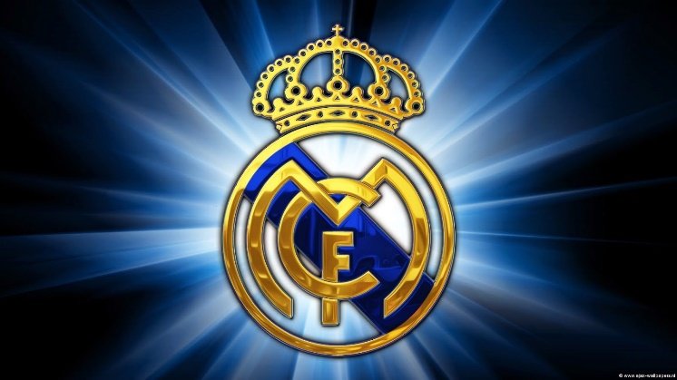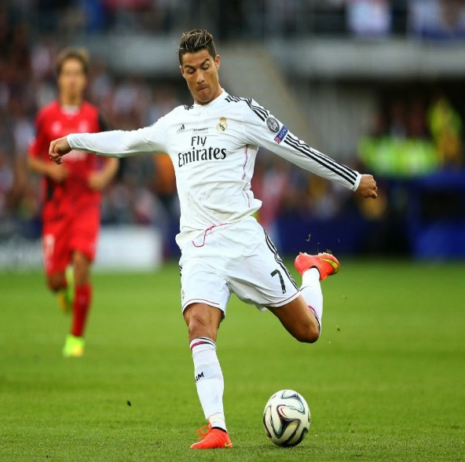

pictures

about real madrid

R

eal Madrid is a professional football club from Madrid, Spain, founded in 1902
Known for their all-white home kit and nicknamed "Los Blancos," the club is one of the most successful and widely supported in the world. The hold the record for most Champions League titles, I LIKE THIS TEAM A LOT because they are so strong and wins a lot and have the best players.

